|  |
| --- |
|  |
| Fiscal Management Policies and Procedures Manual |
| Five Management Systems |
| Bááháálí Chapter |
| **08/17/15** |
|  |

**BÁÁHÁÁLÍ CHAPTER**

FISCAL POLICIES AND PROCEDURES MANUAL

TABLE OF CONTENTS

Preface: Table of Contents 1

1. AUTHORIZATION 3

A. 26 N.N.C., Section 101 (A)

B. Chapter Resolution

II. PURPOSE AND SCOPE OF POLICY 3

1. Statement of Policy
2. Applicability

III. AMENDMENTS 3

* 1. Request for Amendments
  2. The basis for Amendments
  3. Procedures

IV. Role of Chapter OfficialS 4

V. Accounting System RequirementS 5

1. Policy
2. Fund Accounting
3. Funds
4. Financial Accounting Records 6

vi. Chapter Operating Budget 6

1. Policy
2. Proposed Budgeting
3. Fiscal Period 7
4. Budget Preparation and Procedures

vii. Internal Control Policies and Procedures 8

1. Purpose Statement
2. Cash Receipts
3. Petty Cash 10
4. Certificate of Deposits and Other Investments 13
5. Cash Disbursements 14
6. Credit Card 15
7. Payroll 16
8. Travel Policies and Control Procedures 19
9. Financial Assistance 22
10. Bank Accounts 23
11. Bank Reconciliation 24
12. Resale Inventory 26
13. General Fixed Assets 28
14. Financial Statements 29
15. Chart of Accounts 30
16. Audit Requirements
17. Misuse of Chapter Funds or Assets

VIII. Definitions 31

IX. Appendixes 34

* 1. Monthly Monitoring Form 35
  2. Budget Forms 38
  3. Budget Revision Request Form 44
  4. Universal Petty Cash Envelope 45
  5. Petty Cash Voucher 46
  6. Fund Approval Form 47
  7. Purchase Card Authorization Form 48
  8. Purchase Card Authorization for Reoccurring Purchases Form 50
  9. Credit Card Policy 51
  10. Travel Expense Log 54
  11. Fuel Log Sheet 55
  12. Work Site Sign-In Sheet 56
  13. Timesheet 57
  14. Check Sign Out Sheet 58
  15. Travel Request Form 59
  16. Travel Authorization Form 60
  17. Trip Expense Report Packet 61
  18. Scholarship Policy and Application Form 66
  19. Housing Discretionary Policy and Application Form 79
  20. Funeral/Burial Assistance Policy and Application Form 93
  21. Home Site Lease Assistance Policy and Application Form 96
  22. Emergency Assistance Application 102
  23. Veterans Assistance Policy and Application Form 103
  24. Bank Transfer Form 107
  25. Stop Payment/Void Check Form 108
  26. Perpetual Inventory Sheet 109
  27. Physical Inventory Sheet 110
  28. Depreciation Form 111
  29. Chart of Accounts 112

**BÁÁHÁÁLÍ CHAPTER**

FISCAL POLICIES AND PROCEDURES MANUAL

1. AUTHORIZATION
2. Pursuant to 26 N.N.C., Section 101(A), the Bááháálí Chapter is required to adopt and operate under a Five Management System to ensure accountability. The Bááháálí Chapter shall also develop policies and procedures for the Five Management System consistent with applicable Navajo Nation Laws.

B. Pursuant to Bááháálí Chapter Resolution BSPRG-06-07-10 and BHC-11-09-S01, the Fiscal Policies and Procedures Manual is hereby approved.

1. PURPOSE AND SCOPE OF POLICY

A. The fiscal manual is intended to insure that a financial management system is established which provides for planning, organizing, directing, and controlling the limited resources of the Bááháálí Chapter to achieve a desired mission, goals, or objectives, and to meet various governmental compliance requirements.

B. The general principles of this policy are applicable to all employees of the Bááháálí Chapter, including Chapter Officials who will monitor the financial management system to ensure fiscal records are maintained and that this policy is enforced.

1. AMENDMENTS
2. Fiscal Policies and Procedures can be amended based on recommendations from Chapter staff, officials, and Chapter membership; or external influences such as changes in applicable Navajo Nation laws, economy, and governmental structure; or through recommendations from consultants, audits or other reviews, which might cause a need for amendment to this policy. If the policies and procedures warrant amendment, the proposed amendment(s) shall be presented at a regularly scheduled Chapter meeting for approval or disapproval by a simple majority vote.
3. The basis to add/delete or to revise any section(s) or provision(s) of the Bááháálí Chapter Fiscal Policies and Procedures Manual would be subject to the following condition(s):
   1. Additional regular full-time staff positions have been added that would require further segregation of duties and responsibilities.
   2. A change in the Chapter’s organizational structure.
   3. The present Fiscal Management Policies and Procedures Manual is no longer adequate to address the needs of the Bááháálí Chapter government.
4. Procedures and Requirements for Submitting Amendments:
5. Any proposed amendments to the Fiscal Policies and Procedures Manual must be submitted in writing to the Chapter Manager.
6. The proposed amendments must be drafted in a legislative format. New language will be underlined and old language over-stricken.
7. The Chapter Manager in consultation with the Navajo Nation Department of Justice and the Office of the Auditor General will review the proposed amendments to assure compliance with applicable federal, state and Navajo Nation Laws.
8. If requirements 1, 2 & 3 above are met, the Chapter Manager will forward them to the Chapter Officials for review and discussion at a regular scheduled planning meeting.
9. The Chapter Officials may, depending on whether the amendments are substantial and sufficient to warrant a public hearing, direct the Chapter Manager to set a public hearing date, time and location.
10. Based upon information received during the public hearing, the Chapter Officials will forward the recommendations to the Chapter membership for approval or disapproval at a regular duly called Chapter meeting with a simple majority vote.
11. Upon approval, the Chapter Manager will make recommended changes to the manual with a supporting resolution.

IV. ROLE OF THE CHAPTER OFFICIALS

1. The Chapter President shall work closely with the Vice-President and Secretary/Treasurer, to ensure that the Chapter Administration is adequately meeting the Chapter’s directive and expending funds according to the conditions of the Navajo Nation Council and/or the Chapter’s annual budgetary objectives. The Chapter President shall also report to the Chapter membership pursuant to 26 N.N.C, Section 1001 (B) (1) (j). This report will also include regulations, terms and conditions, assurances and certification requirements of all funding agencies other than the Navajo Nation.
2. The Secretary/Treasurer shall monitor the maintenance of an adequate accounting system to ensure accountability of all funds and expenditures; and shall report to the Chapter membership pursuant to 26 N.N.C., Section 1001 (B) (3) (h).
3. The Secretary/Treasurer shall co-sign all checks along with the Chapter Manager. In the event the Secretary/Treasurer is unavailable, the Chapter President or Chapter Vice-President may co-sign checks pursuant to 26 N.N.C., Section 1001 (B) (3) (l).
4. The Secretary/Treasurer, in consultation with other Bááháálí Chapter Officials, shall ensure that the administrative staff prepares monthly financial reports of all transactions and expenditures of the Chapter by categories. The Secretary/Treasurer is responsible for providing all financial reports to Chapter membership at a duly called Chapter meeting pursuant to 26 N.N.C., Section 1001 (B) (3) (I).
5. The Bááháálí Chapter Officials are prohibited from direct involvement in the management and operation of the Chapter Administration pursuant to 26 N.N.C., Section 1001 (E).
6. The Bááháálí Chapter Officials shall review, on a monthly basis, the fiscal management requirements by completing the Monthly Monitoring Form (Exhibit A).
7. The Bááháálí Chapter Officials shall attend, upon taking the oath of office, a training session on Ethics in Government sponsored by the Ethics and Rules Office of the Navajo Nation. Bááháálí Chapter Officials shall maintain a high standard of conduct in all Chapter business consistent with Navajo Law, including the Local Governance Act and the Navajo Nation Ethics in Government Law. Bááháálí Chapter Officials are prohibited from rendering opinions, directions or decisions contrary to the sound practice of leadership or contrary to the best interest of the Bááháálí Chapter pursuant to 26 N.N.C., Section 1001 (H).

H. The Bááháálí Chapter funds shall not be used for personal, business, or other forms of loans. Per capita distribution of funds by the Chapter is prohibited.

V. ACCOUNTING SYSTEM REQUIREMENTS

1. Policy:

It shall be the policy of Bááháálí Chapter that standards for the accounting system will require the following:

1. The Bááháálí Chapter’s accounting system shall be on a modified accrual method of accounting; therefore, the Chapter shall be deviating from the Generally Accepted Accounting Principles (GAAP) with respect to the basis of accounting and types of financial statements.
2. A system of records capable of identifying the source and application of funds.
3. A system of internal control procedures to ensure the funds is used properly.
4. A system for disclosing/reporting the financial position and results of the Chapter operation on a monthly basis.
5. Auditing the Chapter’s financial activities in accordance to Section VII (O).

B. Fund Accounting:

1. The accounts of Bááháálí Chapter are organized by funds and account groups, each of which is considered a separate accounting entity for financial reporting purposes. Each fund will maintain a separate set of self-balancing accounts that comprise its assets, liabilities, fund equity, reserve and budgeted expenditures. The funds are governmental fund types and are grouped as General Fund and Special Revenue Fund.

2. The General Fund is the general operating fund of the Chapter. It is used to account for all financial resources except those required to be accounted for in another fund.

3. The Special Revenue Funds are used to account for specific revenue sources that legally restrict expenditure of funds for specified purposes.

C. Bááháálí Chapter will maintain the following funds, but not limited to:

1. Unrestricted
   1. Chapter General Activity Fund
2. Restricted
   1. Local Governance Act Fund
   2. Housing Discretionary Fund
   3. Chapter Official Stipend Fund
   4. Land Board Stipend Fund
   5. Public Employment Project Fund
   6. Emergency Fund
   7. Land Claims Trust Fund
   8. Student Employment Fund
   9. Veterans Fund
   10. Sales Tax Fund
   11. Scholarship Fund
   12. Navajo Nation Supplemental Funds
   13. Capital Improvement Projects Fund

D. Financial Accounting Records:

1. The accounting system consists of accounting records and procedures, which allow the Chapter to identify, assemble, analyze, classify, record and summarize its financial transactions and report on its financial position and results of operation. An accounting system’s primary objectives are to provide reliable and consistent financial information on a timely basis, safeguard the Bááháálí Chapter’s assets, and to provide reasonable assurance that the Chapter complies with all applicable laws and regulations. Accounting records provide the documentary support for account balances and must be properly maintained to provide financial accountability for the Chapter. Accounting records include source documents, journals, registers, ledgers and other supplementary records.
2. The Chapter will maintain its accounting records in accordance with its Records Management Policies and Procedures Manual.

VI. CHAPTER OPERATING BUDGET

1. It shall be the Bááháálí Chapter’s policy that no expenditure of Chapter funds shall be made without an approved annual budget and that no expenditures shall exceed the budgeted amounts without prior approval by the Chapter membership. Any person, agent or Chapter Official misappropriating or misusing Chapter funds or property shall be subject to prosecution under the applicable laws of the Navajo Nation; and if appropriate, under the laws of the Federal Government.
2. A proposed budget shall be formulated based upon the goals and objectives established through duly called budget hearings. The goals and objectives shall be based upon a community assessment that clearly identifies the community’s needs.
3. The Bááháálí Chapter fiscal period shall be October 01 – September 30.
4. Budget Preparation and Procedures:
5. Upon notification of the Bááháálí Chapter’s base-planning funds from the Navajo Nation, the Chapter Administration, in consultation with the Chapter Officials, will review and follow the budget instruction manual of the Navajo Nation Office of Management and Budget (OMB) when formulating the annual budget. The Chapter Administration and Officials will formulate a proposed budget using the Navajo Nation OMB budget forms (Exhibit B)for all revenues it will receive or generate and all expenditures it will make. This will include all Navajo Nation and non-Navajo Nation funds.
6. At least (4) four months before the end of the Bááháálí Chapter fiscal year (October 01-September 30), the Chapter Administration, in consultation with the Chapter Officials, will prepare a proposed budget, and schedule a meeting to obtain input on the proposed budget from the Bááháálí Chapter membership at a regularly scheduled Chapter meeting. A proposed budget will be formulated based upon the goals and objectives established through these budget hearings.
7. At least (2) two months before September 30, the Chapter Administration and Chapter Officials will prepare, present and explain the Chapter proposed annual budget to the Chapter membership for discussion at a regular scheduled Chapter meeting.
8. The Chapter membership will vote on the budget at a duly called Chapter meeting in September; in which at least (30) days’ notice has been posted and the Chapter membership are informed. The meeting will include discussion and approval of the annual budget. The approved Chapter-operating budget will also include funds other than Navajo Nation appropriated funds; including carryover of previous fiscal year unexpended funds, except where the funding agency(s) may not permit the carryover of funds. The approved budget will be submitted to the Office of Management and Budget of the Navajo Nation.
9. Budget Modifications and Revisions:
10. The Chapter Administration will notify the Chapter Officials if any change in the budget occurs. The Chapter Officials will discuss proposed amendments, or modifications at the next regularly scheduled planning meeting to reflect the budget change amounts. The proposed budget amendment(s) will be forwarded to the next scheduled Chapter meeting for discussion and approval by the Chapter membership. The Administrative Assistant will present, in detail, all budget related documents for review by the Chapter membership prior to approval of amendments.
11. All modifications~~,~~ or revisions, during the fiscal year, will be by budget transfers, and this will require Chapter membership approval. The Administrative Assistant will prepare and present the request for budget transfers.
12. Procedures for Budget Modifications and Revisions:
    * + 1. The Budget Revision Request form (Exhibit C) will be prepared by the Administrative Assistant.
        2. The form will be given to the Chapter Manager for review and approval. If approved, the Administrative Assistant will present the budget transfer to the Chapter membership at a regularly scheduled planning meeting.
        3. The Secretary/Treasurer will review the packet and present the budget transfer request at a regularly scheduled Chapter meeting for final approval by the Chapter membership.
13. General Activity Fund (01) Budget Procedures:
14. The Administrative Assistant will determine the amount of revenue generated for the quarter.
15. The Administrative Assistant will create a budget on the revenues received and meet with the Chapter Manager and Chapter Officials to review and approve.
16. The proposed budget will be presented to the Chapter membership for approval.
17. The budget for the 01 fund will be inputted into the Fund Accounting System.
18. The Administrative Assistant will input the Chapter-adopted budget for each Chapter fund in the Fund Accounting System. The Chapter Manager will refer to these codes during the course of the fiscal year when reviewing purchase requests, approving expenditures and processing transfers.
19. The Administrative Assistant will maintain current records of all financial transactions at all times including any budget modifications or transfers.
20. The Secretary/Treasurer will report the budget activities to the Chapter membership with monthly financial reports.
    1. INTERNAL CONTROL POLICIES AND PROCEDURES

A. The following internal controls are to ensure that Bááháálí Chapter’s assets and resources are protected against waste, fraud, and inefficiency. The internal controls shall ensure that the accounting data received is accurate and dependable, and to comply with the policy and procedures, regulations, terms and conditions, assurances and certification requirements of all funding agencies.

B. Cash Receipts:

1. The following policies shall apply for all cash receipts:
2. The Administrative Assistant shall be designated the custodian of cash receipts by a Chapter resolution.
3. The Administrative Assistant shall use a two-copy receipt form to record cash received whether by check, money order, or currency except for any Navajo Nation appropriations or where the provider/donators/ grantors do not request cash receipts tickets. The cash receipt forms shall be pre-numbered.
4. All checks and money orders received shall be endorsed “for deposit only” immediately upon receipt.
5. Cash receipts shall be deposited (if practical) on a weekly basis, or when it reaches $100.00, into the Chapter’s checking account. Prior to deposit, if there is cash (currency and/or coins) totaling more than $40.00, the Chapter Manager will take the cash and obtain a money order for the amount and endorse the money order immediately. The money order will be placed in the cash box for safekeeping until deposit is made. The fees for the money orders will be paid from the petty cash fund.
6. Cash receipts shall be adequately contained in a cash box and further safeguarded in a safe or locked file cabinet at all times; promptly recorded, and accurately classified.
7. The handling of all cash receipts shall be properly segregated to ensure that no single staff member is in a position to collect, deposit, safeguard, and reconcile all cash receipts.
8. Cash receipts shall not be co-mingled with petty cash or be used as cash disbursements for any expenditure such as travel, salary advances, or personal loans.
9. The Chapter Administration shall use one receipt book on a continuous cycle for sales to ensure the accuracy of receiptsand timely deposits.
10. Cash receipt books shall be stored with the matching fiscal year.
11. A new receipt book shall be started for each new fiscal year.

2. Cash Receipt Control Procedures:

1. The Administrative Assistant will receive and record all transactions in a two-copy receipt book and record the receipts in the Fund Accounting System in preparation of depositing the funds.
2. The Administrative Assistant will stamp all checks or money orders with a restrictive endorsement immediately.
3. All cash receipts will be recorded in the cash receipt book, in ink, with the following information: customer name, purpose/transaction title, amount received (including check or money order number), date received, and signature of person receiving the money. The Administrative Assistant will record all cash received into the Fund Accounting System at the end of each week.
4. The Administrative Assistant will mail or give original copy of receipt(s) to the customer or organization from which the money is received.
5. The Administrative Assistant will safeguard all un-deposited cash, money order, and checks in a locked cash box. For further safety measures, the locked cash box will be placed in the safe/locked file cabinet at the end of each day.
6. The Administrative Assistant will give the Chapter Manager the cash receipt journal, cash receipt book, checks/money orders, cash, deposit tracking sheet, prepared bank deposit slip for reconciliation and bank deposit.
7. The Chapter Manager will ensure the deposit amount reconciles with the total cash receipts in the cash receipts journal and will initial the cash receipts journal if the amounts reconcile.
8. The Chapter Manager will deposit the monies into the Chapter’s bank account, on a weekly basis or when the balance exceeds $100.00.
9. The Chapter Manager will obtain a deposit receipt and return the validated deposit receipt to the Administrative Assistant who will record the deposit into the Fund Accounting System.

j. On a weekly basis, the Chapter Manager will reconcile the cash receipts records to deposits and actual cash by comparing the Fund Accounting System generated cash receipt journal and the deposit tracking sheet. The aggregate amount of receipts issued should equal the amount deposited in the bank.

1. In the event there should be discrepancies or variances, the Chapter Manager will report immediately to the Chapter Officials within 48 hours, and prepare a written report to be turned in before a regularly scheduled planning meeting. Any variances noted will be investigated and resolved. If the Chapter Manager/Officials determines negligence on the part of the Chapter staff, he/she will take immediate action pursuant to the Bááháálí Chapter Personnel Policies and Procedures Manual.
2. Once the discrepancies are resolved, the Chapter Manager will adjust the cash receipts journal accordingly.
3. The Chapter Secretary/Treasurer will report cash receipts as part of the monthly financial report at duly called Chapter meeting.

C. Petty Cash:

1. The following policies shall apply to petty cash:
2. A petty cash fund of $100.00 shall be established by a Chapter-approved resolution during a regularly scheduled Chapter meeting.
3. By a Chapter-approved resolution, the Administrative Assistant shall be designated the custodian of the Petty Cash Fund, and shall be the only person to have the authority to administer the petty cash fund.
4. The petty cash fund shall be used to make payments for small purchases (postage stamps, Xerox/copying fees, coffee, gasoline, and any other miscellaneous expense) of goods or services when issuing checks are not practical.
5. The petty cash fund shall be maintained on an imprest basis. (The cash in the petty cash box plus petty cash vouchers and receipts shall equal the authorized petty cash fund amount of $100.00 at all times.)
6. The petty cash fund disbursement/expenditure shall not exceed $30.00 on any single purchase; and must be supported with adequate documentation (i.e., invoices, cash register tapes, receipts, etc.) at all times.
7. The petty cash fund shall be replenished when it depletes to less than $30.00. Replenishment shall not occur without the petty cash vouchers and receipts to show justification.
8. The petty cash fund shall be established and replenished from the Chapter’s General Activities (01) fund.
9. The petty cash fund shall at all times be accounted for and kept separate from all other cash receipts.
10. Pre-numbered petty cash vouchers shall be used when expending the petty cash fund. The vouchers shall be completed with information such as the amount, date, and purpose for disbursement as well as the signature of the custodian and recipient.
11. All supporting documents shall be defaced after payment to avoid any possible duplicate payment.
12. Petty cash shall not be used for travel/salary advances, or any other forms of monetary assistance or loans.
13. Only the Administrative Staff shall be authorized to request for petty cash.
14. In situations where the custodian utilizes the petty cash fund, the Chapter Manager shall approve the transaction.
15. The Chapter Manager shall conduct a petty cash fund audit without prior notification. Any discrepancies found shall be addressed to the Chapter Officials for disciplinary action.
16. Petty Cash Fund Procedures:
17. Upon approval of the petty cash fund by the Chapter membership, the Chapter Manager and Officials will establish the petty cash fund by issuing a check made payable to the custodian for “Petty Cash”.
18. The Administrative Assistant will establish a Universal Petty Cash Envelope (Exhibit D) to record all expenditures and replenishments.
19. The Administrative Assistant will cash the check and keep the money in the Universal Petty Cash Envelope and in the finance file drawer, separate from all other cash receipts. The total amount of cash and vouchers in the envelope should equal the authorized cash amount.
20. When cash is required for small purchases (i.e. postage, office locks, coffee and food), the Administrative Assistant will prepare a Petty Cash Voucher (Exhibit E) with the required information, verify the petty cash request meets fund requirements, and disburse the funds.
21. The Administrative Assistant will record the transaction on the Universal Petty Cash Envelope once the voucher is issued.
22. If there is change it must be returned to the Administrative Assistant and the amount on the ledger will be adjusted accordingly.
23. Purchases made in small amounts may be reimbursed utilizing the petty cash fund; with the custodian (Administrative Assistant) issuing the reimbursement once the receipt has been submitted.
24. The Administrative Assistant will verify the purchase based on the submitted receipt and stamp it “PAID”.
25. The Administrative Assistant will inform the Chapter Manager when the petty cash fund reaches $30.00.
26. When replenishing the petty cash fund, the Chapter Manager will review all vouchers to make sure they are properly approved and supported by documentation. The Chapter Manager will also verify the expenditures complied with the policies and procedures by initialing the report. If not, the Chapter Manager will recommend changes to the policies and procedures to strengthen controls over the petty cash fund.
27. The Chapter Manager will reconcile the total cash and vouchers to equal the original authorized petty cash amount and authorize to replenish the fund.
28. In the event there should be discrepancies or variances, it will be reported by the Chapter Manager/Administrative Assistant immediately to the Chapter Officials at a regularly scheduled planning meeting. Any variances noted shall be investigated and resolved. If the Chapter Manager/Officials determines negligence on the part of the Chapter staff, he/she will take immediate action pursuant to the Bááháálí Chapter Personnel Policies and Procedures Manual.
29. The Administrative Assistant will prepare a check payable to: PETTY CASH-name of the custodian; for the amount equal to the sum total of all vouchers in the fund. The petty cash custodian will cash the check and return the funds to the Universal Petty Cash Envelope to replenish the fund.

D. Certificate of Deposits and Other Investments:

1. The Bááháálí Chapter may establish reserves for funds not budgeted for operations, and its policies shall include:

1. Investments shall be limited to readily marketable and negotiable instruments that are low in risk.
2. Establishment of an investment account shall require Chapter membership approval evidenced by a Chapter resolution.
3. Funds withdrawn from investment accounts must be requested by an approved Chapter resolution and only by authorized signatories to receive a check to be deposited into the checking or savings account in order to be expended.
4. Investment documentation shall include the investment accounts; maturity dates, the custodian, location, account numbers and changes in value and these documents shall be sent directly to the Bááháálí Chapter’s mailing address.
5. Any changes to the investment(s) (i.e., withdrawals, sale, rollovers, etc.) shall be approved by the Chapter membership at a regularly called Chapter meeting.
6. All interest earned from interest bearing accounts shall be added to the principal amount of the investment and recorded as interest income.
7. All original documents pertaining to investment accounts shall be properly secured in a locked safe at the Bááháálí Chapter.

2. Investment Control Procedures:

1. The Administrative Assistant will ensure that proper documents are maintained, plus record the investment in the Fund Accounting System on a monthly basis.
2. The Administrative Assistant will record all interest income on a monthly basis to the Fund Accounting System.
3. Upon request for investments of Chapter funds, the Chapter Manager will provide pertinent information to the Chapter Officials and Chapter membership.
4. The Chapter Manager will consult with the Chapter Officials on a quarterly basis of any changes, or activities of the Chapter investments.
5. The Chapter Secretary/Treasurer will monitor all investments and keep the Chapter membership informed of investment results at a regularly scheduled Chapter meeting.

E. Cash Disbursements:

1. The following policies shall apply for all cash disbursements:

a. The handling of all cash disbursements shall be properly segregated to insure that no single employee~~s~~ is in a position to authorize, execute, or approve all aspects of cash disbursements.

1. All disbursements (payments) shall be made by check only from the Chapter general checking account, and not the savings account.
2. The Chapter Manager and the Chapter Secretary/Treasurer shall co-sign all checks for disbursement. In the event the Secretary/Treasurer is unavailable, the Chapter President or the Chapter Vice President will be authorized to co-sign checks. Two signatures will be required for all checks.
3. All checks shall be pre-numbered and the Administrative Assistant shall maintain a log of the numbering of the checks held by the Bááháálí Chapter. All checks shall contain the name and address of the Chapter, bank name, and bank account number.

e. The Chapter chart of accounts shall be used to determine the appropriate accounts to which the disbursement will be charged.

1. No checks shall be written out to “cash” or “bearer”.
2. Due to the busy schedule of the Chapter Officials, the Administrative Assistant shall request one of the Chapter Officials to sign blank checks.
   1. The check with one signature will be secured in a locked cabinet until checks are processed.
   2. The second signature will be obtained when the Fund Approval Form and supporting documents are attached and reviewed.

h. The Chapter shall be prohibited from making monetary loans to individuals using Chapter funds.

1. All disbursement transactions shall be reconciled on a monthly basis to ensure funds are disbursed with proper approval, based on adequate documentation and in compliance with funding guidelines and budget stipulations.
2. All paid invoices and supporting documentation shall be properly stamped or defaced to avoid duplicate payments.
3. All funds shall be budgeted and such budget(s) shall be approved by the Chapter membership during a regularly scheduled meeting prior to the beginning of the new fiscal year. The disbursement or expenditure of funds without Chapter membership approval is prohibited unless expenditures are for emergencies or situations that arise to warrant immediate expenditures. All expenditures incurred during an emergency shall be ratified at the next regularly scheduled Chapter meeting.
4. All restricted funds shall be properly budgeted before funds are expended.
5. Disbursements from funds which are not budgeted are prohibited and require the Chapter membership approval during a regularly scheduled Chapter meeting and the approval documented in the Chapter meeting minutes.
6. Cash Disbursements Control:
   * + 1. Upon completion of the Purchase Request process, the Administrative Assistant will complete a Fund Approval Form (Exhibit F) indicating the date, amount, check number, purpose, and account number.
       2. The Administrative Assistant will ensure the fund approval form, invoices, quotes, claim forms, timesheets, etc., support all disbursements and signatures are completed.
       3. Upon receipt of the invoice, the Administrative Assistant will check for purchase discounts and remit payment within the designated time given by the vendor to receive the discount.



* + - 1. The Administrative Assistant will review all invoices according to the Procurement Policy to ensure completeness and that goods or services have been received. He/she will then submit the fund approval form and check to the Chapter Manager for payment approval/disapproval.
      2. The Chapter Manager will ensure the check is payable to the vendor. The Chapter Manager will review the completed check with all supporting documentation. The Chapter Manager and Chapter Secretary/Treasurer will review the check before co-signing.
      3. The original check will be given to the Administrative Assistant for mailing, or distribution to the payee(s).
      4. The Administrative Assistant will ensure all disbursements are posted immediately in the Fund Accounting system.
      5. When a check is written to one of the primary signatories, another authorized signatory will sign in his/her place.
      6. The Chapter Secretary/Treasurer will give a report of disbursements in the monthly financial report.

1. Credit Card
   1. The following policy shall be applied to establish effective controls over credit/debit card transactions:
      1. Bááháálí Chapter shall have a credit card issued to the Chapter Manager and Administrative Assistant for the purposes of making purchases and travel expenses.
      2. Supply-material purchases and food/catering purchases shall follow the procedures lined out in the Procurement Management Policy and Procedures Manual, VI, C and a Purchase Card Authorization Form (Exhibit G) shall be completed.
      3. Receipts shall be submitted at the end of each month.
      4. Fuel expenses shall be recorded in the gasoline/diesel log form located in each vehicle as purchases are made. All Fuel receipts must be submitted to the Administrative Assistant’s office at the end of each month in order for the monthly reconciliations to be completed.
      5. Vehicle Operating Expenses shall be processed utilizing a Reoccurring Purchase Authorization Form (Exhibit H) following the completion of service and submitted to the Administrative Assistant’s Office for reconciliations.
      6. Travel expenditures shall follow the Travel Policy listed below in VII. H. All receipts shall be submitted within ten (10) business days following the end of the travel.
      7. Bááháálí Chapter approved a Credit Card Policy (Exhibit I) for the staff to follow.
   2. Procedures
2. Travel Expenses: All travel expenses shall be listed on the Travel Expenditure Log (Exhibit J) and reconciled with the receipts submitted by the traveler within ten business days following the end of travel.
3. Supply-material purchases, food/catering purchases, and Vehicle operating expenses:
   * 1. For all purchases and expenses, the Purchase Request method, outlined in the Procurement Policy and Procedures Manual shall be followed.
     2. A Purchase Card Authorization Form must be completed and submitted prior to purchase is made.
     3. For reoccurring purchase, a Reoccurring Purchase   
        Authorization Form must be completed for record keeping purposes.
4. Fuel Purchases:
   * 1. All fuel purchased with the Credit Card must be logged in the Fuel Log Sheet (Exhibit K).
     2. The fuel log sheet and receipts must be submitted to the Administrative Assistant for reconciliation within five (5) business days at the end of each month.

G. Payroll:

1. The following policies shall be applied to establish effective controls over payroll and disbursement:

1. The Bááháálí Chapter shall establish and maintain a salary and wage schedule. The Bááháálí Chapter shall abide by the federal minimum wage law in effect.
2. Appropriate segregation of duties shall be maintained to ensure that no single employee is in a position to authorize, execute and approve all aspects of payroll processing and disbursements.
3. The Chapter shall operate under a cash basis of accounting; therefore all payroll expenses shall be recorded on the check date.
4. The Chapter shall establish and maintain a system to account for the accrual and use of annual leave, sick leave, compensatory time or overtime.
5. The Chapter shall follow all applicable Navajo Nation, State and Federal Laws and regulations relating to payroll.
6. The Chapter shall have its own employer identification number for tax purposes when reporting and remitting applicable payroll taxes to the Internal Revenue Service (IRS).
7. Personnel records on each employee shall be maintained at the Chapter Administration on authorized Chapter forms. These records shall include, but are not limited to:
8. Personnel Action Form~~s~~ (PAF)
9. Employment Application
10. Employee’s Federal Withholding Allowance Certificate (W-4)
11. Copy of Social Security Card
12. Copy of the Driver’s License
13. I-9 Form
14. Voluntary Deductions Authorization
15. Employee Performance Evaluation Form
16. New Mexico New Hire Form
17. Wage Garnishments
18. Parental Consent Form

2. Payroll Processing and Procedures:

1. The Administrative Assistant will record the Personnel Action Form information of the employee in to the Fund Accounting System.
2. The designated supervisor will be responsible to maintain a Work Site Sign In Sheet (Exhibit L) on all Chapter employees.



1. These records will be transmitted bi-weekly to the Administrative Assistantwho will forward these documents to the Chapter Manager for review.
2. The Administrative Assistant will retain these records to prepare the payroll and file chronologically in accordance with the Records Management Policies and Procedures Manual.
3. The Administrative Assistant will be responsible for calculating the time and hours worked for each employee based upon the daily sign-in sheets and enter the total hours on the Timesheet (Exhibit M). Timesheets will also document regular, compensatory, and overtime hours worked, annual leave, sick leave and leave without pay taken during each pay period. Any absences from work will be documented on leave slips.
4. The Administrative Assistant will prepare payroll checks based on the timesheets and summarize the payroll expenses on the payroll journal issued in the Fund Accounting System . The payroll checks and all supporting documents are submitted to the Chapter Manager for review and approval.
5. The Chapter Manager will review the timesheets and sign the payroll checks. The Chapter Manager will then forward the payroll checks with applicable documentation for the Secretary/Treasurer to review and co-sign the checks.
6. The Administrative Assistant will post the payroll from the Payroll Module to the Accounting Module of the Fund Accounting System.
7. After completing the signature requirement, the payroll checks are given to the Administrative Assistantfor distribution. Each employee is required to personally obtain his or her check by signing the Check Sign Out Sheet (Exhibit N). In the event the employee is unable to pick up his/her check, the employee will provide a written authorization to release his/her payroll check to the authorized individual. The written documentation will clearly state the employee’s social security number, address, signature and the person designated to pick up the payroll check.



1. The Chapter Manager’s time, attendance and payroll check will be reviewed and signed by designated immediate supervisor. The Chapter Officials will decide among themselves who will be designated the local direct supervisor of the Chapter Manager. This designation as the immediate supervisor will be approved during a regularly scheduled Chapter meeting in September for the new fiscal year.
2. The Bááháálí Chapter will ensure that Worker’s Compensation is paid for Chapter employees and Chapter Officials. The Chapter will provide for compensation by ensuring the payment of such premium with the Workers Compensation Department of the Navajo Nation. The Bááháálí Chapter, not the employee, will be responsible for paying the premium for the Worker’s Compensation coverage for its employees.
3. The Bááháálí Chapter will participate in the State Unemployment Compensation Act Fund. The Chapter will be responsible for submitting the contribution to the New Mexico Department of Workforce Solutions on a quarterly basis.
4. The Administrative Assistant will remit Social Security, Medicare (both employer and employee), and Employee Federal Taxes withheld via the Electronic Filing Tax Payment System on a monthly basis. The Administrative Assistant will ensure that timely deposits are made on the quarterly payroll tax deposit to avoid penalties. Form 941 will be filed with the Internal Revenue Service on a quarterly basis according to the due dates set forth by the IRS.
5. The Chapter Manager will verify the accuracy of the calculations on form 941 to the payroll journal before submitting the form and payment.
6. The Administrative Assistant will prepare and electronically file and submit a W-2 form for all employees and the Chapter Officials. These forms will be submitted to the employees and Chapter Officials by January 31st and to the Internal Revenue Service and Social Security Office by February 28th of the following year.
7. The Chapter Manager will monitor all payroll deductions such as 401K, health insurance premiums, etc. in accordance with Bááháálí Chapter Personnel Management Policy and Procedures Manual.
8. The Administrative Assistant will prepare and submit a US Department of Treasury Form 1099-MISC to each vendor to whom $600 or more in fees, commissions, or other forms of compensation is paid. Such vendors will include independent contractors, attorneys, accountants and other professionals contracted for services. These forms will be submitted to the vendor by January 31st and with the Internal Revenue Service by February 28th of the following year.
9. Employees who request and are approved for payroll advances will follow the procedures outlined in the Bááháálí Chapter Personnel Management Policy and Procedures Manual.
10. The Chapter Manager and Secretary/Treasurer will monitor pay advances and back pays to ensure accountability and proper management.

H. Travel Policies and Control Procedures:

1. It shall be the policy of the Bááháálí Chapter that only reasonable and necessary travel expenses are reimbursed, and that the traveler shall submit a report for each trip describing what was accomplished and how the Bááháálí Chapter and community benefited from the travel.
2. The designated duty station for Bááháálí Chapter Officials shall be from the Bááháálí Chapter House. This designated duty station shall be used to calculate all travel mileage claims for meetings outside the designated duty station. For Chapter employees, travel between an employee’s home and office or workstation is not considered official travel.
3. Travel Authorization: Authorized travel expenses shall include transportation, lodging, meals and other cost directly related to Chapter business travel conducted by a Chapter employee or officials. All requests for travel funds must be available in the Bááháálí Chapter’s approved budget. To reduce cost, travel shall be limited to the most cost efficient method of travel available.
4. Travel Advances: The Bááháálí Chapter shall allow travel advances up to 70% of the total estimated travel expense.
5. An employee/Chapter official can only have one outstanding travel advance at any one time.
6. Any outstanding travel advances delinquent over ten (10) calendar days after completion of travel shall be deducted from the employee’s salary or the Chapter Official’s meeting stipend.
7. Requests for Travel Advances must be made two days prior to travel commencing.
8. Travel Expenses: The Bááháálí Chapter Officials and employees shall be reimbursed for reasonable expenses while on Chapter business travel including lodging, meals, transportation, telephone and telegrams for Chapter business related calls only. Other incidental expenses which shall require receipts in support of costs. Bááháálí Chapter shall pay any special fees, which might include seminars, symposium, registration fees, etc., in advance for the traveler.
9. Transportation: The Bááháálí Chapter shall reimburse all necessary transportation expenses on private vehicles, commercial airfare, rental vehicles, and other modes of transportation. Receipts shall be required for airfare, taxis and buses. Reimbursements shall be made at a rate equal to the least expensive mode of transportation reasonably available. If a personal vehicle is used on Chapter business, employees and officials shall be reimbursed for actual mileage at the Navajo Nation established mileage rate. If the traveler does not provide odometer readings, the Administrative Assistant is required to use a mileage chart.
10. Meals and Incidental Expenses: Bááháálí Chapter may establish a maximum amount allowable for reimbursement for meals, and incidental expenses. In any circumstances, the Chapter reimbursement rate for meals shall not exceed the Navajo Nation established rates. Meals provided at no additional cost to the employee (such as meals included in travel, conference, etc.) shall not be reimbursed. The Bááháálí Chapter shall prohibit employees and Chapter Officials from obtaining government credit cards for travel.
11. Lodging: To be reimbursed, all incurred room charges including mandatory taxes, shall be supported by an original itemized bills/receipt. A credit card slip or a room booked through the Internet shall be insufficient and not reimbursed. Reimbursements will be based on actual costs. The maximum allowable reimbursement for daily lodging shall be the amount specified in the CONUS PER DIEM RATES (which is published by the GSA Travel Services) for the city in question. If the city where lodging is purchased is not listed in the CONUS PER DIEM RATES, the allowable reimbursement shall be the amount specified for the city nearest to the one listed on the TA.
12. Each traveler shall submit the trip expense report with attached receipts stating the purpose of the trip, accomplishments and benefits to the Chapter, within ten (10) calendar days of his/her return. Failure to submit a trip expense report within ten (10) calendar days means the traveler shall forfeit any reimbursement unless approved by the Chapter Manager/designated Chapter Official. Nevertheless, the traveler is still required to submit a trip report.
13. If the traveler was given an advance that exceeds the balance of the trip report or if the individual does not go on the trip they were scheduled to go on, then they are responsible for re-paying the amount exceeded or the amount of the advance. Re-payment may come from deducting it from their stipend/payroll.

11. Travel Authorization (TA) Process and Payments:

1. The potential traveler must complete a Travel Request Form (Exhibit O) and submit it to the Administrative Assistant for a Travel Authorization form to be completed two days prior to travel commencing.
2. Upon approval, the Administrative Assistant will type and complete all requests for Travel Authorization (Exhibit P).
3. The Administrative Assistant will be required to obtain from each traveler proof of current insurance and a valid driver’s license when the traveler is using his/her personal vehicle. Photocopies shall be obtained and filed.
4. The Administrative Assistant, after reviewing the TA, will forward the TA for signature to the Chapter Manager.
5. If a traveler requests travel advance, the Chapter Manager will approve/disapprove the request. Once the request is approved, the Administrative Assistant will prepare check for signatory authorities to sign. After check is signed, Administrative Assistant will disburse check(s). If traveler is the Chapter Manager, then the request will be approved or disapproved by the Chapter Manager’s immediate supervisor. The Administrative Assistant will keep the travel authorization form with the travel advance information in a suspense file until the trip expense report is completed.
6. The Administrative Assistant will monitor the travel advances daily after the trip has been completed.
7. On completion of the signature requirement for the TA, the Chapter Manager will return the travel documents to the Administrative Assistant.



1. The Administrative Assistant will disburse the TA to the traveler; and file copies of the travel request documents appropriately.
2. Upon completion of travel, the employee/Chapter Official will be required to submit a Trip Expense Report packet (Exhibit Q)to the Administrative Assistant. Once the packet is complete with the trip report the Administrative Assistant will forward the packet to the Chapter Manager. The Chapter Manager will review all supporting documents and calculate any over or underpayment from the total estimated costs. Traveler will remit payment within (10) ten working days to the Chapter for any overpayment.
3. The Chapter Manager, after approval of the trip expense report, will return travel documents to the Administrative Assistant for the reimbursement check to be prepared and to file copies of the travel documents appropriately. The reimbursement check will be co-signed by the required two signatures pursuant to Section IV (C). The check will be made out to the traveler and disbursed by the Administrative Assistant.
4. The Administrative Assistant will record check in the Check Sign-Out Sheet (Exhibit N) and will post the disbursement in the appropriate ledgers.



I. Financial Assistance:

It shall be the policy of the Bááháálí Chapter that no financial assistance is awarded without a Chapter-approved budget. The Chapter Manager is authorized to approve requests by complying with the respective budgets and all financial assistance must comply with their applicable policies and procedures. It shall be standard policy that regardless of the type of assistance, the Chapter will comply with the following criteria for all financial assistance:

1. All recipients must be registered members of the Chapter.
2. All requests for assistance shall be documented on the applicable assistance application and supported with other documents as required by the type of assistance requested (i.e. scholarship award will need transcripts, etc.).
3. All assistance shall be awarded based on availability of funds and in accordance with the ceiling limits set forth in the policies approved by the Chapter membership. The applications shall be reviewed administratively and approved by the Chapter membership.
4. All checks will be made payable directly to the vendor(s) and/or educational institution(s). When applicable, check(s) will be made payable to the requestor. The Administrative Assistant shall record and post all transactions to the appropriate accounting records.
5. Assistance will be limited according to the applicable policies.
6. The Bááháálí Chapter will provide the following financial assistance:
   1. Post-Secondary Scholarship *(*Exhibit R)
   2. Housing materials (Exhibit S)
   3. Funeral/Burial (Exhibit T)
   4. Survey/Archeological (Exhibit U)
   5. Emergency (i.e. energy assistance) (Exhibit V)
   6. Veterans (i.e. housing materials, etc.) (Exhibit W)
   7. Student Enrichment (Exhibit X)

J. Bank Accounts:

1. The Bááháálí Chapter shall maintain only one checking account and one savings account at a federally insured depository institution; and:
2. All bank records shall be sent directly to the Bááháálí Chapter’s mailing address
3. A signature authorization card for each bank account shall be maintained and kept on file at the bank and at the Chapter Administration Office.
4. Upon a change in authorization bank account signatories, the Bááháálí Chapter shall immediately, by resolution, notify the bank.
5. All bank accounts shall be held in the name of the Bááháálí Chapter.
6. Each check issued shall have two (2) required signatures.
7. Bááháálí Chapter shall have its own employer identification number for its bank account, including investments and savings account.
8. The Bááháálí Chapter prohibits against direct cash withdrawals and ATM cards.
9. Bááháálí Chapter has a credit card policy that is included as Exhibit I, which outlines the usage of the Chapter Credit Card.
10. All unused checks, check books, and bank records shall be safe guarded in a locked safe at the Chapter.
11. Any bank account changes (transfers, change in bank, closing accounts, signature changes, etc.) shall be put before the Chapter membership for approval.
12. When accessing the Chapter bank accounts via the Internet, the following shall apply:
    * + 1. The Chapter Manager shall be assigned the access level that allows him/her to view and process account changes such as transfers, request a stop payment or make other requests to the financial institution.
        2. The Chapter Manager and Administrative Assistant shall be the only people with access information (user ID and password) for the bank accounts.
           1. The Chapter Manager shall change the password on a quarterly basis and be prohibited from disclosing the access information to anyone else.
           2. Disclosure of this confidential information may result in disciplinary action pursuant to the Personnel Management Policies and Procedures.
        3. All bank account changes shall be properly documented and approved by an authorized individual.
        4. The Administrative Assistant shall be assigned the access level that allows him/her to only view the bank account activities for purposes of monitoring checks and deposits, and completing the bank reconciliations. The Administrative Assistant or any other staff who is not an authorized signatory to the bank accounts will not have the authority to make account changes.
        5. The Secretary/Treasurer shall monitor the bank activities by periodically reviewing the bank records maintained by the Administration Staff.
      1. To process bank account transfers electronically, the staff shall adhere to the following:
         1. The Administrative Assistant will prepare the Bank Transfer form (Exhibit Y) by clearly indicating the accounts to transfer from/to, amount and description. The form will be forwarded to the Chapter Manager for review and approval.



* + - 1. Upon the Chapter Manager’s approval, the form will be forwarded to the Secretary/Treasurer for review and concurrence.
      2. Upon the Secretary/Treasurer’s concurrence, the Chapter Manager will access the bank account via the Internet and process the bank transfer.
      3. Once the transfer is completed, the Chapter Manager will print a copy of the completed transaction (with reference number) and attach to the transfer form.
      4. The Chapter Manager will forward the documents to the Administrative Assistant for appropriate posting of the transaction in the applicable financial records (i.e. check register, fund ledgers, etc.); and file.
      5. The Secretary/Treasurer will review the financial records monthly to ensure any and all bank transfers are properly documented and approved.
    1. The Chapter Manager shall monitor all bank account balances to avoid overdraft charges.

K. Bank Reconciliation:

1. The following policies shall apply to bank reconciliation:
2. Only the Administrative Assistant shall be designated to prepare the bank reconciliation. Bank reconciliation shall be prepared by an employee who does not have check signing duties.
3. Reconciliation shall be accomplished within five (5) days upon receipt of the bank statement.
4. Any unexplained discrepancies must be reported immediately to the Chapter Manager for corrective action.

d. All outstanding check(s) that exceed ninety (90) calendar days from issue date shall be automatically voided and credited to the subsidiary ledgers accordingly. Further, a stop payment will be placed with the bank. Any check reissued will be deducted the current stop-payment fee.

2. Procedures for Bank Reconciliation:



a. The Administrative Assistant, upon receiving the bank statement and cancelled checks, will compare the cancelled checks to the check register to ensure that the numbers, dates, payees, and amounts are in agreement. Cancelled checks shall be examined for alterations, authorized signatures, and irregular endorsements.

b. The Administrative Assistant will complete the bank reconciliation by using the Fund Accounting System.

1. If the listing of outstanding checks discloses checks have been outstanding for ninety (90) days or longer, the Administrative Assistant will submit a Stop Payment/Void Check form (Exhibit Z) to the Chapter Manager for review and approval.
2. If approved, a stop payment will be initiated and the applicable check(s) will be deleted from the list of outstanding checks and the Fund Accounting System will credit the amount of the voided check(s).

c. All voided check(s) will require proper justification from the payee and approval from the Chapter Manager prior to re-issuance. All bank service fee(s) incurred to re-issue the check will be assessed to the payee.

d. The Administrative Assistant will compare the date and the amount shown on the bank statement to the validated bank deposit slips and checkbook register maintained on file, and prepare a listing of deposits in transit. Any variance noted will be investigated, resolved and the check register balance adjusted if necessary. The bank charges indicated on the bank statement will be recorded in the Fund Accounting System.

1. The Administrative Assistant will begin with the bank statement ending balance and adjust as follows:

(+) Deposits in transit

(-) Outstanding Checks

(=) Month-end reconciled balance should be the same as the balance in the check register

f. If there are differences, then an investigation to resolve the matter is necessary.

g. The Administrative Assistant will sign and date the reconciliation form. Once completed, the reconciliation form, check register, bank deposit slips and bank statements will be forwarded to the Chapter Manager for review.

* + - 1. The Chapter Manager will cross reference the documents received and check the computation for accuracy and assurance. If there are discrepancies, the Chapter Manager will consult with Administrative Assistant for appropriate action.
      2. The Administrative Assistant will print out a report in the Fund Accounting system to ensure reconciliation between the check register and fund accounts.
      3. The Secretary/Treasurer will review documents and ensure that the bank reconciliation is accurate. If discrepancies are found, the Chapter Manager will consult with Administrative Assistant and/or Chapter Officials for the appropriate action to be taken. Once discrepancies have been addressed or resolved, documents will be filed in accordance with Bááháálí Chapter’s Records Management Policies and Procedures Manual.

L. Resale Inventory:

The development and implementation of the resale inventory policy prevents overstocking, shortage and loss as a result of theft, spoilage, breakage, etc.

1. The Bááháálí Chapter shall maintain detailed records of inventory items showing the description, cost, quantity and location on the Perpetual Inventory Sheet (Exhibit AA). An inventory sheet shall be maintained for each resale item.
2. The total dollar value of inventory items and the changes thereto shall be recorded in the Chapter’s financial records.
3. Verification of inventory shall be made on a monthly basis through a physical count.
4. Any differences in the financial records shall be investigated for cause and the records adjusted accordingly.
5. The inventory shall consist of goods purchased and/or produced for resale. Examples of such inventory are hay, grain, craft items and wood/coal fuel for households. Resale items will be safeguarded at a location designated by the Chapter Manager.
6. First-in-First-Out (FIFO) Inventory Method: Bááháálí Chapter shall use the FIFO inventory method. It is based on the assumption that the first items in are the first out of inventory. Under this method, the ending inventory balance will reflect the cost of the most recent purchases. The advantage of this method is that it gives an up-to-date inventory value.
7. The following example illustrates the use of the FIFO method for one inventory item under a perpetual inventory system. In this method, a cost must be assigned to each item of inventory purchased or sold.

|  |  |  |  |  |  |
| --- | --- | --- | --- | --- | --- |
| **Date** | **Purchases(s)** | **Sale(s)** | **On-hand** | **Cost** | **Amount** |
| 03/02/99 | 100 @ $1.50 |  | 100 | $1.50 | $150.00 |
| 03/10/99 | [50 @ $1.60](mailto:50@$1.60) |  | 150 | $1.60 | $230.00 |
|  |  |  |  |  |  |
| 03/15/99 |  | 100 @ $1.50 | 50 | $1.60 | $80.00 |
|  |  | 25 @ $1.60 | 25 | $1.60 | $40.00 |
| 03/20/99 | 25 @ $1.55 |  | 25 | $1.60 |  |
|  |  |  | 25 | $1.55 | $78.75 |

1. The Bááháálí Chapter will determine the cost and value of the resale items based upon the following factors:
2. Cost to produce the item
3. Economic demand for the item
4. Comparable price on the market
5. Chapter approved amount, (hay, grain, etc.)
6. The Bááháálí Chapter will maintain support documentation on all inventory transactions on an ongoing basis. These inventory records shall reflect the inventory receipts, issuances and balances. The inventory record keeping and custodial functions shall be segregated for internal control measures.
7. Inventory Sales Receipt (cash receipt): Pre-numbered and numerically controlled sales receipt form shall be prepared in duplicate for each sale. Each form shall be properly prepared and have the following information: number and quantities issued; unit sale price; customer; date; total amount of sales; and the signature of employee who sold the inventory. The inventory sale receipts shall be reconciled with the inventory records on a monthly basis, or whenever necessary.
8. The Chapter Manager shall sell the goods.
9. The Administrative Assistant shall receive the money and write the receipts.
10. An available Chapter Official and Administrative Assistant shall reconcile according to the physical inventory taken before the sale occurs.



8. Inventory Control Procedures:

1. The Administrative Assistant, at the time of inventory count, will obtain the current perpetual inventory record and cross reference items during a physical count to determine whether any items are missing, damaged, spoiled, or obsolete.
2. The Administrative Assistant will report any discrepancies in the inventory immediately to the Chapter Manager.
3. The Chapter Manager will review the inventory count listing and any findings by the Administrative Assistant. If there is a major deficiency or changes in the inventory not properly recorded, the Chapter Manager will consult with the Chapter Officials within twenty-four hours, and correct the deficiencies with the Administrative Assistant.
4. It will be the responsibility of the Administrative Assistant to handle all daily inventory record keeping. The Chapter Manager will perform monthly physical count and reconciliation of cash receipt tickets to the inventory records.

M. General Fixed Assets:

1. It shall be the policy of Bááháálí Chapter that accurate and reliable records be maintained on all fixed assets. The records shall include a description of the asset, identification numbers, cost of the asset; date acquired, location and custodial responsibility. Expected lifetime and depreciation records will also be maintained.
2. General Fixed Assets shall include Plant, Property, and Equipment items the Chapter has acquired through the procurement process (lease or purchase) or donations.
3. The capitalization threshold for Bááháálí Chapter shall be $500.00 or more.
4. Control of Fixed Assets:
5. The Administrative Assistant will maintain the fixed asset records on a Physical Inventory Sheet (Exhibit BB). The Administrative Assistant will insure that all fixed assets are tagged with identification tags and/or engraved bearing description, date acquired, and identification number.
6. The Chapter Manager and Administrative Assistant will record and report in the Chapter’s accounting financial records, the total dollar value of inventory items and the changes thereto; including acquisition and disposition of fixed assets and funding source.
7. The Administrative Assistant will make verification of inventory on an annual basis through physical count. Any differences from the financial records will be investigated for cause and the records adjusted accordingly.
8. If there are no documents to show the cost of any Chapter fixed asset, the value will be estimated by the Chapter Manager using the fair market value.
9. The Chapter Manager will be responsible for the disposition of these assets, and in the event of loss or theft, the Chapter Manager will refer to Bááháálí Chapter Property Policies and Procedures Manual, Section IX (B).
10. The recording and reporting of the Chapter’s general fixed assets in its accounting records and financial statements will be the responsibility of the Chapter Manager and Administrative Assistant pursuant to Bááháálí Chapter Property Policies and Procedures Manual, Section VII.
11. The Chapter Manager will reconcile the accounting records to the fixed assets inventory.
12. The total of the fixed asset inventory will be entered into the Balance Sheet under Fixed Assets. An equal amount will be entered into the financial statement under Investments in Fixed Assets.
13. All fixed assets shall be identified by fund source.
14. Depreciation Process
    1. Bááháálí Chapter shall use the Straight-line Depreciation method for all property items listed under the General Fixed Assets listing.
    2. Depreciation shall be setup according to the audit report submitted by Harshwal and Company during the 2009 Financial Audit.
    3. All General Fixed Assets shall be listed on the Depreciation Work Sheet (Exhibit CC) with the current depreciation value listed on a yearly basis.

N. Financial Statements:

* + 1. Policy:

It shall be the policy of Bááháálí Chapter to generate the following basic financial statements and prepare reports on the Chapter’s financial position and results of operations on a periodic (monthly, quarterly, annually) basis in the following areas:

1. Combined Statement of Revenues, Expenditures and Changes in Fund Balances-All Governmental Fund Types.
2. Combined Balance Sheet - All Fund Types and Account Groups.
3. Combined Statement of Revenues, Expenditures and Changes in Fund Balances – Budget and Actual.

2. Procedures:

a. The Administrative Assistant and Chapter Manager will prepare monthly financial statements from the Fund Accounting System and provide the reports to the Secretary/Treasurer to present to the Chapter membership at regularly scheduled chapter meetings.

b. Within sixty (60) days after the end of the fiscal year, the Administrative Assistant and Chapter Manager shall prepare the annual financial statements and forward to the Secretary/Treasurer to present to the Chapter Membership at regularly scheduled chapter meetings.

3. Financial statements shall be submitted to the Local Governance Support Center-Eastern Navajo Agency Office.



O. Chart of Accounts:

1. The Bááháálí Chapter, pursuant to the Navajo Nation Local Governance Act (LGA) 26 N.N.C., Section 2003 (B) (1), is required to follow the Navajo Nation Budget Instructions Manual when formulating its annual Chapter budget.
2. The Bááháálí Chapter will use the Navajo Nation chart of accounts when Navajo Nation General and Fiduciary funds are involved.
3. For a Chapter-base accounting, the Bááháálí Chapter shall utilize the Fund Accounting System Chart of Accounts (Exhibit DD).

P. Audit Requirements:

1. The Bááháálí Chapter shall require an audit of its financial operations at least every two years; including funds received from the Navajo Nation, State, County and Federal sources.
2. The Bááháálí Chapter may obtain the services of the Auditor General of the Navajo Nation, or at its discretion, contract with an independent licensed Certified Public Accountant to conduct the biennial audit. The Chapter Manager, in consultation with the Auditor General, Navajo Nation, shall ensure that the independent Certified Public Accountant, meets all requirements of the Generally Accepted Government Auditing Standards issued by the Comptroller General of the United States.
3. In the process of selecting an auditor, the Bááháálí Chapter shall meet the policies and procedures established for procurement. The Chapter shall also contact potential audit firms through request for proposal and request that the audit firms submit bids for evaluation.
4. Upon completion of the audit, the auditors shall be required to furnish a statement of findings on the results of the examination.
5. The Bááháálí Chapter shall require that an exit conference be held between the auditor(s) and Chapter Officials to review the procedures taken by the auditor(s) and the findings identified. The Chapter Manager and Officials shall have the opportunity to furnish written comments concerning the report. These comments will then be incorporated into the overall report and submitted to the funding agency and to the Chapter membership.

Q. Misuse of Chapter Funds or Assets:

Any individual, Chapter employee or official who witnesses or has knowledge of misuse of financial improprieties shall immediately report the violation to the appropriate office of the Navajo Nation. Each official and employee shall understand that it is part of his/her fiduciary duty to report any and all violations.

**VIII. DEFINITIONS**

The language contained in this section applies generally to the Fiscal Policies and Procedures Manual except as otherwise provided elsewhere in the Five Management Systems.

* + 1. Accounting System **–** is the method and records established and maintained to identify, assemble, analyze, classify, record and report the Bááháálí Chapter’s financial transactions and to maintain accountability, in accordance with generally accepted accounting principles, of such transactions and related assets and liabilities.
    2. Administrative Staff – are the Chapter Manager, Administrative Assistant, Office Assistant, and Custodian.
    3. Assets – The total amount of petty cash, undeposited revenue, checking, saving and investment balances and resale inventory, and property and equipment that are recorded in the General Fixed Assets Account Group.
    4. Bank Account – is any money held in a bank.
    5. Bank Reconciliation – is the verification of bank balances to the Bááháálí Chapter book balance.
    6. Bank Transfer – is funds transferred between Bááháálí Chapter bank accounts without withdrawing cash.
    7. Budget – a plan of financial operations embodying an estimate of proposed expenditures for a given period and the proposed means of financing them; it usually indicates a financial plan for a single fiscal year.
    8. Carry Over Funds – means unexpended funds from the previous fiscal year that is authorized to be carried into the next fiscal year.
    9. Cash **–** is currency, coin, checks, money orders, and banker’s draft on hand or on deposit with an official or agent designated as custodian of cash and bank deposits
    10. Cash Basis Method of Accounting – is the basis of accounting under which revenues are recorded when received in cash and expenditures are recorded when cash is disbursed.
    11. Cash Disbursements – is payments for goods and services.
    12. Cash Receipts – is receiving cash, coins, checks, or money orders in a sales transaction.
    13. Chapter Manager – means the individual who is responsible for administering the Five Management System and the administration of the Chapter.
    14. Chapter Membership –

1. For purposes of services and benefits, all tribal members, young and old, who either reside within or are registered Chapter members. An individual may not be a member of more than one Chapter.

2. For voting purposes and participation in the Chapter government, all registered voters of the Chapter.

* + 1. Chapter Officials – means the following public officials elected by the chapter membership: Chapter President, Chapter Vice-President, and Chapter Secretary/Treasurer.
    2. Custodian – means an individual having day-to-day charge of official books, records, documents, equipment, property and funds of the Chapter government.
    3. Five Management System – means a management system that includes fiscal, procurement, records, personnel and property management.
    4. Form W-2 – is an earnings statement for employee’s salary/wages and Chapter Officials’ stipends.
    5. Form 941 – is an employer’s quarterly federal tax return.
    6. Form 1099 – is a non-employee earnings statement to report income that is not salary or wage (self-employment income).
    7. Fund Accounting – provides the means to segregate financial resources into funds or account groups in order to determine compliance with finance related legal, contractual, or other restrictive requirements; aid Chapter management by transactions related to certain restrictions and specific Chapter functions and activities.
    8. Fund Balance – the difference between all asset and liability balances; represents the net worth of a particular fund and is increased by revenues and decreased by expenditures.
    9. General Fixed Assets – are items of tangible property having a value of more than $500.00 and has an estimated useful life of one year or more as distinguished from intangible property and consumable tangible property. Fixed assets includes building, infrastructure, improvements, property and equipment.
    10. General Fixed Assets Account Group – is a self-balancing group of accounts, set up to account for the general fixed assets of the Chapter.
    11. General Ledger – is the summary of financial transactions and the basis for preparing trial balances and financial reports.
    12. Financial Statements - describes the financial activities of the chapter that include: Combined Balance Sheet, Combined Statement of Revenues and Expenditures – Change in Fund Balance and Combined Statement of Revenues and Expenditures – Budget vs. Actual.
    13. Generally Accepted Accounting Principles (GAAP) – are financial accounting and reporting assumptions, standards, and practices that a business or governmental entities rely upon in preparing fair and consistent financial statements.
    14. Incidental Revenues – are revenues that include shower, copies, printouts, or other every-day revenue generated that is under $5.00.
    15. Investments - securities and real estate held for the production of income in the form of interest, dividends, and rental or lease payments. The term does not include capital assets included in governmental operations.
    16. Journal – is defined as a book of original entry. Journals provide a chronological detailed record of daily financial transactions and support balances in the general ledger accounts. Journals may be posted manually or generated by computer.
    17. Liabilities – amounts owed for goods and services (labor, materials, or services), which are recognized each month and recorded in the financial records of the Chapter so as to properly reflect the Chapter’s financial condition. Debts maturing more than a year later should be shown as non-current liabilities.
    18. Payroll Taxes – consists of federal withholding, social security, Medicare, FUTA and SUTA taxes.
    19. Petty Cash – is cash set aside to purchase items of small dollar amounts (under $25.00)
    20. Source Documents – are used to initiate accounting transactions and should be retained to support each entry recorded in the accounting records. Examples of cash receipts source documents include pre-numbered cash receipt tickets, cash register tapes and validated bank deposit receipts. Examples of cash disbursements source documents include requisitions, purchase orders, receiving reports and vendor invoices.
    21. Straight-Line Depreciation - Method of computing depreciation in which the depreciable cost (historical or purchase price) of a tangible capital asset is reduced by an equal amount in each accounting period (usually a year) over the asset's estimated useful life. Straight line depreciation is computed as a fixed expense by dividing the asset's depreciable cost by the number of years the asset is estimated to remain in service. Suitable where the usage of an asset remains generally uniform despite the asset's age, it is the simplest and most common method of computing depreciation.
    22. Subsidiary Ledgers - a book of accounts that provides supporting details in individual balances, the total of which appears in a general ledger.

IX. Appendixes

1. Monthly Monitoring Forms Appendix A
2. Budget Forms Appendix B
3. Budget Revision Request Form Appendix C
4. Universal Petty Cash Envelope Appendix D
5. Petty Cash Voucher Appendix E
6. Fund Approval Form Appendix F
7. Purchase Authorization Form Appendix G
8. Reoccurring Purchase Authorization Form Appendix H
9. Credit Card Policy Appendix I
10. Travel Expense Log Appendix J
11. Fuel Log Sheet Appendix K
12. Work Site Sign-In Sheet Appendix L
13. Timesheet Appendix M
14. Check Sign Out Sheet Appendix N
15. Travel Request Form Appendix O
16. Travel Authorization Appendix P
17. Trip Expense Report Packet Appendix Q
18. Scholarship Policy and Application Form Appendix R
19. Housing Discretionary Policy and Application Form Appendix S
20. Funeral/Burial Policy and Application Form Appendix T
21. HSL Assistance Policy and Application Form Appendix U
22. Emergency Assistance Form Appendix V
23. Veterans Assistance Policy and Application Form Appendix W
24. Student Enrichment Policy and Application Form Appendix X
25. Bank Transfer Form Appendix Y
26. Stop Payment/Void Check Form Appendix Z
27. Perpetual Inventory Sheet Appendix AA
28. Physical Inventory Sheet Appendix BB
29. Depreciation Form/Log Appendix CC
30. Chapter Chart of Accounts Appendix DD

exhibit a

PLANNING MEETINGS

MONTHLY FINANCIAL REVIEW FOR BÁÁHÁÁLÍ CHAPTER

REVIEWING FINANCES FOR THE MONTH OF:

MONTHLY REPORTS ARE AS FOLLOWS: Comments/Findings

|  |  |  |
| --- | --- | --- |
| Monthly Check Register (For All Accounts) | Yes / No |  |
| Monthly Bank Reconciliation (For All Accounts) | Yes / No |  |
| Bank Statements (For All Accounts) | Yes / No |  |
| Cash Receipt Journal | Yes / No |  |
| Copies of Deposit Slips | Yes / No |  |
| Fund Ledgers for All Funds | Yes / No |  |
| Payroll Journal | Yes / No |  |
| Rev, Exp, & Changes in FB | Yes / No |  |
| Rev, Exp, & Changes in FB – Budget & Actual | Yes / No |  |
| Balance Sheet | Yes / No |  |
| Monthly Back-up on electronic storage device | Yes / No |  |

QUARTERLY REPORTS ARE AS FOLLOWS:

|  |  |  |
| --- | --- | --- |
| Budget Form 2 | Yes / No |  |
| Form 941 | Yes / No |  |
| Form 600 – NN Sales Tax | Yes / No |  |
| SUTA Tax Report | Yes / No |  |
| Subsidiary Ledger for All Funds | Yes / No |  |

OTHER REPORTS:

|  |  |  |
| --- | --- | --- |
| Are the resolutions completed? | Yes / No |  |
| Monitoring of Community Projects? | Yes / No |  |
|  |  |  |

Explanation/Comments/Recommendations:

Signature of Acknowledgement: Date:

Chapter Manager:

Administrative Assistant:

Chapter President:

Chapter Vice President:

Chapter Secretary/Treasurer:

FINANCIAL REVIEW FOR BÁÁHÁÁLÍ CHAPTER

REVIEWING FINANCES FOR THE MONTH OF:

|  |  |  |
| --- | --- | --- |
| Is the Chapter Manager monitoring and reviewing the Administrative Assistant’s duties and responsibilities by initialing all documents? |  |  |
| Are the monthly expenditure reports submitted to LGSC? |  |  |
| For what month is submitted? |  |  |
| Is the Check Register updated? |  |  |
| What is the last Check Number? |  |  |
| Is the Bank Reconciliation completed? |  |  |
| Is the Cash Receipts Journal updated? |  |  |
| Are the Revenues deposited? |  |  |
| Are Deposit Slips filed with the Cash Receipt Journal? |  |  |
| How much cash is still On-Hand? |  |  |
| Are the Subsidiary Ledgers updated? |  |  |
| Are the Fund Balance Ledgers Updated? |  |  |
| Are the three basic financial statements being prepared by the Chapter Manager? |  |  |
| Which Financial Statements? |  |  |
| 1. Combined Statement of Revenue, Expenditures, and Changes in Fund Balance |  |  |
| 1. Combined Balance Sheet |  |  |
| 1. Combined Statement of Revenue, Expenditures, and Changes in Fund Balance – Budget and Actual |  |  |
| Is the Physical Inventory up to date? |  |  |
| When was the last inventory done? |  |  |
| Do we have a perpetual inventory? |  |  |
| Is the perpetual inventory up to date? |  |  |
| Are the monthly Social Security and Medicare Taxes deposited? |  |  |
| For what month is completed? |  |  |
| Is the Form 941 completed and reported to IRS? |  |  |
| For what quarter is completed? |  |  |
| Are the NN Sales Tax Paid (Quarterly)? |  |  |
| For what quarter is completed? |  |  |
| Is the State Unemployment Tax Act report completed, reported, and paid to New Mexico Department of Workforce Solutions? |  |  |

Explanation/Comments/Recommendations:

SIGNATURE OF ACKNOWLEDGMENT: DATE:

Chapter Manager:

Administrative Assistant:

Chapter President:

Chapter Vice President:

Chapter Secretary/Treasurer:

Exhibit b  
PAGE 1 OF 6

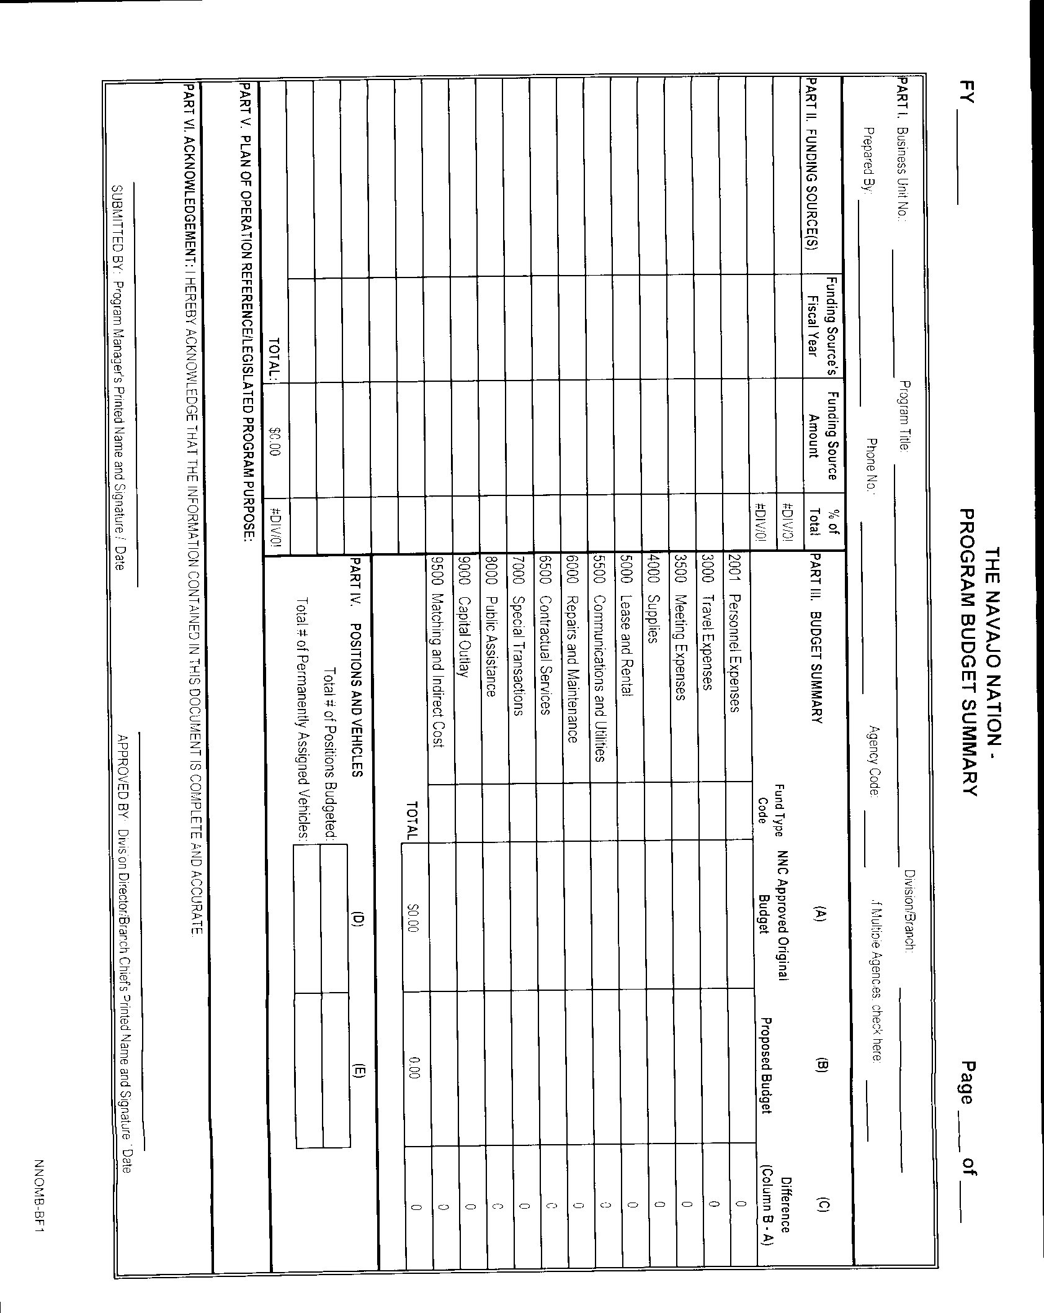PAGE 2 OF 6

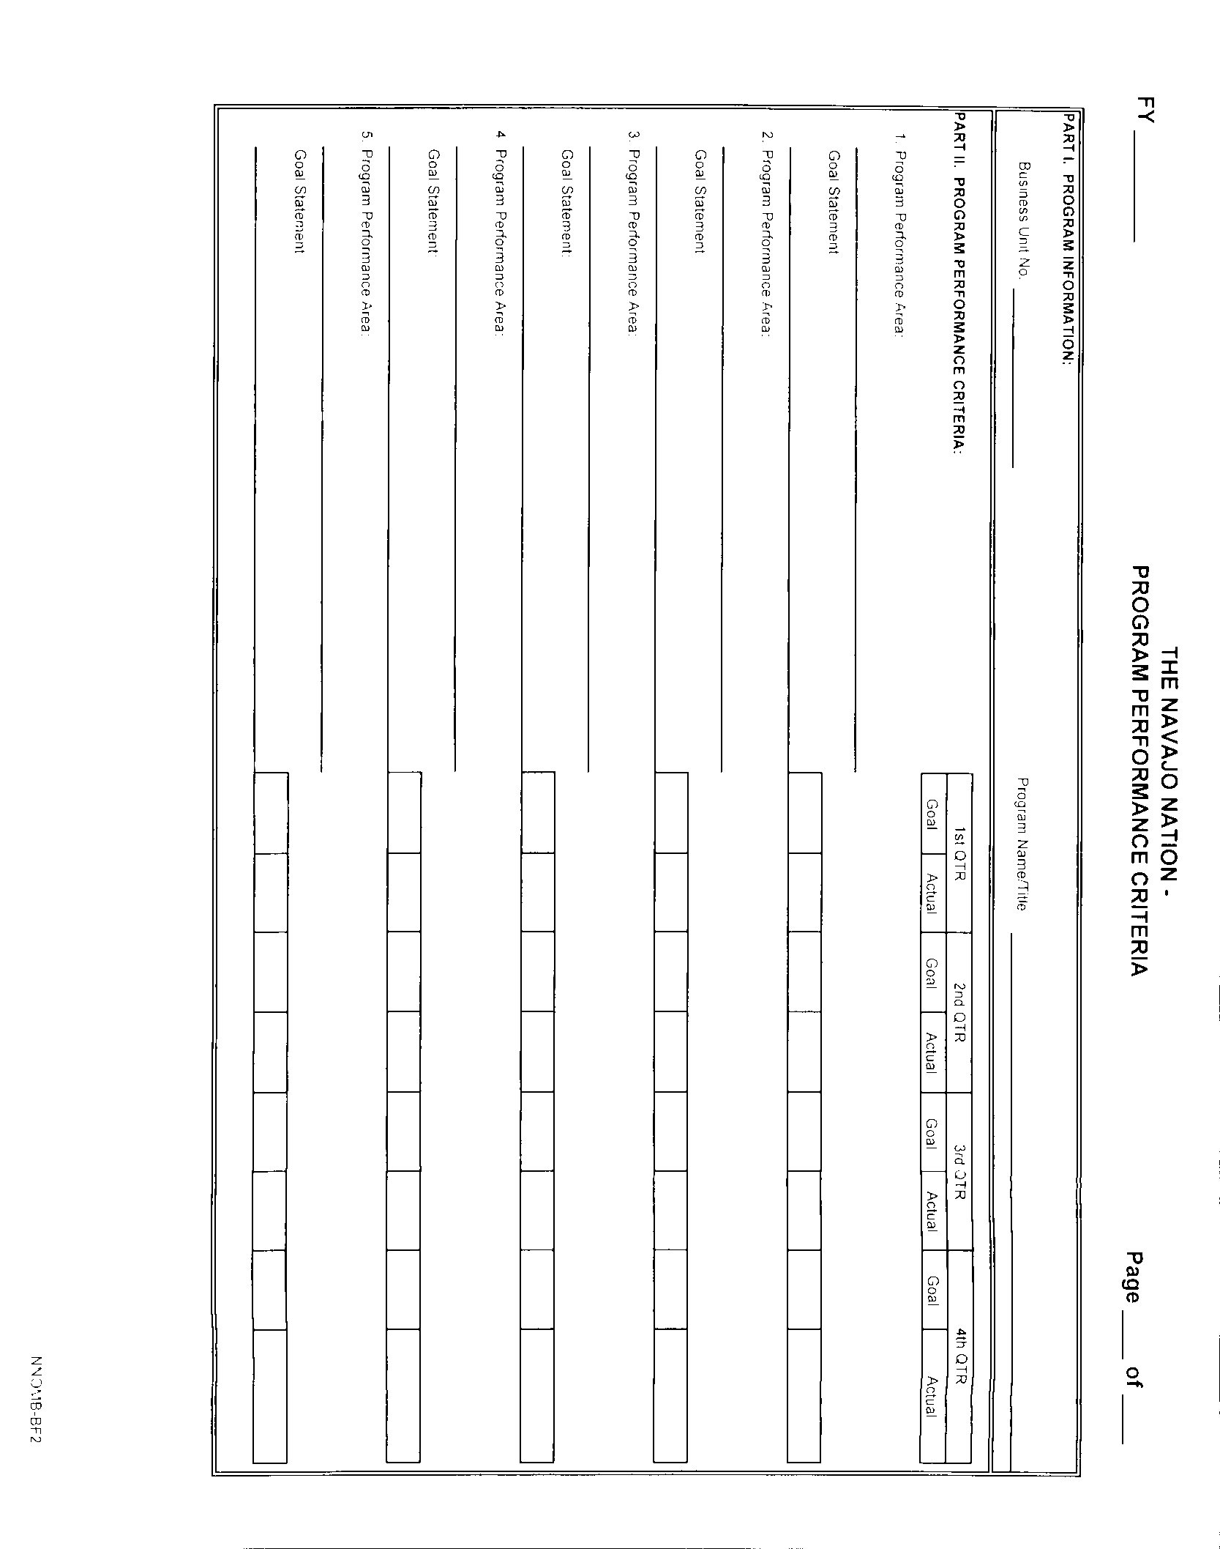PAGE 3 OF 6

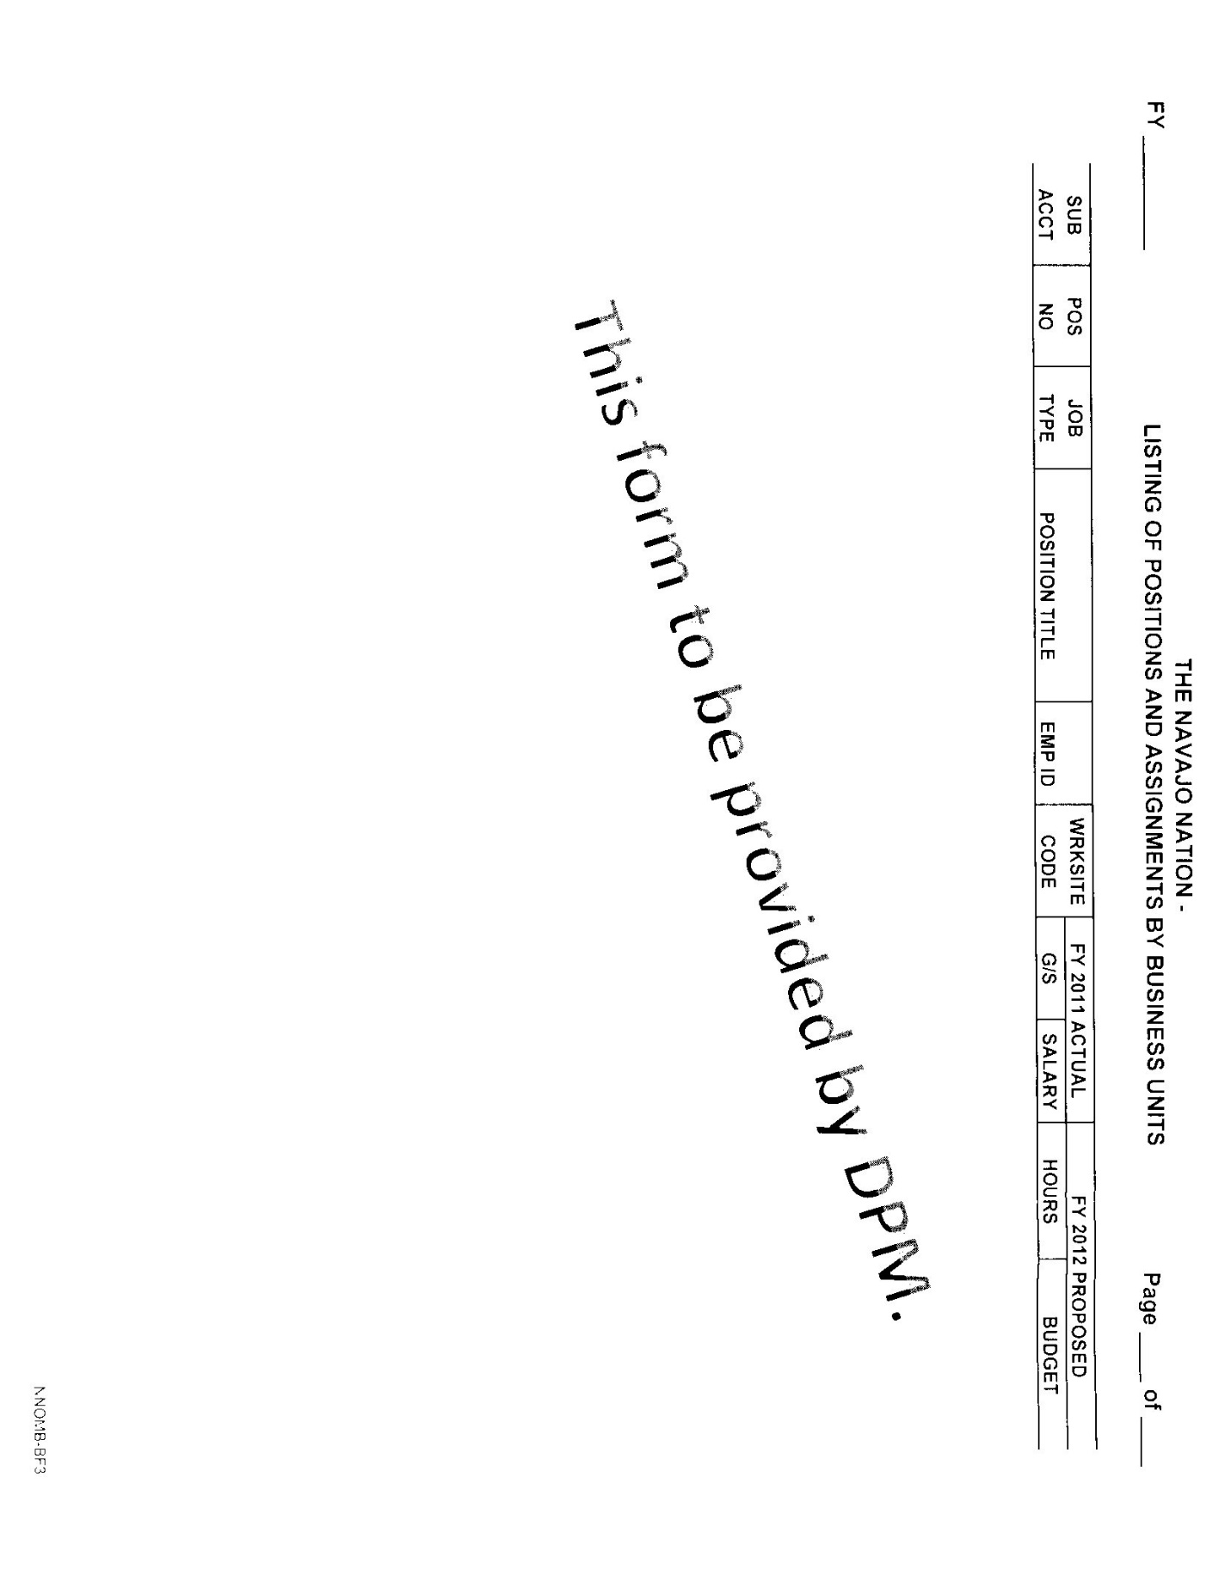PAGE 4 OF 6

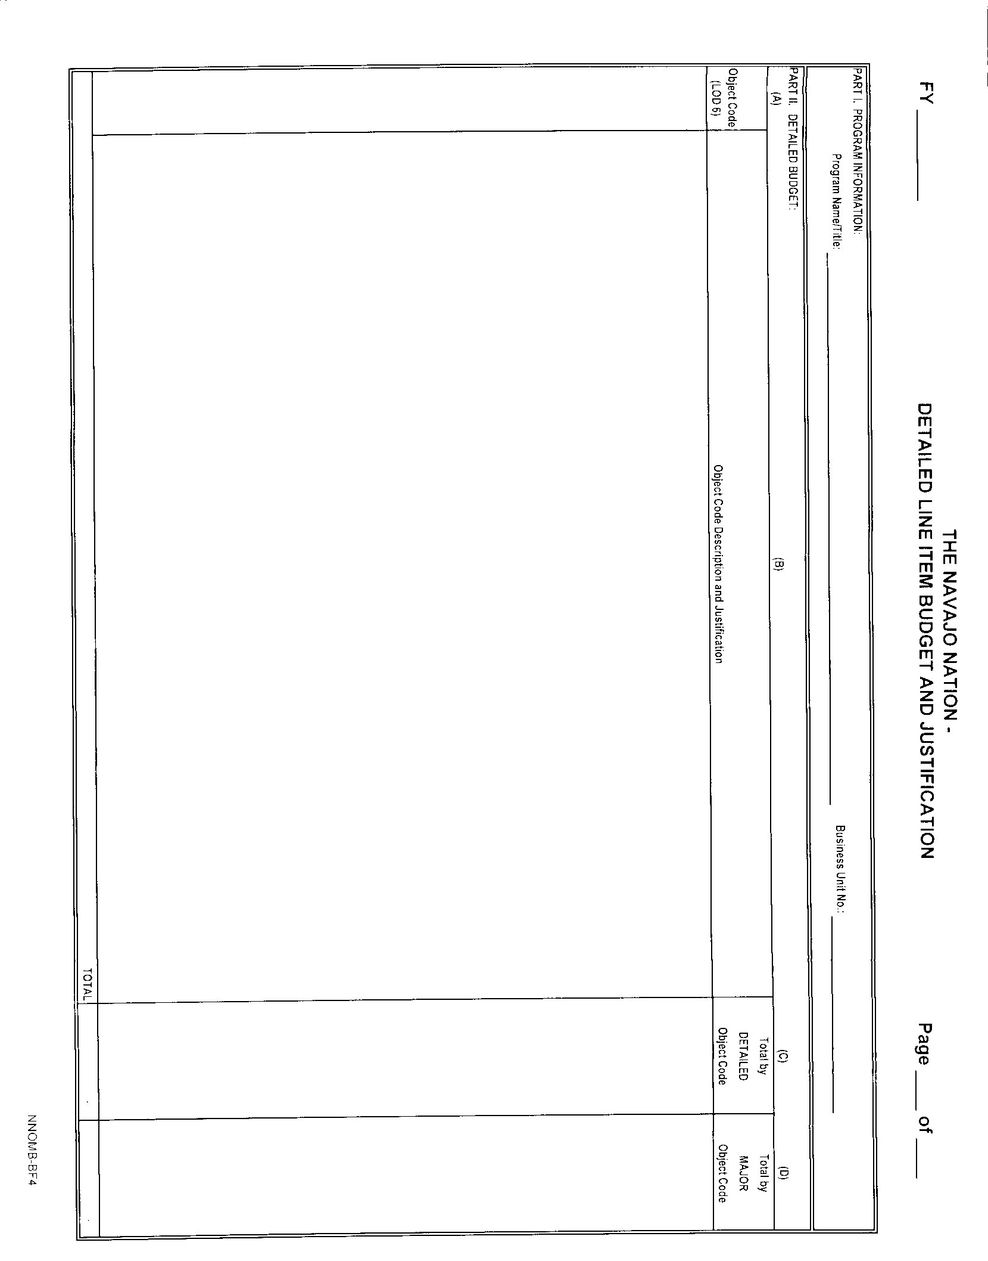PAGE 5 OF 6

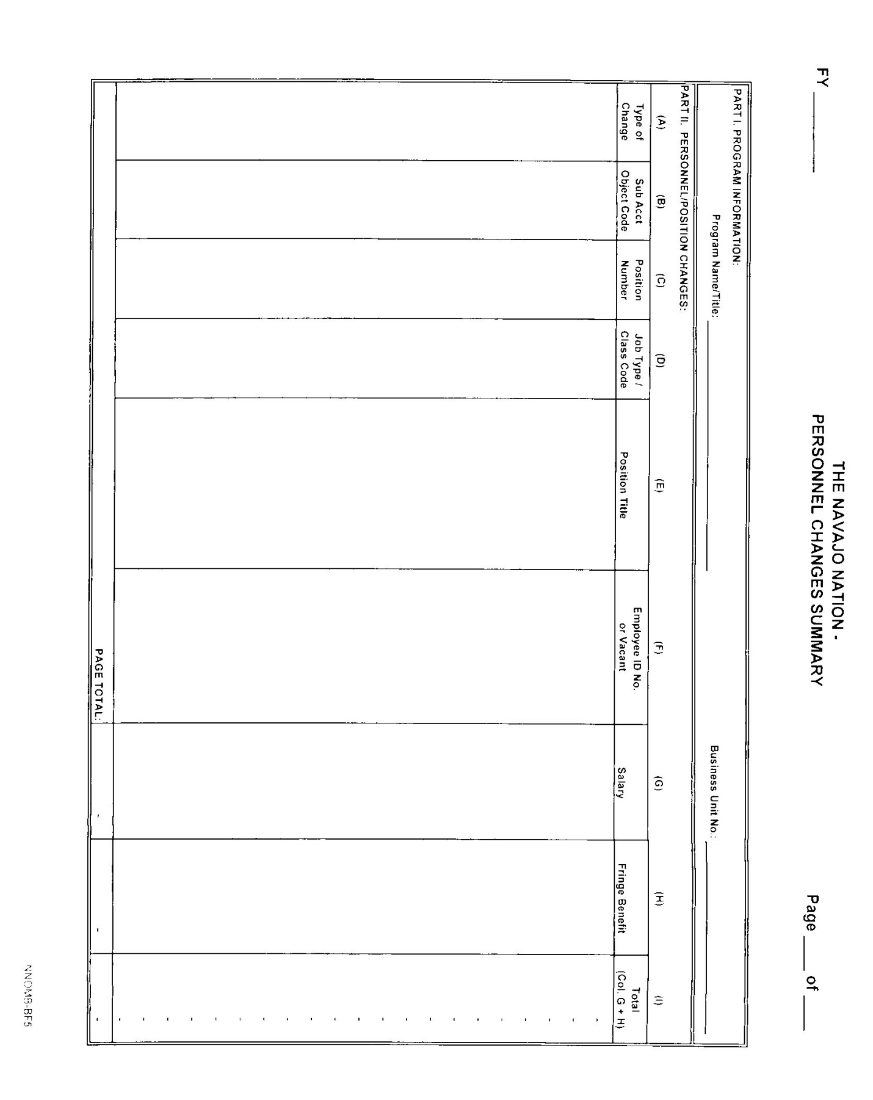PAGE 6 OF 6

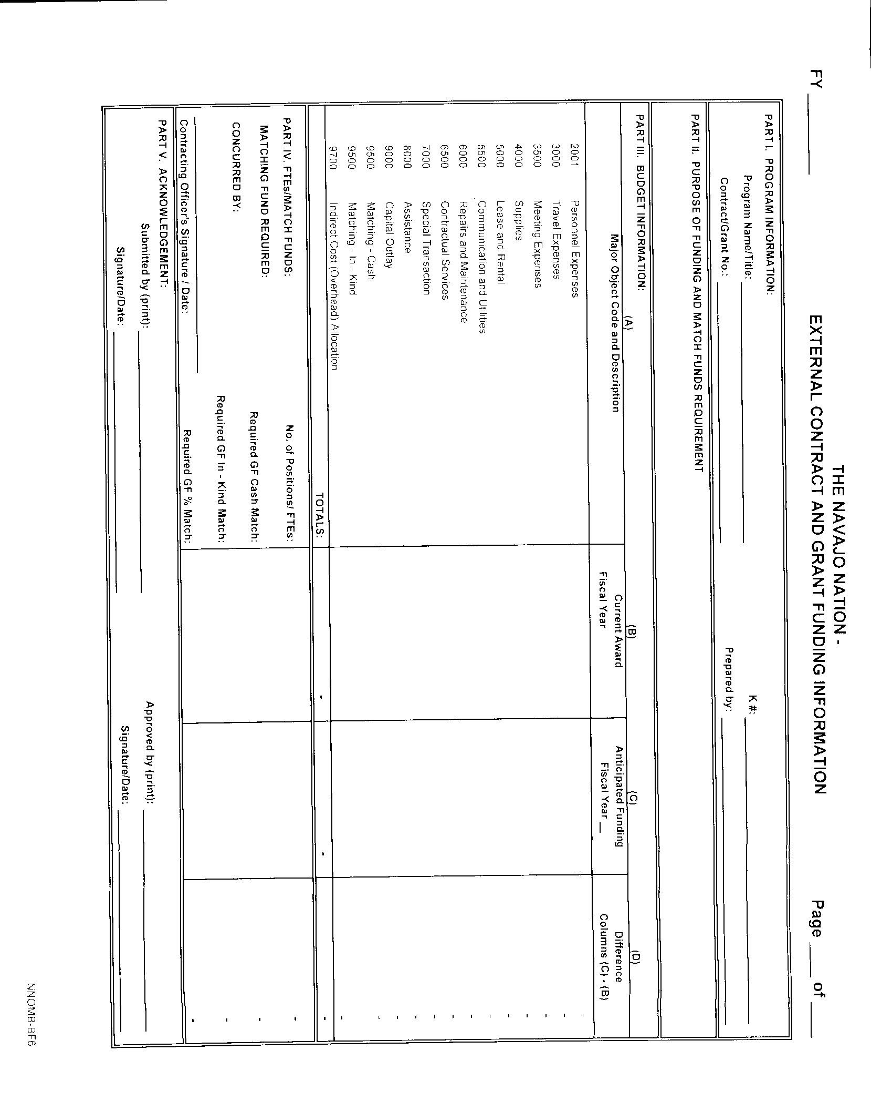

exhibit c

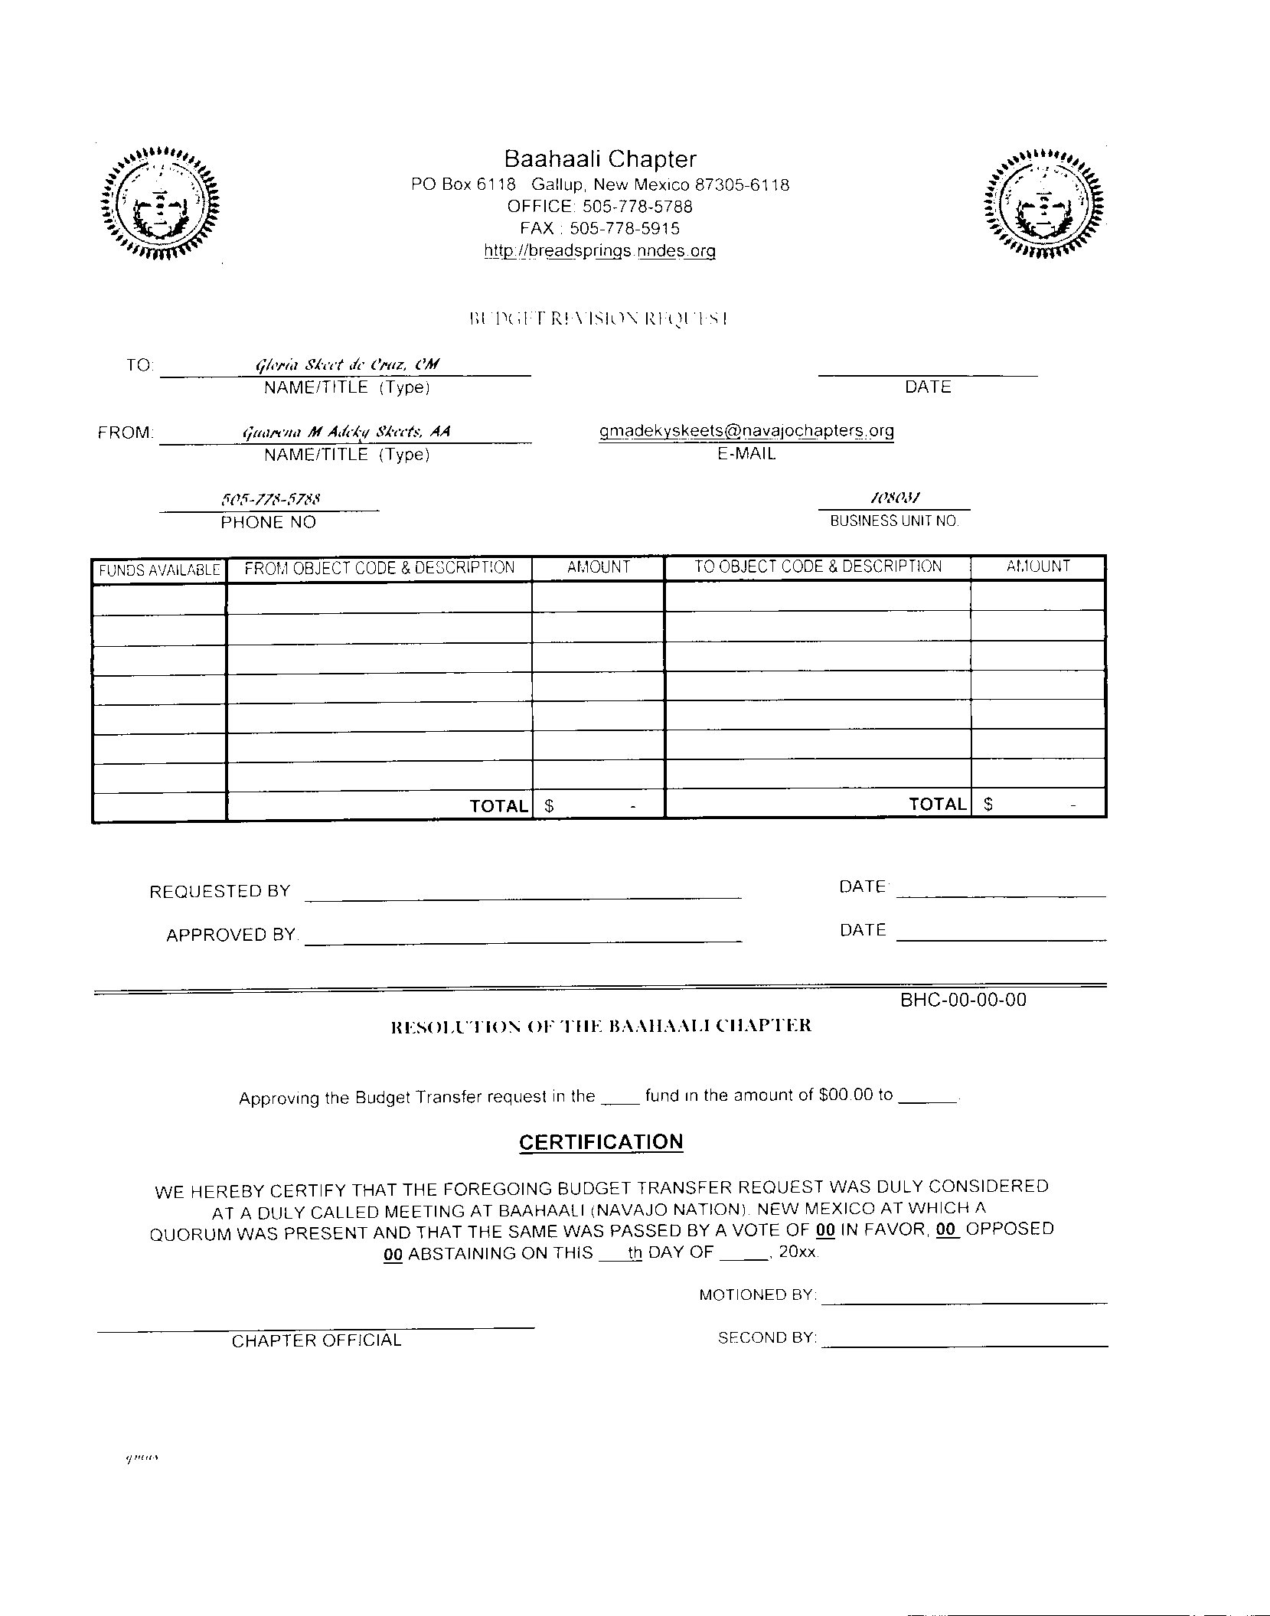exhibit d

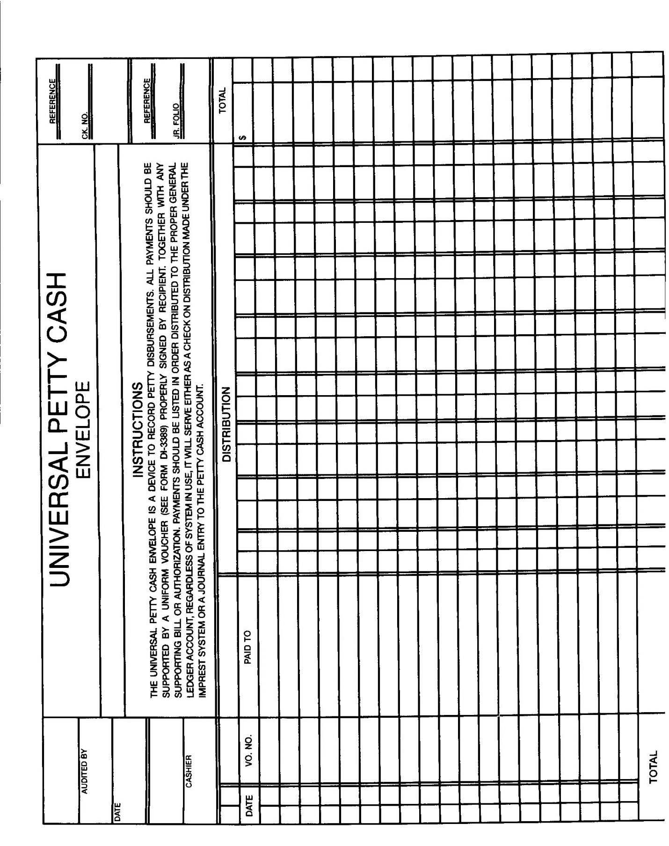

exhibit e

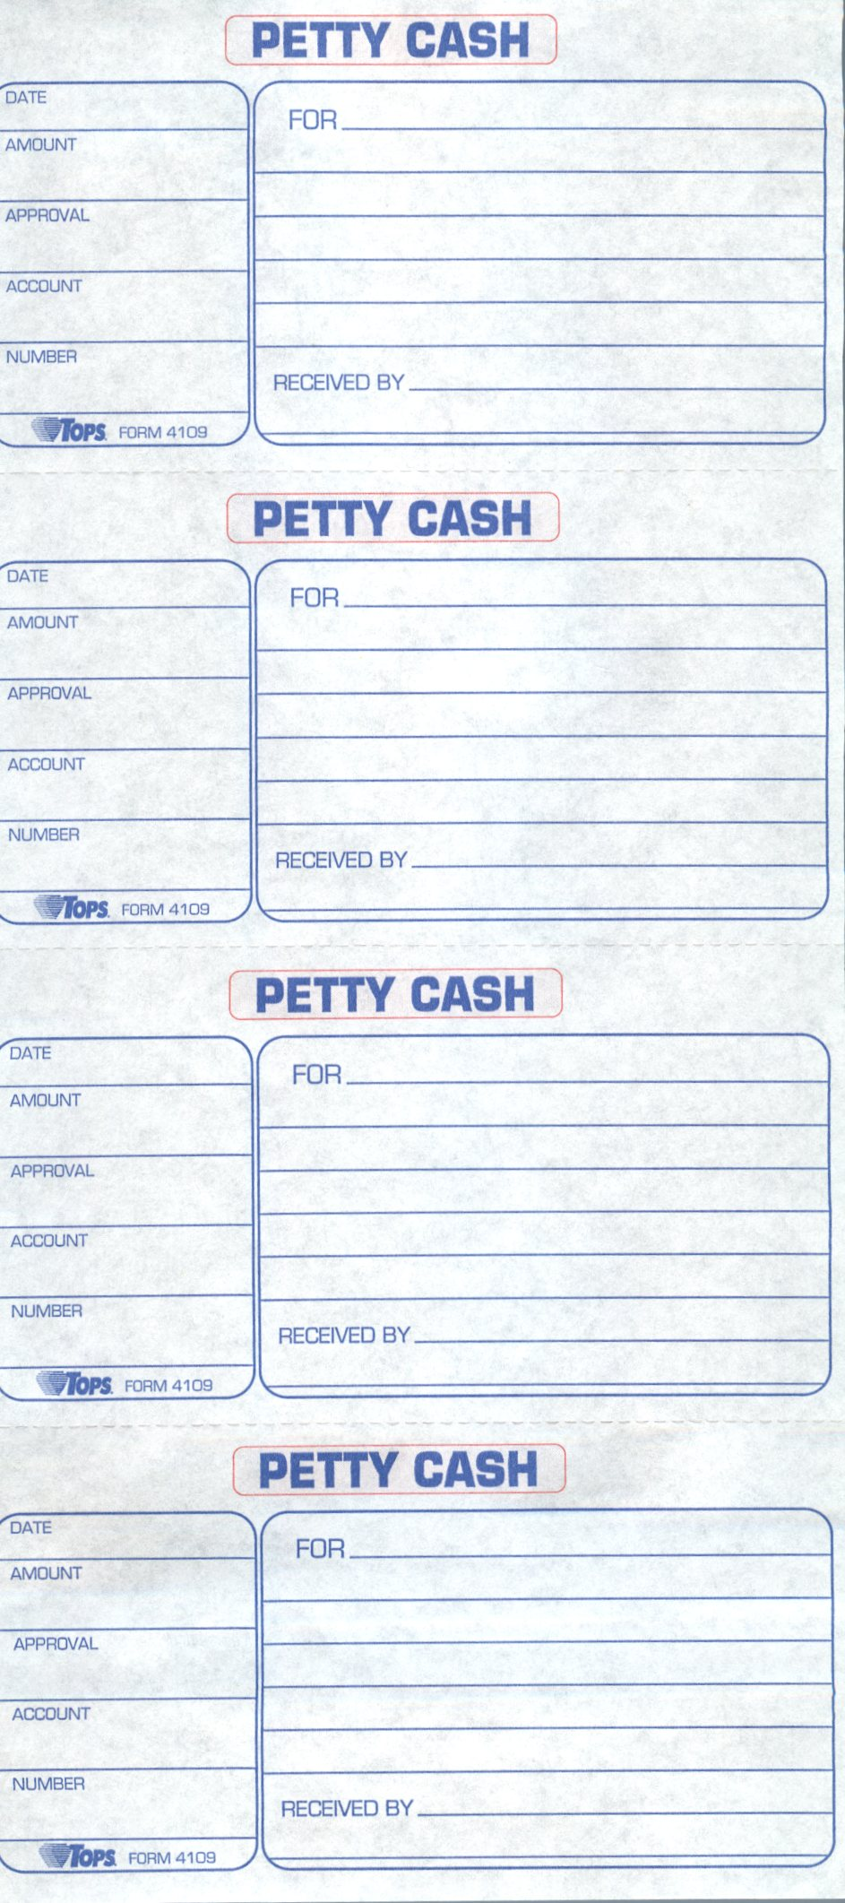

exhibit f

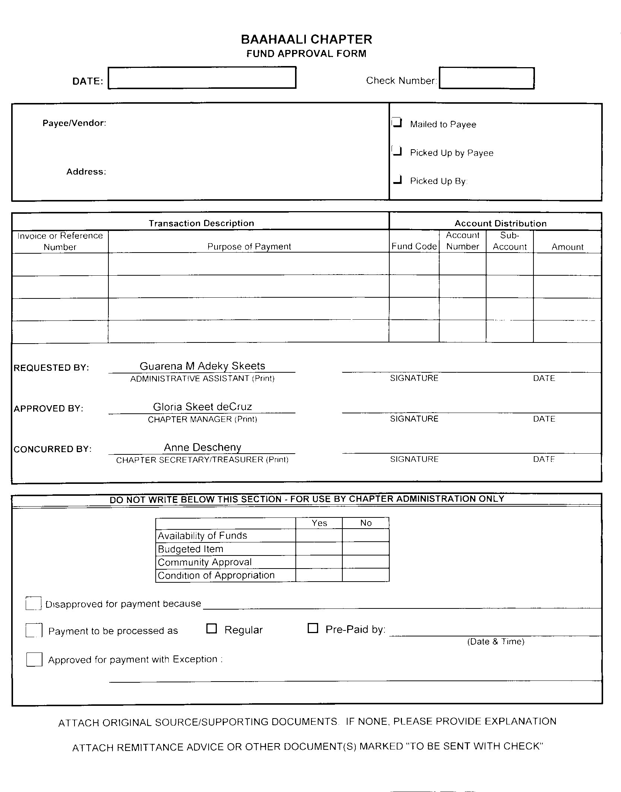

exhibit g

Bááháálí Chapter

Purchase Card Authorization Form

NAME: TITLE:

PURPOSE FOR CARD USAGE:

QUOTATIONS ATTACHED? Y N If Yes, Number of Quotations:

If no quotations, Justification:

Approval / Disapproval : Date:

Receiving Report

|  |  |  |
| --- | --- | --- |
| ITEM DESCRIPTION | AMOUNT | Fund Code:  GL Code:  Vendor Name:    Amount Total:  $ |
|  |  |
|  |  |
|  |  |
|  |  |
|  |  |
|  |  |
|  |  |

Receipt Submitted by: Date:

Reconciled by: Date:

Reviewed by: Date:

Receipt Copy:

exhibit H

Bááháálí Chapter

Purchase Card Use on Recurring Expense

|  |  |  |  |  |  |
| --- | --- | --- | --- | --- | --- |
| Vendor Name: | |  | | | |
| Fund No. |  | Account No. |  | Amount. |  |
| Description of Service: | | | | | **Category:**   * Utility * Payroll Tax * Retirement * Subscription * Fuel Purchased * Renewal |
|  | | | | |
|  | | | | |
|  | | | | |
|  | | | | |

Request Submitted by: Date:

Reconciled by: Date:

Reviewed by: Date:

exhibit I

Bááháálí Chapter

Purchase Card Policy

1. Purpose
   1. The purpose of the Bááháálí Chapter Purchase Card Policy is to:
      1. Streamline purchases made for Bááháálí Chapter
      2. Provide a method of payment when purchasing fuel and maintenance the Bááháálí Chapter Vehicles
      3. To make purchases via the internet using the same procedures as stated in the Bááháálí Chapter Procurement Policy and Procedures Manual
2. Restrictions
   1. The Administrative Assistant and Chapter Manager will be the only parties given permission to purchase items with the Purchase Card.
   2. The only time any other staff member will be allowed to take the purchase card is to purchase fuel for the vehicle they are using or to take the vehicle to get maintenance.
   3. A Purchase Card Purchase Request Form (Exhibit A) must be used in order for the purchase to be approved.
   4. Any unauthorized purchases will be investigated.
      1. If the purchase was for the benefit of the chapter, a justification must be submitted in writing along with the receipt and receiving report.
      2. If it was a personal purchase, the person must repay the amount that was not authorized as well as be written up and put on suspension according to the Table of Penalties, in the Personnel Policy and Procedures Manual.
   5. Any purchases made over $100.00 will require a prior approval from a Chapter Official and Chapter Manager. (Exception: Fuel and Maintenance Purchases)
3. Procedures for Fuel Purchase & Maintenance
   1. A purchase made for the Bááháálí Chapter Vehicles or heavy equipment will be allowed without a form to be in place prior to purchase, provided a receipt from the gas station is submitted with a Fuel/Maintenance Report Form (Exhibit B), in which the mileage will be printed on the receipt to indicate when the fuel was purchased.
   2. For Maintenance transactions, a Fuel/Maintenance Report Form will need to be completed and a copy of the receipts will be submitted.
   3. Any differences or personal use of the card will result in the cardholder’s suspension from the card and possibly from their position.
4. Procedures for Purchases Other than Fuel
   1. A purchase card purchase request form is completed and submitted to the Administrative Assistant.
   2. The Administrative Assistant will confirm the availability of funds.
   3. The Administrative Assistant will forward the form to the Chapter Manager for approval.
   4. Upon approval, the Chapter Manager will return the form to the Office Assistant who will then procure three quotations of the items listed on the form.
   5. The Vendor with the lowest bid will be chosen by the Administrative Assistant and an order will be placed.
   6. The Administrative Assistant will indicate on the form the tentative shipment date and place the packet in a holding file until the shipment have been received.
   7. Once the order arrives, the Office Assistant will review invoice list and items received. If there are any problems or items not received, the Office Assistant will contact the vendor and list when the new shipment will be received.
   8. Upon completion of the order the Administrative Assistant will submit the packet to the Chapter Manager for review and closure.
   9. The Administrative Assistant will post the transaction via a journal voucher in the MIP system and post.
5. Accountability Procedures
   1. The Administrative Assistant will complete the Bank Reconciliation and verify the purchase card purchases with the bank statements.
   2. All purchase card packets must match the bank statements.
      1. Any unknown purchases must be identified and reported to the Chapter Manager in order for an investigation of misuse of the purchase card may begin.
      2. If there were purchases made in which the purchase packets that were not submitted to the Administrative Assistant, a justification memorandum must be submitted and attached to the purchase card purchase form.
   3. All Purchase Card Purchase Packets must be kept in a “Pending” folder until reconciliations are complete.
   4. The Chapter Manager will review and sign that the transaction as completed and is posted to the MIP system.
   5. The Office Assistant will then file the Purchase Card Purchase Packet in the appropriate vendor file.
6. Unauthorized Purchase Procedures
   1. If the purchase was for the benefit of the chapter, a justification must be submitted in writing along with the receipt and receiving report.
   2. If it was a personal purchase, the person must repay the amount that was not authorized.
      1. Due to the nature of Purchase Card usage, this infraction may result in being written up and put on suspension according to the Table of Penalties, in the Personnel Policy and Procedures Manual.
      2. If the person fails to set up a payment or payment plan, then the amount will be deducted from the next payroll check.
7. Amendments
   1. Bááháálí Chapter Administrative reserves the right to recommend amendments to the Bááháálí Chapter Purchase Card Policy.
   2. Any amendments to the policy must be approved at a duly called chapter meeting.

EXHIBIT J



exhibit k



exhibit l

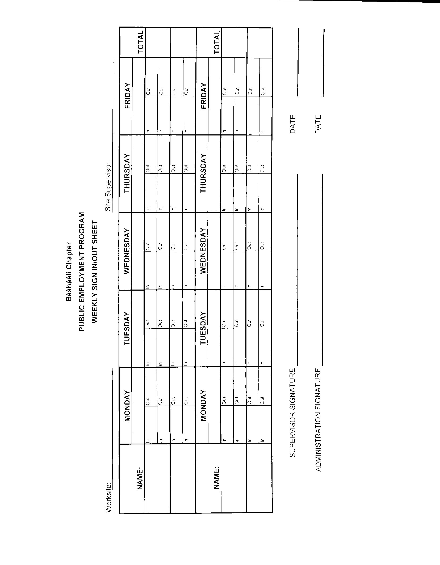

EXHIBIT M



EXHIBIT N



EXHIBIT O

Bááháálí Chapter

Travel Request Form

Form must be submitted to the Administrative Assistant one week prior to travel date to ensure proper processing for travel authorization approval.

NAME: TITLE:

ADDRESS:

PHONE NUMBER: CELL NUMBER:

TRAVEL BEGINNING DATE:

TRAVEL ENDING DATE:

TRAVEL PURPOSE:

TRAVEL TO: ESTIMATED MILES:

WILL YOU NEED TO HAVE A RESERVATION MADE FOR YOU? YES NO

WHAT IS YOUR PREFERRED HOTEL?

CREDIT CARD: VISA MASTERCARD AMERICAN EXPRESS DISCOVER

CREDIT CARD NUMBER: EXP. DATE:

**HOTEL CANCELLATIONS ARE THE RESPONSIBILITY OF THE TRAVELER**

I hereby authorize Guarena Adeky Skeets, Bááháálí Chapter Administrative Assistant, to use my credit card information to make a hotel reservation for my travel to on . This only authorizes the credit card usage for holding the hotel room; any other charges made without prior authorization will be the responsibility of Ms. Skeets to repay.

Signature: Date:

TRAVELER SIGNATURE: DATE:

RECEIVED BY: DATE:

APPROVAL OF TRAVEL: DATE:

DISAPPROVAL OF TRAVEL: DATE:

EXHIBIT P

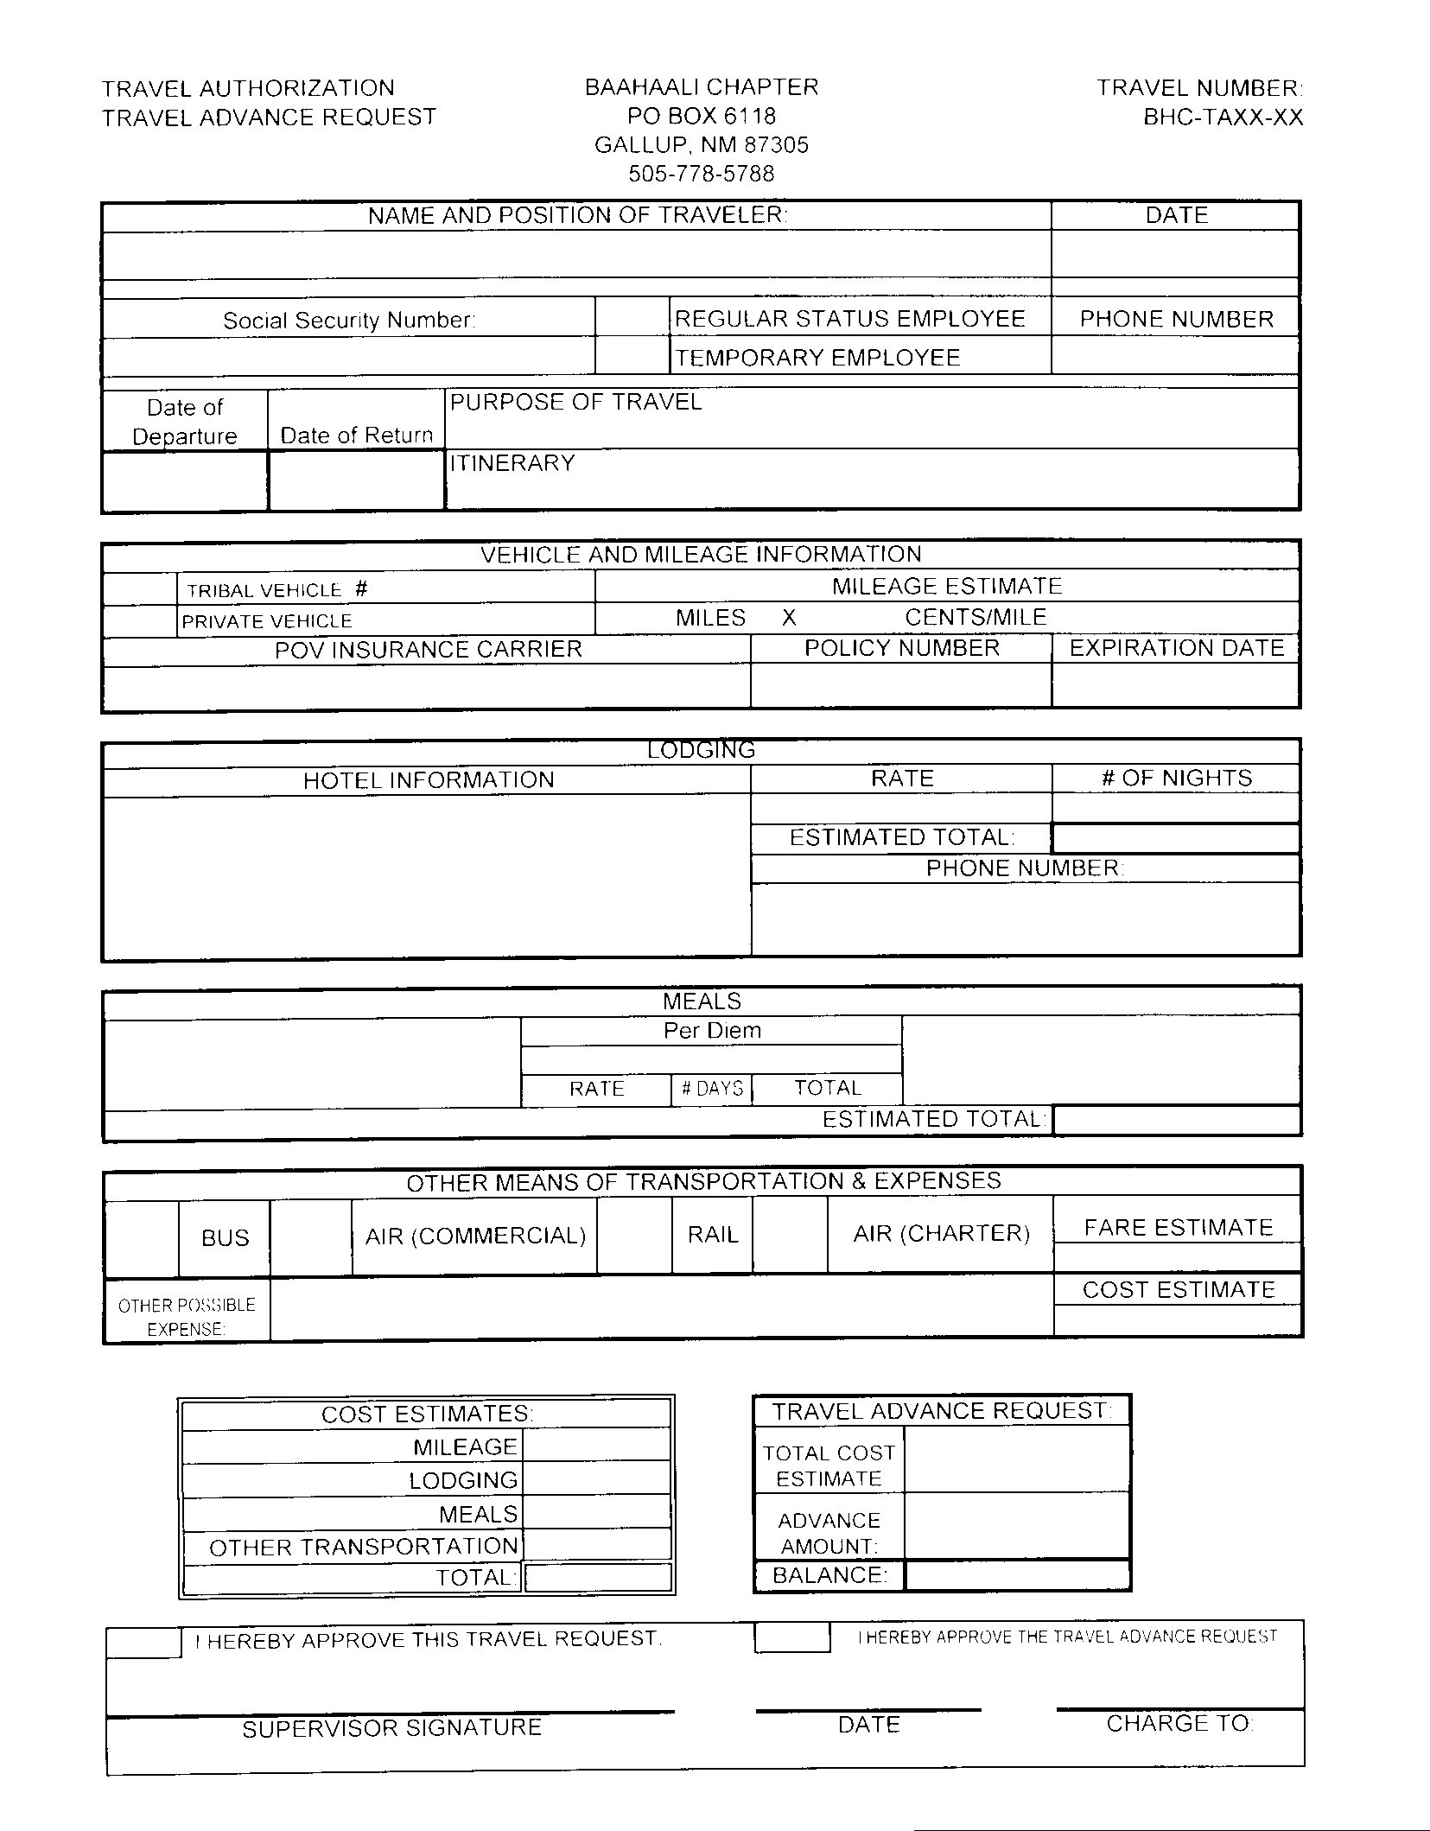

EXHIBIT Q

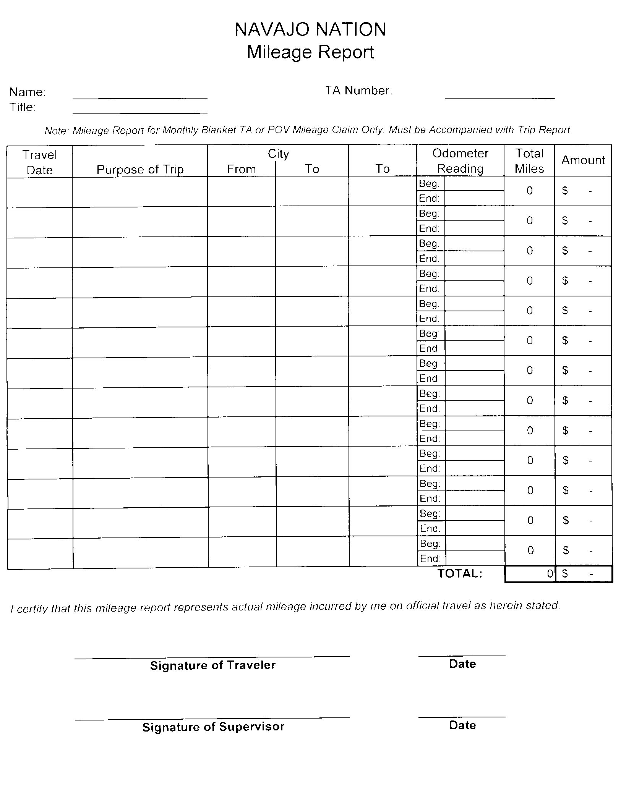

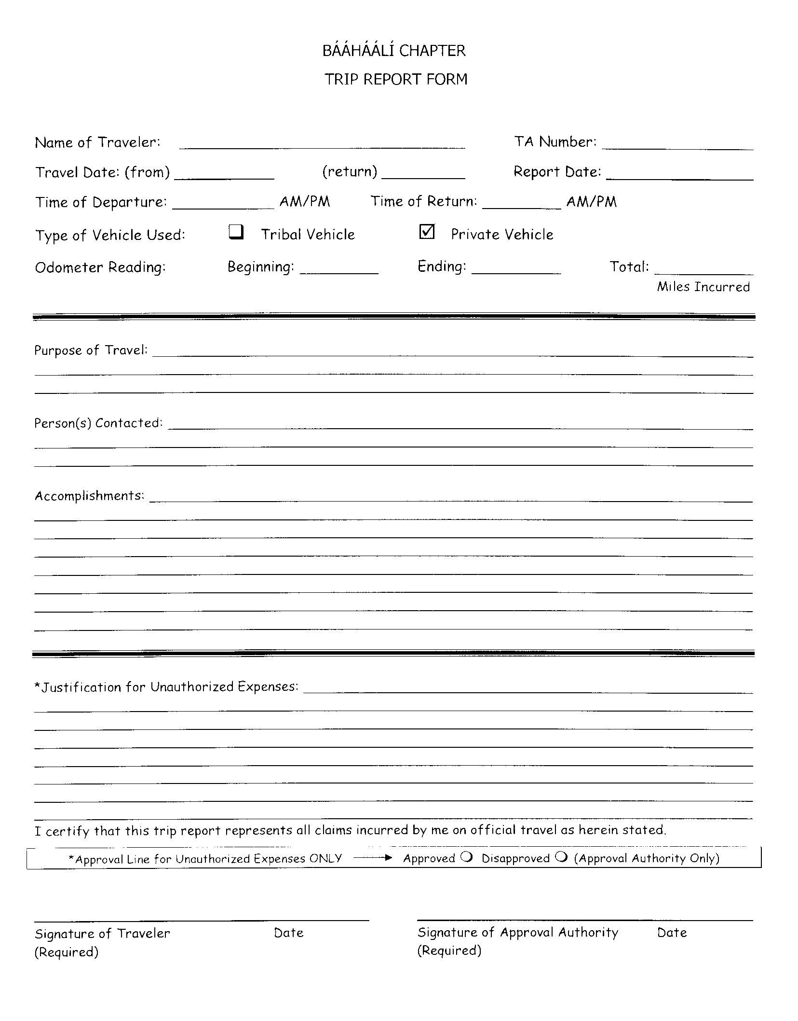

This form is used for Conference or overnight trips

BÁÁHÁÁLÍ CHAPTER

TRIP REPORT FORM

Travel Authorization Number:

Name:  Report Date:

Travel Date:  Time Left:  Time Returned:

|  |  |  |
| --- | --- | --- |
| Beginning  Personal Vehicle Usage: | Ending | Total |
|  |  |  |

Purpose of Travel:

|  |  |  |  |  |
| --- | --- | --- | --- | --- |
| □ MEETING | □ MAIL-RUN | □ HOME VISIT | □ WORK SESSION | □ OTHER |
| □ TRAINING | □ SUPPLY-RUN | □ HMA ASSESSMENT | □ HSL |  |

Person(s) Contacted:

Accomplishments:

□ Over Mileage Allocation □ Justification Attached

I certify that this trip report represents all claims incurred by me on official travel as herein stated.

Traveler’s Signature Date

APPROVED:

Supervisor’s Signature Date

**This form is used for daily trip reports.**

BÁÁHÁÁLÍ CHAPTER

CHAPTER VEHICLE USAGE

TRIP REPORT FORM

Name:  Travel Date:

Time Left:  Time Returned:

|  |  |  |
| --- | --- | --- |
| Beginning  Chapter Vehicle Usage: | Ending | Total |
|  |  |  |
| **Fuel Purchased: (Amount)** | **Oil Change: (Amount)** | **Other Maintenance: (Amount & Type)** |

Purpose of Travel:

|  |  |  |  |  |
| --- | --- | --- | --- | --- |
| □ MEETING | □ MAIL-RUN | □ HOME VISIT | □ WORK SESSION | □ OTHER |
| □ TRAINING | □ SUPPLY-RUN | □ HMA ASSESSMENT | □ HSL |  |

Person(s) Contacted:

Accomplishments:

□ I certify that this trip report represents all claims incurred by me on official travel as herein stated.

Traveler’s Signature Date

APPROVED / DISAPPROVED :

Supervisor’s Signature Date

**This form is used for Chapter Vehicle Usage**

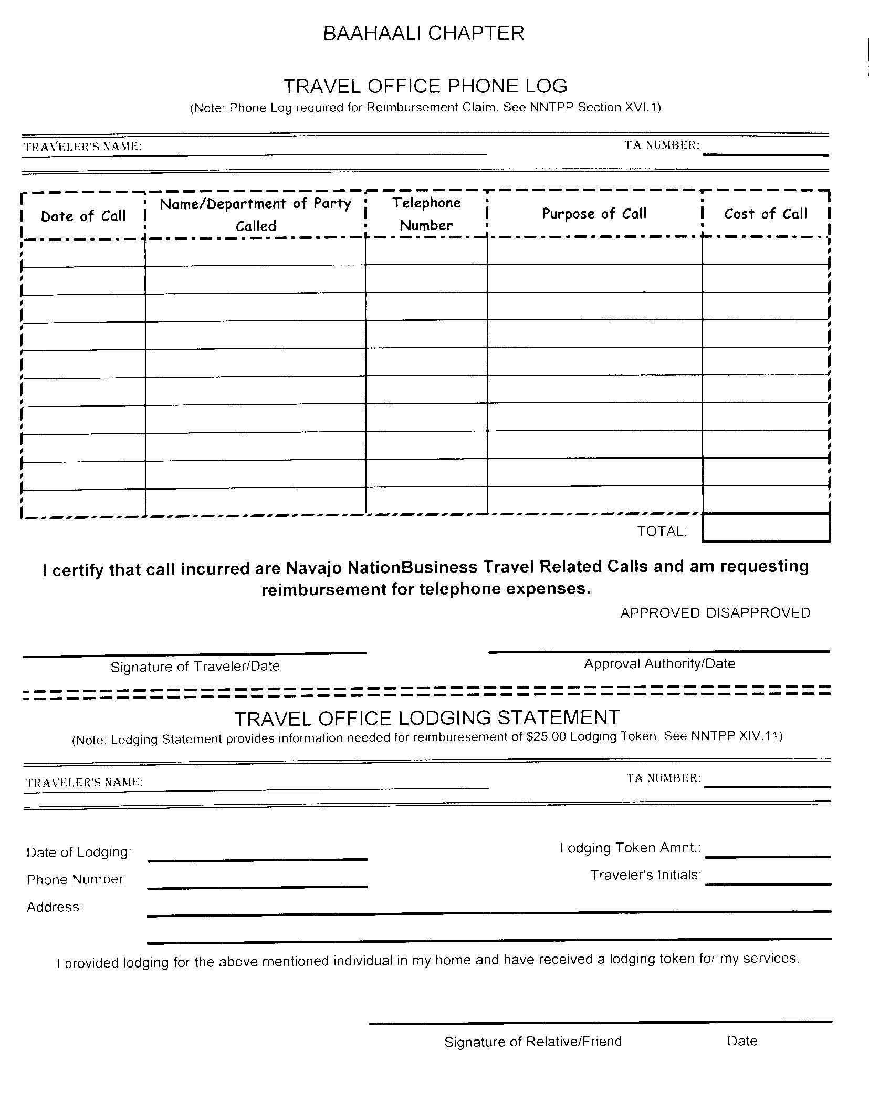

EXHIBIT R

Bááháálí Chapter

Scholarship Policy

1. Purpose
   1. The purpose of the Bááháálí Chapter Scholarship Policy is to provide supplemental funding for students attending Accredited Post-Secondary Institutions.
   2. The secondary purpose of the Bááháálí Chapter Scholarship Policy is to motivate students attending Accredited Post-Secondary Institutions to excel in their studies and succeed in obtaining their degree or certificate.
2. Application Required Documents
   1. The Bááháálí Chapter Scholarship Application must be completed along with the following required documents listed below:
      1. New Students:
         1. Application Form
         2. Certificate of Indian Blood
         3. Letter of Admission
         4. Schedule of Classes
         5. Social Security Card
         6. Letter of Interest
         7. Navajo Nation Voter’s Registration Card
         8. High School Transcript or G.E.D. (Must have a 2.25 GPA or above) or College Transcript
         9. Student ID or Driver’s License
      2. Continuing Students:
         1. Application Form
         2. Schedule of Classes
         3. Letter of Interest
         4. Grades from Previous Semester
         5. Students in their fifth semester of study must submit a degree audit.
      3. Transfer Students:
         1. Application Form
         2. Letter of Admission
         3. Schedule of Classes
         4. Letter of Interest
         5. Transcript
3. Deadlines
   1. Deadlines must be adhered to in order to be considered for funding:
      1. Spring—December
      2. Fall—July
   2. There are two deadlines:
      1. First deadline is for the application and letter of interest
      2. The second deadline is for the required documents.
      3. Bááháálí Chapter understands there may be delays with schedules and grades and will make exceptions for such delays on a case-by-case basis.
   3. Refer to website for deadlines. (baahaali.navajochapters.org)
   4. Deadline for packet submittal is 4:00 p.m.
4. Eligibility
   1. Students must be full-time (12 hours or more) or part-time students (six to eleven hours).
   2. Students must be registered with Bááháálí Chapter.
   3. Students must be admitted to an accredited post-secondary institution recognized by the Navajo Nation.
   4. Students seeking a second Certificate, Associates, or Bachelor’s degree will be considered if funds are available.
   5. A registered member of the Chapter for six months.
   6. If under 18, the student’s parent(s) must be a registered voter with the chapter for one year.
5. Funding
   1. Full-time students will receive $400.00 per semester and part-time students will receive $200.00 per semester, according to the Fiscal Year Budget.
   2. Post-graduate students will receive $600.00 per semester provided funds are available
   3. The Chapter will fund up to nine (9) hours of developmental studies (Classes designated under 101).
   4. Funding is for Fall and Spring Semesters only.
6. Processing
   1. Application Packets received prior to the deadline are time stamped and processed by Administrative Assistant.
   2. Complete applications are submitted to the Chapter Manager for final review and recommendation.
   3. Upon approval, the Administrative Assistant will process the scholarship check following the Expenditure processing as stated in the Procurement Policy for Disbursements, to be written to the student and mailed to the student’s current address.
   4. The Administrative Assistant will send an award E-mail/letter to the student along with a notice of the next semester deadline.
7. Monitoring
   1. In order to be considered, students must maintain a 2.25 Grade Point Average, for both the previous semester and overall transcript.
   2. Repeat classes will not be considered in the formula for full/part time funding.
   3. Students who were funded full time and did not complete their full credits will not be eligible for funding.
   4. Degree audits will be used to determine eligibility for funding. Students who earn credits hours beyond their degree program’s required hours will be given an additional semester (s) to complete their degree requirements.
      1. Associate/Certificate Programs one semester
      2. Bachelor Programs –two semesters
8. Stop-Out Students
   1. Students who have not been enrolled in a post-secondary institution for three or more years and have received chapter scholarship funds are considered Stop-Out Students.
   2. Stop-Out Students in good standing (had a minimum 2.25 GPA the last semester attended) will be considered depending on fund availability.
   3. Stop-Out Students who had a minimum GPA less than 2.25 the last semester attended will be required to attend classes for two semesters before being considered for the chapter scholarship.
9. Suspension of Award
   1. In the event a student’s GPA is below a 2.25:
      1. Bááháálí Chapter will suspend the award for one academic year.
      2. Once the suspension period expires, Bááháálí Chapter will need a verification of enrollment with the application packet in order to be considered for funding.
   2. Withdrawals
      1. If the student has withdrawn from the institution, they will not be eligible for one year.
      2. If the student withdrew from one or two classes for two consecutive semesters, the student will be suspended from funding for one semester.
10. Amendments
    1. Bááháálí Chapter may amend these policies and procedures as deemed necessary.

ATTACHMENTS:

1. New Student Packet (Cover Sheet & Application)
2. Continuing Student Packet (Cover Sheet & Application)

ATTACHMENT a

BÁÁHÁÁLÍ CHAPTER

**NEW STUDENT**

SCHOLARSHIP ASSISTANCE COVER SHEET

Name: Date:

CURRENT SCHOLARSHIP APPLICATION

CERTIFICATE OF INDIAN BLOOD TRACKING NO: SCH-13-

LETTER OF ADMISSION

CLASS SCHEDULE Full/Part Time:

SOCIAL SECURITY CARD

LETTER OF INTEREST School Name:

VERIFICATION OF NN VOTER REGISTRATION

PHOTO IDENTIFICATION

TRANSCRIPT (Last School Attended) GPA:

DOCUMENTS CHECK BY:

Administrative Assistant DATE

BÁÁHÁÁLÍ CHAPTER ADMINISTRATIVE APPROVAL:

PACKET IS APPROVED

PACKET IS NOT APPROVED DUE TO:

REVIEWED BY:   
 Chapter Manager Date

COMPLETED PACKET READY FOR PAYOUT AND CLOSE OUT:

* MISSING INFORMATION LETTER
* FUND APPROVAL PACKET
* AWARD LETTER TO STUDENT

VERIFIED BY: DATE:

Administrative Assistant

COMMENTS

BAAHAALI CHAPTER

OFFICE USE ONLY:

DATE STAMP:

All Documents In: Y N

SCHOLARSHIP APPLICATION

PO Box 6118 Gallup, New Mexico 87305

Office: 505-778-5788/778-5796 Fax: 505-778-5915

**NEW STUDENT APPLICATION CHECKLIST**

1. APPLICATION—Complete the Chapter Scholarship Application
2. CERTIFICATION OF INDIAN BLOOD—a copy is acceptable
3. LETTER OF ADMISSION—All first-time applicants (and first year graduate students) must submit a Letter of Admission.
4. SOCIAL SECURITY CARD—A copy is acceptable
5. LETTER OF INTEREST—A current letter of interest is required for **each** semester applied. Please include your name, name of the university you are attending, major, and reason for asking for the scholarship.
6. NAVAJO NATION VOTER’S REGISTRATION CARD—A copy is acceptable. This is to establish that you are a registered member of the chapter.
7. PROOF OF IDENTIFICATION—First time applicants need to submit a copy of your Student ID or Driver’s License

**Schedule of Classes and Previous Semester Transcripts (or High School Transcripts for new applicants) are due by Month Day, Year.**

**APPLICANTS MUST SUBMIT ALL PAPERWORK LISTED ABOVE**

General Eligibility

* All applicants must be admitted to a post-secondary institution accredited by one of six regional accrediting associations as recognized by the Navajo Nation:

MSA-Middle States Association of Colleges and Schools

NCA-North Central Association of Colleges and Schools

NEASC-New England Association of Schools and Colleges

NASC-Northwest Association of Schools and Colleges

SACS-Southern Association of Colleges and Schools

WASC-Western Association of Schools and Colleges

* The appropriate accrediting association for highly specialized majors including, but not limited to, the National Architectural Accrediting Board for schools of architecture.
* Vocation Institutions chartered by the Navajo Nation.

**DEADLINES**

**Spring Semester December XX, 20XX @ 4:00 pm**

**Fall Semester July XX, 20XX @ 4:00 pm**

**\*\*These are the deadlines set by the Administration Office allowing for processing time. NO APPLICATIONS WILL BE ACCEPTED AT THE PLANNING OR REGULAR CHAPTER MEETINGS.**

**\*\*AWARDS ARE SUBJECT TO FUND AVAILABILITY**

**\*\*You must submit all the documents listed above before a check is issued.**

Date: Term Applying For:

PERSONAL AND FAMILY DATA

Legal Name: (Last, First, Middle Initial)

Social Security No: Census Number:

Date of Birth: Sex: Veteran: Y or N

Marital Status: Spouse’s Name: No. of Children:

Current Mailing Address (Address, City, State, Zip Code):

E-mail Address (please include your email so we keep in touch with you on your scholarship application progress):

Phone Number: Cell Phone:

Mother’s Name: Tribe/Chapter Affiliation:

Father’s Name: Tribe/Chapter Affiliation:

EDUCATION DATA

High School: (Name, City, State)

Graduation or GED Certificate Received: (Month & Year)

College or University Attending:

Location: (City, State)

Major: Type of Degree Seeking:

College Classification:

Freshman Sophomore Junior Senior Graduate Student Post-Graduate

If a transfer student, name of last University/College attended:

Month/Year attended:

New Applicant? Yes or No

If no, date of last award and university/college attended:

STUDENT AGREEMENT

The student, to ensure reconsideration for the next application received by the office, must meet the following conditions:

1. Attend the institution, as stated on the letter of admission (or schedule of classes).
2. Submit an official grade report to the Bááháálí Chapter no later than 15 days after the completion of the academic term.
3. Earn a 2.0 grade point average for the semester.

I, , certify that the above institution is correct to the best of my knowledge. I also understand that if I do not complete this application fully, have missing information, or do not sign the consent form, then I will be ineligible to receive the scholarship until it is corrected. If and when this application is approved, I shall accept and abide by the terms and conditions above and will be bound by the responsibilities and consequences thereof and give permission to the Bááháálí Chapter to receive my transcripts.

Signature Date

**Student Consent to Release Information**

Bááháálí Chapter requires your written authorization to release your confidential information. This requirement is in compliance with the Privacy Act of 1974 (Public Law 93-579) to protect and control the Federal Government’s collection and dissemination of personal information on individual citizens. The Act does not allow any person(s) to have access to an individual’s information without consent, therefore, to authorize release of any information to person(s) other than yourself; you must provide consent in writing.

This form will allow you to designate who will have access to your Bááháálí Chapter file or records. You can also limit the amount of information we can release to those individuals. Please complete and return the following information and return to Bááháálí Chapter.

**Applicant’s Name: Social Security No:**

I authorize the following individual(s) to have access to my Bááháálí Chapter Scholarship folder to make inquiries on my behalf regarding my application status and eligibility. (Please Print)

1. Full access *Limited access

Name of Individual

2. Full access *Limited access

Name of Individual

3. Full access *Limited access

Name of Individual

• *Limited access only - please specify below what access the individual is limited to:

**Applicant’s signature: Date**

**(Not valid without Student Signature)**

EXAMPLE OF LETTER OF INTEREST (Please submit with your information):

Student Address

Student City, State, Zip Code

Date

Gloria Skeet deCruz, Chapter Manager

Bááháálí Chapter

PO Box 6118

Gallup, New Mexico 87305

Dear Ms. Skeet deCruz:

Greetings! My name is and I am attending (College/University). I will be majoring in , minoring in . I am applying for the Bááháálí Scholarship because I (Please include what you would like to accomplish with your degree and how you plan to use your degree to assist your community/people).

I appreciate the opportunity the chapter has given me in applying for the Bááháálí Chapter Scholarship. If you have any questions, please contact me at (phone number and email address).

Sincerely,

Your Name

ATTACHMENT B

BÁÁHÁÁLÍ CHAPTER

CONTINUING OR TRANSFER STUDENT

SCHOLARSHIP ASSISTANCE COVER SHEET

Name: Date:

CURRENT SCHOLARSHIP APPLICATION TRACKING NO: SCH-13-

CLASS SCHEDULE

LETTER OF INTEREST

TRANSCRIPT (Last School Attended)

ACCEPTANCE LETTER (FOR TRANSFER STUDENTS ONLY)

Full/Part Time: GPA:

Name of School:

DOCUMENTS CHECK BY:

Administrative Assistant DATE

BÁÁHÁÁLÍ CHAPTER ADMINISTRATIVE APPROVAL:

PACKET IS APPROVED

PACKET IS NOT APPROVED DUE TO:

REVIEWED BY:   
 Chapter Manager Date

COMPLETED PACKET READY FOR PAYOUT AND CLOSE OUT:

* MISSING INFORMATION LETTER
* FUND APPROVAL FORM
* AWARD LETTER TO STUDENT

VERIFIED BY: DATE:

Administrative Assistant

COMMENTS

BAAHAALI CHAPTER

OFFICE USE ONLY:

DATE STAMP:

All Documents In: Y N

SCHOLARSHIP APPLICATION

PO Box 6118 Gallup, New Mexico 87305

Office: 505-778-5788/778-5796 Fax: 505-778-5915

CONTINUING/TRANSFER STUDENT APPLICATION CHECKLIST

1. APPLICATION—Complete the Chapter Scholarship Application
2. LETTER OF INTEREST—A current letter of interest is required for **each** semester applied. Please include your name, name of the university you are attending, major, and reason for asking for the scholarship.
3. LETTER OF ADMISSION—Transfer Students must submit a Letter of Admission.

**Schedule of Classes and Previous Semester Transcripts (or High School Transcripts for new applicants) are due by Month Day, Year.**

**APPLICANTS MUST SUBMIT ALL PAPERWORK LISTED ABOVE**

General Eligibility

* All applicants must be admitted to a post-secondary institution accredited by one of six regional accrediting associations as recognized by the Navajo Nation:

MSA-Middle States Association of Colleges and Schools

NCA-North Central Association of Colleges and Schools

NEASC-New England Association of Schools and Colleges

NASC-Northwest Association of Schools and Colleges

SACS-Southern Association of Colleges and Schools

WASC-Western Association of Schools and Colleges

* The appropriate accrediting association for highly specialized majors including, but not limited to, the National Architectural Accrediting Board for schools of architecture.
* Vocation Institutions chartered by the Navajo Nation.

**DEADLINES**

**Spring Semester December 20, 2013 @ 4:00 pm**

**Fall Semester July 26, 2013 @ 4:00 pm**

**\*\*These are the deadlines set by the Administration Office allowing for processing time. NO APPLICATIONS WILL BE ACCEPTED AT THE PLANNING OR REGULAR CHAPTER MEETINGS.**

**\*\*AWARDS ARE SUBJECT TO FUND AVAILABILITY**

**\*\*You must submit all the documents listed above before a check is issued.**

Date: Term Applying For:

PERSONAL AND FAMILY DATA

Legal Name: (Last, First, Middle Initial)

Social Security No: Census Number:

Date of Birth: Sex: Veteran: Y or N

Marital Status: Spouse’s Name: No. of Children:

Current Mailing Address (Address, City, State, Zip Code):

E-mail Address (please include your email so we keep in touch with you on your scholarship application progress):

Phone Number: Cell Phone:

Mother’s Name: Tribe/Chapter Affiliation:

Father’s Name: Tribe/Chapter Affiliation:

EDUCATION DATA

High School: (Name, City, State)

Graduation or GED Certificate Received: (Month & Year)

College or University Attending:

Location: (City, State)

Major: Type of Degree Seeking:

College Classification:

Freshman Sophomore Junior Senior Graduate Student Post-Graduate

If a transfer student, name of last University/College attended:

Month/Year attended:

New Applicant? Yes or No

If no, date of last award and university/college attended:

STUDENT AGREEMENT

The student, to ensure reconsideration for the next application received by the office, must meet the following conditions:

1. Attend the institution, as stated on the letter of admission (or schedule of classes).
2. Submit an official grade report to the Bááháálí Chapter no later than 15 days after the completion of the academic term.
3. Earn a 2.0 grade point average for the semester.

I, , certify that the above institution is correct to the best of my knowledge. I also understand that if I do not complete this application fully, have missing information, or do not sign the consent form, then I will be ineligible to receive the scholarship until it is corrected. If and when this application is approved, I shall accept and abide by the terms and conditions above and will be bound by the responsibilities and consequences thereof and give permission to the Bááháálí Chapter to receive my transcripts.

Signature Date

**Student Consent to Release Information**

Bááháálí Chapter requires your written authorization to release your confidential information. This requirement is in compliance with the Privacy Act of 1974 (Public Law 93-579) to protect and control the Federal Government’s collection and dissemination of personal information on individual citizens. The Act does not allow any person(s) to have access to an individual’s information without consent, therefore, to authorize release of any information to person(s) other than yourself; you must provide consent in writing.

This form will allow you to designate who will have access to your Bááháálí Chapter file or records. You can also limit the amount of information we can release to those individuals. Please complete and return the following information and return to Bááháálí Chapter.

**Applicant’s Name: Social Security No:**

I authorize the following individual(s) to have access to my Bááháálí Chapter Scholarship folder to make inquiries on my behalf regarding my application status and eligibility. (Please Print)

1. Full access *Limited access

Name of Individual

2. Full access *Limited access

Name of Individual

3. Full access *Limited access

Name of Individual

• *Limited access only - please specify below what access the individual is limited to:

**Applicant’s signature: Date**

**(Not valid without Student Signature)**

EXAMPLE OF LETTER OF INTEREST (Please submit with your information):

Student Address

Student City, State, Zip Code

Date

Gloria Skeet deCruz, Chapter Manager

Bááháálí Chapter

PO Box 6118

Gallup, New Mexico 87305

Dear Ms. Skeet deCruz:

Greetings! My name is and I am attending (College/University). I will be majoring in , minoring in . I am applying for the Bááháálí Scholarship because I (Please include what you would like to accomplish with your degree and how you plan to use your degree to assist your community/people).

I appreciate the opportunity the chapter has given me in applying for the Bááháálí Chapter Scholarship. If you have any questions, please contact me at (phone number and email address).

Sincerely,

Your Name

EXHIBIT s

BÁÁHÁÁLÍ CHAPTER

HOUSING MATERIAL ASSISTANCE PROGRAM

1. PURPOSE

The purpose of these policies and procedures is to provide guidance to eligible community members with housing assistance in the form of minor repair, major repair, renovation, addition, electrical wiring, and new construction to their primary residence.

1. DEFINITIONS
   1. “Applicant”: Person(s) who apply for the Housing Material Assistance Program.
   2. “Chapter Administration”: means the employees of the chapter which includes but is not limited to, the chapter manager, administrative assistant, and office assistant.
   3. “Chapter Manager”: means a chapter employee who performs the duties prescribed in 26 N.N.C. 1004 (B), 1004 (C), and 2003 (B), and includes those employees referred to as community service coordinators.
   4. “Handicapped”: means a person who is legally visually impaired, legally hearing impaired, physically challenged due to the loss of one or more limbs, chair or bed bound, unable to walk without crutches or walker, a mentally challenged adult who requires a companion to aid in basic needs, or prevented from minor physical exertion such as housework due to severe health of respiratory problems.
   5. “Houses”: means framed construction (conventional, prefab, modular, steel, etc.), block and brick construction, Hogan construction (log or framed, adobe block, adobe as a filler material, rammed earth, etc.), and/or solar energy construction (passive, active, and appropriate technology).
   6. “Primary Residence”: House in which the applicant eats, sleeps, and lives in.
2. TYPES OF ASSISTANCE
   1. Category A (minor repairs) is for minor repairs and maintenance type work for occupied existing houses.
   2. Category B (Major Repair or Addition) is for repairs of occupied existing housing to bring the structures up to safe and livable conditions, and may include plumbing and electrical work. It also is for an addition~~al~~ to occupied existing houses in order to provide more adequate living space~~d~~ or bathrooms for sanitation reasons.
   3. Category C (Partial Assistance) is for partially financed, self-help construction of new houses. Electrical wiring and plumbing ~~is~~ supplies are allowed under this category.
   4. Category D (New Construction) is for construction of new houses with electrical wiring and plumbing, if funds are available.
   5. No assistance will be given for Hogan or Storage repairs. That is the responsibility of the home owner.
3. EXPENDITURE REQUIREMENTS AND REPORTING
   1. All expenditures shall be duly approved by the chapter membership and comply with the approved budget.
   2. The Administrative Assistant shall make proper accounting and bookkeeping entries for all expenditures.
   3. The chapter has the discretion to allow for pre-construction costs including costs associated with obtaining home site leases, including but not limited to, archeological survey costs, environmental clearance costs, and land survey costs. These costs are dependent upon the approved budget for the Bááháálí Chapter.
      1. Refer to the Home Site Lease Assistance Program policy.
   4. At the end of each quarter, the Administrative Assistant shall prepare a written expenditure report which includes a brief description of the expenditures and achievements for that quarter.
4. PROJECT APPLICATION
   1. To be eligible to receive Housing Material Assistance Program, an applicant must be:
      1. A registered member of the chapter for one year;
      2. In possession of a Certificate Degree of Indian Blood;
      3. Able to prove home ownership by title or lease;
      4. Able to prove the home is the primary residence of the applicant; and
      5. Able to prove the home is in need of renovation, repair, or improvement.
   2. The applicant must submit:
      1. A completed Housing Application;
      2. Evidence of land ownership or potential ownership in the form of an affidavit or documented proof of fee title, leasehold interest, use permit, indefinite assignment, other exclusive possessory interest including customary use;
      3. For funding pursuant to Category D and on Navajo Nation trust or allotted trust land, Navajo Home Site Leases, Residential Leases, or allotment records are required. Certification from the Office of Navajo Land Administration can be utilized in lieu of Navajo Home Site or The BIA Realty Office Residential Leases provided local clearances are in order and Home Site Lease/Residential Lease processing is assured in the near future. Alternatively, an affidavit signed by the Chapter Officers and Grazing Committee Members stating there is no land disputes where construction is to occur can be utilized in lieu of the records or certification mentioned above;
      4. For funding pursuant to Category C, Evidence that partial construction has occurred;
      5. Authorization for Release of Information;
      6. A map to the property;
      7. A copy of the applicant’s Certificate Degree of Indian Blood; and
      8. A list of materials and their cost or bid sheet.
   3. The Administrative Assistant shall make sure all documents have been properly completed, dated and signed by the applicant.
5. AWARD PROCESSING
   1. Awards will be done on a case by case basis, dependent upon availability of funds.
   2. If applicant was assisted with the Home Site Lease Assistance Program, the award amount for Housing Material Assistance will be reduced to $300.00.
   3. Application process:
      1. Individual must pick up an application packet from the Administrative Office.
      2. Once all the documents are received, the Administrative Assistant will process the documents and submit the packet to the Chapter Manager for review and approval.
         1. The Administrative Assistant will inform the applicants that their packet will be included in the next Planning Meeting following the two week processing time frame.
         2. The packet will then be given to the Administrative Assistant for assessment and photographs.
      3. Once the Chapter Manager reviews and approves the packet and the assessment and photographs are submitted, the packet will be forwarded to the Planning Committee to be put on the agenda for community approval.
      4. During the Chapter Meeting, the Secretary/Treasurer will read the names of the applicant(s) requesting assistance. Once approved, the packet will then be returned to the Administrative Assistant to process the assistance check.
   4. The application will be valid for thirty-days after the packet has been submitted to the Administrative Office.
      1. The application packet must be completed and all documents submitted.
      2. Any changes to the request must be completed within 10 days of the change, with an Assistance Change Form submitted for verification.
      3. If the packet is not complete, the applicant will be sent a letter informing them the folder has been closed and they will be eligible for Housing Material Assistance one year after the first submission date.
   5. There is a moratorium of Housing Material Assistance from October through March to prevent the loss or damage of material for the homeowner.
6. PRIORITY CRITERIA
   1. Families living within the amended service area of Bááháálí Chapter will be considered for funding first.
   2. Families living outside the amended service area will be taken under consideration pending fund availability.
7. MONITORING
   1. The Applicant will be given 30 days from the time they pick up their assistance check to complete their project.
   2. The Housing Material Assistance Program Completion Assessment Form will be completed by the Administrative Staff.
   3. If PEP was requested, then the thirty-day time limit will be lifted, and the project must be implemented as soon as possible.
   4. If the assistance is not used within thirty-days, an extension of fifteen (15) days will be given upon approval from the Chapter Manager.
      1. If the Applicant is not finished with utilizing their award, the applicant will be put on the waiting list for seven years before being eligible for housing material assistance.
      2. If the check has not been cashed a stop payment will be completed and if the client still wants the award, the stop payment fee will be deducted from the award and the client will be responsible for making up for the amount.
      3. If the materials have been purchased and no work completed, the chapter will consider confiscating the material until such time may be found to hire workers to complete the work needed. If there are no funds available to hire PEP, the materials may be confiscated and returned to the lumber company for a refund and the client may be put on a waiting list for seven years.
8. AMENDMENTS

The Housing Material Assistance Program Policies and Procedures may be amended as deemed necessary by the Bááháálí Chapter.

ATTACHMENTS:

1. Coversheet
2. Application
3. Quote Tracking Sheet
4. Assessment Form
5. Completion Form

Attachment a

BÁÁHÁÁLÍ CHAPTER

HOUSING MATERIAL ASSISTANCE COVER SHEET

Name: Date:

TRACKING NUMBER:

APPLICATION

NN VOTER REGISTRATION

HOME SITE LEASE

MATERIAL LIST

DOCTOR’S STATEMENT (If applicable)

FAMILY INFORMATION   
 (CIB FOR ALL HOUSEHOLD MEMBERS)

DOCUMENT CHECK BY:

ADMINISTRATIVE ASSISTANT DATE

BÁÁHÁÁLÍ CHAPTER ADMINISTRATIVE APPROVAL:

APPROVED

DISAPPROVED: REASON FOR DISAPPROVAL:

APPROVED/DISAPPROVED BY:

CHAPTER MANAGER DATE

CLOSE OUT CHECKLIST

|  |  |  |  |  |  |  |
| --- | --- | --- | --- | --- | --- | --- |
|  | Type of Assistance | * Weatherization * Repairs * Addition * New Construction | | | | |
|  | Quotations | (1) | (2) | | | (3) |
|  | PEP Request | Yes | | | No | |
|  | Assessment Form | Date: | | | | |
| Initials: | | | | |
|  | Pictures | Date: | | | | |
| No of Pictures: | | | | |
|  | Fund Approval Packet | Vendor: | | | | |
| Date of Check: | | | | |
|  | Receipt of Purchase | Date: | | | | |
| Match?: | | | | |
|  | Completion Form | Date: | | Initials: | | |

CLOSED OUT BY:

ADMINISTRATIVE ASSISTANT DATE

# Attachment B



# Bááháálí ChapterLee C. Jim, Chapter President

P.O. Box 6118, Gallup, New Mexico 87305 Benjamin Livingston, Chapter Vice President

## Phone (505) 778-5788 or 778-5796 Annie Descheny, Chapter Secretary/Treasurer

#### Fax (505) 778-5915 Emery Chee, Land Board Member http://baahaali.navajochapters.org Charles Damon II, Council Delegate

Gloria Skeet deCruz, Chapter Manager Guarena Adeky Skeets, Administrative Assistant

**APPLICATIONS ARE DUE THE 16TH OF EACH MONTH**

**REQUIRED DOCUMENTS NEEDED FOR CONSIDERATION OF HOUSING DISCRETIONARY ASSISTANCE:**

1. APPLICATION: Please answer all questions and if it doesn’t apply to you, please write in “N/A” in the blank
2. ROAD MAP: Need a direction from the chapter to your residence in order for an assessment to be completed for your application.
3. LAND OWNERSHIP: A Navajo Home Site Lease or Residential Lease is required in all renovations and/or additions along with a copy of the survey plat.
4. PHYSICAL PROBLEM/ Need a doctor’s evaluation report or referral form from  
   ILLNESS: the physician who is aware of your physical problem   
    or illness
5. MATERIAL LIST: Please submit a detailed material list that includes dimensions and all information concerning the items you are requesting the chapter assist you purchasing.
6. FAMILY INFORMATION: Submit each family member’s Certificate of Indian Blood who live in your household.
7. PEP REQUEST: If you are requesting for PEP workers, this form needs to be completed so that the project can be developed to your needs.
8. RECOMMENDATION: An approval from the chapter membership is needed in order for this application to be approved and will be done so during a duly called Regular Chapter meeting. All Chapter Officials must have their signatures of the approval sheet.

**\*\*You are required to attend the scheduled chapter meeting to make your request in person\*\***

**Quotations are required to be submitted after your application has been approved at a duly called chapter meeting.**

FOR ADDITIONAL INFORMATION CONTACT:

Bááháálí Chapter Administration Staff 505-778-5788 or 505-778-5796

BÁÁHÁÁLÍ CHAPTER

HOUSING DISCRETIONARY ASSISTANCE APPLICATION

1. HOUSEHOLD INFORMATION
   1. HEAD OF HOUSEHOLD: DOB:

SOCIAL SECURITY #: CENSUS:

SPOUSE NAME: DOB:

SOCIAL SECURITY #: CENSUS:

* 1. MAILING ADDRESS:

PHYSICAL ADDRESS:

PHONE NUMBER: MESSAGE PHONE:

CELL PHONE: FAX NUMBER:

* 1. MARITAL STATUS: SINGLE [ ] MARRIED [ ] WIDOW [ ] SEPARATED [ ]
  2. TOTAL HOUSEHOLD MEMBERS: FAMILIES IN HOUSEHOLD:
  3. LIST ALL HOUSEHOLD MEMBERS

|  |  |  |  |  |
| --- | --- | --- | --- | --- |
| NAME | RELATIONSHIP | DOB | CENSUS # | SS# |
|  |  |  |  |  |
|  |  |  |  |  |
|  |  |  |  |  |
|  |  |  |  |  |
|  |  |  |  |  |
|  |  |  |  |  |
|  |  |  |  |  |
|  |  |  |  |  |
|  |  |  |  |  |
|  |  |  |  |  |

**Copies of all household members CIB are required.**

* 1. Are you a Veteran? **Y N** if “Yes”, indicate term of service:

Are you a disabled or handicapped? **Y N**  Nature of disability or handicap:

* 1. Do you have a Disability? **Y N** nature of disability or handicap:

1. PRESENT HOME CHARACTERISTICS
   1. Home Owner Name: Year Built:
   2. Type of Construction: Condition:   
       (Frame, Block, Adobe, etc.) (Poor, Fair, Good, Excellent)
   3. Number of home(s): and Locations:
   4. Type of Heating System: Wood/Coal Stove [ ] Propane/Gas Heater [ ] Pellet Stove [ ]  
       Other:   
        
      Average Heating Bill: $ or Wood/Coal $
   5. Type of Water Supply:
   6. Type of Electrical Source:
   7. Type of Sewage container:
   8. Do you have a Home Site Lease? If no, would you like to apply for one?
   9. Land Use Status: Allotment land [ ] Trust Land [ ] BLM [ ] NPL [ ] Private [ ]  
       Other:
2. PAST HOUSING ASSISTANCE INFORMATION
   1. WERE YOU ASSISTED BY:

|  |  |  |
| --- | --- | --- |
| Southwest Indian Foundation? | Y N | If “Yes”, when was it given? |
| What was the service? | | |
| Navajo Housing Services? | Y N | If “Yes”, when was it given? |
| What was the service? | | |
| Navajo Housing Authority? | Y N | If “Yes”, when was it given? |
| What was the service? | | |
| Bááháálí Chapter? | Y N | If “Yes”, when was it given? |
| What was the service? | | |
| Saint Bonaventure? | Y N | If “Yes”, when was it given? |
| What was the service? | | |

1. TYPE OF HOUSING ASSISTANCE REQUESTING FROM BÁÁHÁÁLÍ CHAPTER
   1. [ ] Weatherization [ ] Minor Repairs [ ] Major Repairs [ ] Addition  
      Other:
   2. What will you asking to be repaired or added on to your home:
   3. Labor to be utilized {If PEP, please fill out the PEP Request Form, if not, move to section V}:
   4. Comments:

***PLEASE NOTE: IF YOU NEED TO USE THE CEMENT MIXER OR TRACTOR, YOU WILL HAVE TO PAY FOR THE RENTAL FEES APPLIED TO EACH HEAVY EQUIPMENT REQUESTED. FOR MORE INFORMATION CONTACT THE ADMINISTRATION STAFF

**For all Electrical Wiring or Plumbing, you are required to hire a licensed professional. The Bááháálí Chapter does not have a licensed electrician or plumber employed.**

1. ROAD MAP TO PROPERTY FROM THE CHAPTER HOUSE:

I, , HEREBY CERTIFY THAT THE INFORMATION GIVEN ABOVE IS TRUE AND CORRECT AND GIVEN IN GOOD FAITH FOR THE PURPOSES OF OBTAINING HOUSING ASSISTANCE FROM THE BÁÁHÁÁLÍ CHAPTER. I ACKNOWLEDGE THIS INFORMATION WILL BE USED IN DETERMINING MY ELIGIBILITY AND EXTENT OF HOUSING ASSISTANCE THROUGH THE BÁÁHÁÁLÍ CHAPTER. FALSE INFORMATION IS SUBJECT TO DENIAL OF HOUSING ASSISTANCE.

Applicant’s Signature Date

Co-Applicant’s Signature Date

Administration Signature Date

Bááháálí Chapter

Public Employment Project Request Form

REQUESTOR INFORMATION

Name: Date:

Physical Address: Phone #:

**(We need a working number)**

PROJECT INFORMATION

Project Description (Must be specific on what is needed to be done):

Material(s) Provided (Be specific on what you will be providing: lumber, nails, sheetrock, cement, etc.):

Equipment needed (Be specific on what the workers need to bring such as: saws, hammers, etc.):

Project Length: Number of individuals needed:

Heavy Equipment Needed:

Tractor (Rental fees: $20.00 /hour or $125.00 /day [includes trailer] plus tax from Chapter)

Cement mixer (Rental fees: $30.00/2 days and $10.00/additional day plus tax from Chapter)

**FOR ELECTRICAL WIRING OR PLUMBING, YOU ARE REQUIRED TO HIRE A LICENSED PROFESSIONAL **AT YOUR OWN EXPENSE**. THE BÁÁHÁÁLÍ CHAPTER DOES NOT HAVE A LICENSED PLUMBER OR ELECTRICIAN EMPLOYED.

**I, , Acknowledge that the work listed on this form is the only work to be conducted. No additional work will be allowed after this form is submitted. I understand that if i need any new work I will be required to submit a whole new work order.**

**Signature: Date:**

ADMINISTRATION OFFICE ONLY:

Administrative Assistant : Date Received:

Approved: Date:

ATTACHMENT C



# Bááháálí ChapterLee C. Jim, Chapter President

P.O. Box 6118, Gallup, New Mexico 87305 Benjamin Livingston, Chapter Vice President

## Phone (505) 778-5788 or 778-5796 Annie Descheny, Chapter Secretary/Treasurer

#### Fax (505) 778-5915 Emery Chee, Land Board Member http://baahaali.navajochapters.org Charles Damon II, Council Delegate

Gloria Skeet deCruz, Chapter Manager Guarena Adeky Skeets, Administrative Assistant

Bááháálí Chapter

Housing Material Assistance Quote Tracking Sheet

Tracking Number:

Name: Date:

Assistance Approved:

|  |  |  |  |
| --- | --- | --- | --- |
| **Date** | **Vendor Name** | **Amount** | **Chosen** |
|  |  |  |  |
|  |  |  |  |
|  |  |  |  |
|  |  |  |  |

Does quotation match material list? Y N

If different, what materials are different?

Will materials listed provide needed repairs? Y N

Client preferred:

Vendor Chosen:

# ATTACHMENT D

# imagesBááháálí ChapterLee C. Jim, Chapter President

P.O. Box 6118, Gallup, New Mexico 87305 Benjamin Livingston, Chapter Vice President

## Phone (505) 778-5788 or 778-5796 Annie Descheny, Chapter Secretary/Treasurer

#### Fax (505) 778-5915 Emery Chee, Land Board Member http://baahaali.navajochapters.org Seth Damon, Council Delegate

Gloria Skeet deCruz, Chapter Manager Guarena Adeky Skeets, Administrative Assistant

Bááháálí Chapter

Housing Material Assistance

MATERIAL LIST

Name: Date:

|  |  |
| --- | --- |
| **Quantity** | **Description of Item (include size, length, etc)** |
|  |  |
|  |  |
|  |  |
|  |  |
|  |  |
|  |  |
|  |  |
|  |  |
|  |  |
|  |  |
|  |  |
|  |  |
|  |  |
|  |  |
|  |  |
|  |  |
|  |  |
|  |  |
|  |  |
|  |  |
|  |  |

attachment e

Bááháálí Chapter

Housing Material Assistance Program

Assessment/Recommendation Form

Tracking Number: BHC-

|  |  |
| --- | --- |
| Name: |  |
| Physical Address: |  |
| Phone Number: |  |
| Cell Number: |  |

|  |  |
| --- | --- |
| Type of House: |  |
| Condition of House: |  |
| Condition of Roof: |  |
| Condition of Foundation: |  |

|  |  |
| --- | --- |
| Client’s Requested Repairs Listed on Application: |  |
|  |
|  |
|  |

|  |  |  |
| --- | --- | --- |
| Repairs Needed:  (Per Assessment) | 1. |  |
| 2. |  |
| 3. |  |
| 4. |  |
| 5. |  |
| 6. |  |

Assessment Prepared by: Date:

attachment e

Bááháálí Chapter

Housing Material Assistance

Completion Form

Tracking Number: BHC-20

|  |  |  |  |  |
| --- | --- | --- | --- | --- |
| **Name:** |  | | | |
| **Physical Address:** |  | | | |
| **Phone Number:** |  | | | |
|  | | | | |
| **Date of Award:** | | | |  |
| **Vendor:** | | | |  |
| **Receipt Submittal Date:** | | | |  |
| **Does the receipt match quote sheet?** | | | |  |
|  | | | | |
| **Are the home repairs completed?** | |  | | |
| **Are more repairs needed?** | |  | | |
| **If so, what else is needed?** | |  | | |
|  | | | | |
| **Does the client need a new home?** | | |  | |
| **Do they qualify for SWIF or NHA?** | | |  | |

|  |  |
| --- | --- |
| **Mileage:** |  |
| **Time:** |  |

Completed by:

Date:

EXHIBIT T

BÁÁHÁÁLÍ CHAPTER

FUNERAL ASSISTANCE POLICY AND PROCEDURES

1. PURPOSE
   1. Purpose of the Funeral Assistance is to provide family members of Bááháálí Chapter Community with supplemental funding to assist with burial costs, provided funds are available.
2. ELIGIBILITY
   1. The deceased must have been a registered voter with the Bááháálí Chapter.
   2. If the deceased is a minor, then a parent must be registered with Bááháálí Chapter.
3. PROCESS
   1. A family member of the deceased must complete the Funeral Assistance Form (Exhibit A) provided by the Administrative Office.
   2. Once the form is completed, the Administrative Assistant will forward the completed application to the Chapter Manager for review and approval.
   3. Upon approval, the Administrative Assistant will process the assistance in accordance to the disbursement policies and procedures:
      1. The check will be made payable to the family member who complete the assistance form.
      2. The maximum amount allowed is $100.00, per funds availability.
   4. The family member must sign out for the check with the Administrative Assistant.
   5. A receipt must be returned to the Chapter for accountability.
   6. Veterans will be referred to the Bááháálí Veterans Committee and Eastern Agency Veterans Office for funeral assistance.
4. AMENDMENTS
   1. The Chapter Funeral Assistance policies and procedures may be amended as deemed necessary. Any amendments will require Chapter Membership approval.

Attachment:

1. Application
2. Assistance Letter

attachment a

BÁÁHÁÁLÍ CHAPTER

**FUNERAL ASSISTANCE APPLICATION**

NAME: PHONE NO.:

ADDRESS: PHONE NO 2:

* REGISTERED MEMBER OF THE CHAPTER
* DECEASED IS A REGISTERED MEMBER OF THE CHAPTER
* DATE OF FUNERAL:

COMMENTS:

SIGNATURE OF APPLICANT DATE

INTAKE:   
 ADMINISTRATION

APPROVAL/DISAPPROVAL: DATE:   
 Chapter Manager

**OFFICE USE ONLY:**  
 € CHECK NO:   
 € REGISTERED

DATE OF APPROVAL:

ATTACHMENT B

Bááháálí ChapterLee C. Jim, Chapter President

P.O. Box 6118, Gallup, New Mexico 87305 Benjamin Livingston, Chapter Vice President

Phone (505) 778-5788 or 778-5796 Annie Descheny, Chapter Secretary/Treasurer

Fax (505) 778-5915 Emery Chee, Land Board Member  
http://baahaali.navajochapters.org Charles Damon II, Council Delegate

Gloria Skeet deCruz, Chapter Manager Guarena Adeky Skeets, Administrative Assistant

<Date>

<Name>

<Address>

<City, State Zip Code>

Dear Mr. or Ms. <Last Name>:

We are sorry to hear of your loss and hope this small contribution will go towards any expense your family may have in the funeral expenses. One thing we do ask is that you return a receipt for our records to close out this assistance.

Also, if you need the chapter house for the funeral reception, please let me know as soon as possible so that we may make necessary arrangements.

In Sympathy,

Guarena Adeky Skeets

eXHIBIT u

**BÁÁHÁÁLÍ CHAPTER**

**HOME SITE LEASE/RESIDENTIAL LEASE ASSISTANCE PROGRAM**

1. Purpose
   1. The purpose of the Bááháálí Home Site Lease/ and Residential Lease Assistance t Program is to provide assistance to community members in securing their home site/residential leases so as to establish long-term residency. The program provides financial assistance on a cost-sharing basis for applicant to have their land survey and archeological survey completed, a requirement for securing a certified home site/residential lease, and become residents and voting members of the Bááháálí Community.
2. Definitions
   1. Allotment: a parcel of land granted to an Individual Indian by the United States and held in trust or restricted status for the Individual by the Government.
   2. Cost Sharing/matching funds: payment made by individual to share in the cost of a fee.
   3. “Home site Lease” – means a written document evidencing approval from approved by the Navajo Nation and the BIA Bureau of Indian Affairs to lease one (1) acre or less of Navajo Nation Tribal trust or fee land for residential purposes for 65 years.
   4. Navajo Nation Trust Land: lands where the Federal Government holds the fee title for the Tribe and is subject to a fiduciary responsibility to the Navajo Nation.
   5. Residential Lease: One-acre tract approved by the Bureau of Indian Affairs Realty Office for the purpose of home-ownership on Allotment Land.
3. Requirements
   1. The applicant must be registered with Bááháálí Chapter;
   2. Applications
      1. Must have completed the Navajo Nation Home Site Lease application with the $15.00 processing fee money order and current Certificate of Indian Blood submitted to the Navajo Land Department; or
      2. Must have the residential lease paperwork in process with the BIA Realty Office; and
   3. The applicant must pay matching fee to Bááháálí Chapter within one month of the application submission.
   4. The applicant is required to attend a CLUPC meeting for approval before beginning the home site lease application process.
      1. Application must be complete with an updated copy of their CIB.
4. Qualifications/Restrictions
   1. The applicant seeking assistance must be registered with Bááháálí Chapter for one year before assistance is considered and granted, unless a long-time resident of Bááháálí Chapter.
   2. The proposed home site /residential lease site must be within the Bááháálí Chapter Boundary.
   3. This is a one-time cost sharing award package for both the land and archeological surveys.
   4. If the name is on the list and payment is not received within one month of approval, the applicant will be moved to the bottom of the list.
5. Processing
   1. Home Site Lease
      1. In order to be considered for assistance, a home site lease application packet must be submitted to the Navajo Land Department.
      2. Once complete, a copy needs to be submitted to the Bááháálí Chapter Administrative Office and the Assistance form needs to be completed, this will cover both the Survey and Archeological Survey.
      3. The cost-sharing payment must be submitted prior to work commencing.
      4. Once the survey has been completed by the private surveyor, and a copy of the plat and topography map has been submitted to the chapter, the applicant, and the Navajo Land Department, the documents will be forwarded to the Navajo Archeology Department along with a completed Navajo Archeology Form
      5. Once the Compliance Form has been issued, the applicant must submit a copy to the Bááháálí Chapter Administrative Office. The Administrative Assistant will submit the packet to the Navajo Land Department for review, who will send it forward to the BIA for review and approval.
      6. Once the home site lease has been approved, a copy must be submitted to the Bááháálí Administrative Office for our records.
   2. Residential Leases
      1. In order to request for a Residential Lease packet, the applicant must be accompanied by the heir of Allotment area to the BIA Realty Office.
      2. Once the signatures are complete, a copy needs to be submitted to the Bááháálí Chapter Administrative Office and an Assistance form needs to be completed.
      3. The matching funds must be paid within one month of completing the application, if not, the applicant will be put on hold until payment is made and approval will be given until payment is received.
      4. Once the survey has been completed by the private surveyor, a copy of the plat and topography map will be submitted to the chapter, the applicant, and the BIA Realty Services.
      5. The matching funds for the Archeology Survey Assistance must be paid before the survey, topography map, and the Navajo Archeology Form is submitted.
      6. Once the archeological survey is completed by the Navajo Archeological Department, a copy of the report as well as the topography map must be submitted to the Navajo Historical Preservation Office for a Compliance Form to be issued by the HPO and BIA.
      7. Once the Compliance Form has been issued, the applicant must submit a copy to the Bááháálí Chapter Administrative Office so that it may be submitted to the BIA-Realty Services for review and approval.
      8. Once the residential site lease has been approved, a copy must be submitted to the Bááháálí Administrative Office for their records
6. Approval Procedures
   1. The applicant seeking a home site or residential lease must complete a home site lease packet or give a copy of the residential lease packet to the Bááháálí Administrative Office.
   2. A Home Site Lease Assistance form must be completed with a payment of $276.25 (in money order payable to Bááháálí Chapter) to be given to the Chapter Manager for review and approval.
   3. The Administrative Assistant will then make arrangements with the hired surveyor and archeologist to complete the work.
   4. Receipt of the survey plat and archeological report will constitute a receipt for each type of assistance and the compliance form must be submitted to complete the packet.
   5. Upon submission of the packet to the Navajo Nation Home Site Lease Office or the Bureau of Indian Affairs Realty Services Office, a copy of the approved packet must be submitted to the Bááháálí Chapter Administrative Office to complete the file.
7. Amendments
   1. Amendments to the Survey and Archeological Assistance Program policy and procedures can be made as needed during a duly called chapter meeting.

attachment a

BÁÁHÁÁLÍ CHAPTER

HOME SITE LEASE ASSISTANCE PROGRAM

APPLICATION

DATE:

NAME: PHONE NO:

ADDRESS: PHONE 2:

* REGISTERED MEMBER OF THE CHAPTER
* APPLICATION AND FEE PAID WITH NAVAJO NATION HOME SITE SECTION
* MONEY ORDER PAYABLE TO **BÁÁHÁÁLÍ CHAPTER** IN AMOUNT OF $276.25.

COMMENTS:

SIGNATURE OF APPLICANT DATE

INTAKE:

ADMINISTRATION

OFFICE USE ONLY:

DATE OF APPROVAL: APPROVAL SIGNATURE:

CHAPTER MANAGER

MONEY ORDER SUBMITTED: AMOUNT SUBMITTED:

SERVICES NEEDED:  Survey  Archeological Clearance

DATE OF SURVEY COMPLETED:

DATE OF ARCHEOLOGICAL SURVEY COMPLETED:

Please Draw a Detailed Map to the Proposed Home Site Lease:

EXHIBIT V

BÁÁHÁÁLÍ CHAPTER

Emergency Assistance Request Application

Date __________________

Name _______________________________________ Phone No._______________________

Address _____________________________________________________________________

ENERGY ASSISTANCE REQUESTING:

COAL

ELECTRIC

PROPANE

PELLETS

WOOD

OTHER TYPE OF ASSISTANCE REQUESTING:

_________________________________________ ________________

Signature of applicant Date

**Do not write below, for Administrative use only.**

Registered member of the Chapter ____yes ____no Verified by: ____________Date:______

(If individual is under age of 18 years of age, a parent must be a registered voter.)

|  |  |  |
| --- | --- | --- |
|  | Yes | No |
| Availability of Funds |  |  |
| Item Budgeted |  |  |
| Community Approval |  |  |
| Amount Approved |  |  |

Approval:

_________________________________________ ________________

Chapter Manager Date

EXHIBIT W

Bááháálí Chapter

Veterans Assistance Policy

1. Purpose
   1. Purpose of these policies and procedures is to provide guidance to Bááháálí Chapter to provide eligible Veterans with assistance for travel, housing materials, funeral, and personal assistance.
2. Eligibility Requirements
   1. Must be a Registered Voter with Bááháálí Chapter
   2. Must provide a copy of their DD-214 and
   3. Must have served 6 months in active duty
3. Application Requirements
   1. New Applicants are required to submit the following documents to complete their application packet and file.
      1. DD-214
      2. Social Security Card
      3. Certificate of Indian Blood (CIB)
      4. Navajo Nation Voter Registration Card
   2. Bááháálí Chapter Veterans Assistance Application
   3. All applications submitted require supporting documentation for the type of assistance requesting. Those documents include, but are not limited to:
      1. Housing Material Assistance: three quotations
      2. Personal Assistance: invoice copy of personal assistance
      3. Emergency Assistance: Emergency Incident Form
4. Type of Assistance and Funding Allowances
   1. Housing Material and Home Appliance Assistance
      1. Housing Material Assistance
         1. A maximum of $400.00 is available to those Veterans who are in need of improving their homes.
         2. Three quotations need to be submitted along with a material list for housing materials.
         3. Material list must match submitted quotations.
      2. Home Appliance Assistance
         1. A maximum of $400.00 is available to those Veterans who are in need of purchasing home appliances.
         2. Three matching quotations need to be submitted for home appliances.
   2. Funeral Assistance
      1. The deceased Veterans must have been a registered voter with the Bááháálí Chapter.
      2. The maximum amount allowed is $300.00.
   3. Personal/Emergency Assistance
      1. Personal Assistance
         1. Eyeglass, hearing aid, etc. purchase and repair will be allowable up to $200.00
         2. A copy of the invoice is required and the amount shown on the invoice will be paid out, up to $200.00
      2. Emergency Assistance
         1. In order for Emergency Assistance to be awarded, an Emergency Incident Report Form must be completed.
         2. Pellet purchase, propane purchase, or wood purchase up to $200.00 will be allowable.
         3. Past due Electric payments will be allowed once. A copy of the invoice must be submitted and only $200.00 will be paid.
         4. Burn-out victims will be assisted up to $500.00.
5. Limitations
   1. Housing Material Assistance will be limited to one time assistance. If all Veterans have been served then the assistance will be opened for the second round.
   2. All assistance will be determined on a case-by-case basis and awarded based upon previous assistance.
6. Amendments
   1. The Veterans Assistance Policy may be amended as deemed necessary during a duly called Veterans Committee Meeting.

ATTACHMENT:

1. Application Requirements
2. Application
3. Tracking sheet

ATTACHMENT a

Veterans New Applicant Required Documents:

|  |  |
| --- | --- |
| Document | Submitted |
| DD-214 – Honorable Discharge |  |
| Certificate of Indian Blood |  |
| Social Security Card |  |
| Driver’s License/ID Card |  |
| Chapter Voter Registration Card |  |

ATTACHMENT B



# Bááháálí ChapterLee C. Jim, Chapter President

P.O. Box 6118, Gallup, New Mexico 87305 Benjamin Livingston, Chapter Vice President

## Phone (505) 778-5788 or 778-5796 Annie Descheny, Chapter Secretary/Treasurer

#### Fax (505) 778-5915 Emery Chee, Land Board Member http://baahaali.navajochapters.org Charles Damon II, Council Delegate

Gloria Skeet deCruz, Chapter Manager Guarena Adeky Skeets, Administrative Assistant

VETERANS FINANCIAL ASSISTANCE REQUEST FORM

DATE:

NAME: CENSUS NUMBER:

ADDRESS: TELEPHONE NO.:

Choose One: Choose One

|  |  |  |  |  |
| --- | --- | --- | --- | --- |
| Army |  |  | WWII |  |
| Marine |  |  | Korean |  |
| Navy |  |  | Vietnam |  |
| Air Force |  |  | Persian Gulf |  |
| National Guard |  |  | Desert Storm |  |
| Coast Guard |  |  | Iraq |  |
|  |  |  | Afghanistan |  |
|  |  |  | Peace Time |  |

SUBJECT:

❑ HOME IMPROVEMENT

❑ MATERIAL FOR REPAIRS

❑ PURCHASE HOUSEHOLD ITEMS

❑ PERSONAL EXPENSE

❑ MEDICAL EXPENSE

❑ MONTHLY UTILITY BILL

* EMERGENCY REQUEST
* VA TRAVEL FUND REQUEST

PURPOSE AND NEED FOR REQUEST:

Are you employed: Yes / No If yes, Permanent / Temporary

Have you requested any financial assistance from other programs or agencies? ❑ YES ❑NO

Where?

I hereby Certify that the above information is true and given to be used for consideration of Financial Assistance Request.

Client’s Signature Date

EXHIBIT X

Bááháálí Chapter

Student Enrichment Program Policy and Procedures

1. Purpose
   1. The purpose of the Student Enrichment Program (SEP) is to provide students financial assistance to attend an academic based event and be a representative of the Bááháálí Chapter.
2. Eligibility
   1. To qualify for this program, the applicant must:
      1. Be a student attending Elementary, Middle, or High School; or a post-secondary institution.
      2. Be a registered voter of Bááháálí Chapter. If the student is a minor, the parent(s) must be registered with Bááháálí Chapter.
      3. Be attending or giving a presentation at an academic based event.
3. Process
   1. Student requesting the assistance must pick up and submit the Youth Enrichment Program form.
   2. Once submitted, the Administrative Assistant will request for additional information from the student/parent depending upon the type of request.
      1. If requesting for conference fee assistance, the student/parent must submit a copy of the completed conference form along with a copy of the agenda for the conference.
      2. If requesting for travel assistance, the student/parent must submit a copy of the travel itinerary and information on the academic-based event for which the student is traveling for.
   3. The Administrative Assistant will put the packet together and forward to the Chapter Manager for final review.
   4. Upon review approval, the Chapter Manager will return the packet to the Administrative Assistant.
   5. The Administrative Assistant will begin processing the check. The Fund Approval Process will be followed in check processing.
      1. The check will be issued according to the type of assistance requested.
   6. Bááháálí Chapter requires the student submit a summary report of the event upon their return as well as any receipts procured during their travel.
4. Award
   1. Students may request up to $125.00 from the Student Enrichment Program.
5. Restrictions
   1. This is a one-time award, due to the budget constraints of Bááháálí Chapter.
   2. The student must provide all information prior to approval.
   3. Receipts must be submitted ten (10) business days following return from trip. Failure to do so will result in a request from the Chapter to pay the assistance back to the Chapter.
6. Amendments
   1. Amendments to the Student Enrichment Program policy and procedures can be made as needed during a duly called chapter meeting.

# imagesBááháálí ChapterLee C. Jim, Chapter President

P.O. Box 6118, Gallup, New Mexico 87305 Benjamin Livingston, Chapter Vice President

## Phone (505) 778-5788 or 778-5796 Annie Descheny, Chapter Secretary/Treasurer

#### Fax (505) 778-5915 Emery Chee, Land Board Member http://baahaali.navajochapters.org Charles Damon II, Council Delegate

Gloria Skeet deCruz, Chapter Manager Guarena Adeky Skeets, Administrative Assistant

YOUTH ENRICHMENT PROGRAM

FINANCIAL ASSISTANCE REQUEST FORM

DATE:

NAME: CENSUS NUMBER:

ADDRESS: TELEPHONE NO.:

Subject:

Choose One: Choose One

|  |  |  |  |  |
| --- | --- | --- | --- | --- |
| Elementary School |  |  | Conference Fees |  |
| Middle School |  |  |  |  |
| High School |  |  | Travel Fees |  |
| FT-Undergraduate |  |  |  |  |
| FT-Graduate |  |  |  |  |

School Attending: Grade Level:

PURPOSE AND NEED FOR REQUEST:

Are you employed: Yes / No If yes, Permanent / Temporary

Have you requested any financial assistance from other programs or agencies? ❑ YES ❑NO

Where?

I hereby Certify that the above information is true and given to be used for consideration of Financial Assistance Request.

Client’s Signature Date

**Administration Office:**

Approval: Date:

Amount: Check no:

Receipts Received:

EXHIBIT Y

BÁÁHÁÁLÍ CHAPTER

BANK ACCOUNT TRANSFER FORM

Date:

TRANSFER FROM: 🞏 CHECKING 🞏 SAVINGS 🞏 OTHER ACCNT NO.:

BALANCE:

TRANSFER TO: 🞏 CHECKING 🞏 SAVINGS 🞏 OTHER ACCNT nO.:

BALANCE:

AMOUNT: $

DESCRIPTION:

FROM CHECKING/SAVINGS/OTHER BALANCE AFTER TRANSFER:

TO CHECKING/SAVINGS/OTHER BALANCE AFTER TRANSFER:

PREPARED BY: DATE:

APPROVED BY: DATE:

CONCURRED BY: DATE:

EXHIBIT Z

BÁÁHÁÁLÍ CHAPTER

STOP PAYMENT/VOID CHECK FORM

Date:

CHECK NO.: AMOUNT: $

ISSUED TO:

REASON FOR STOP PAYMENT/VOID CHECK:

TO BE REISSUED?: yES nO

CHECK NO: REISSUE DATE:

REISSUE FEE: pAID BY: MO CK CA

PREPARED BY: DATE:

APPROVED BY: DATE:

EXHIBIT AA

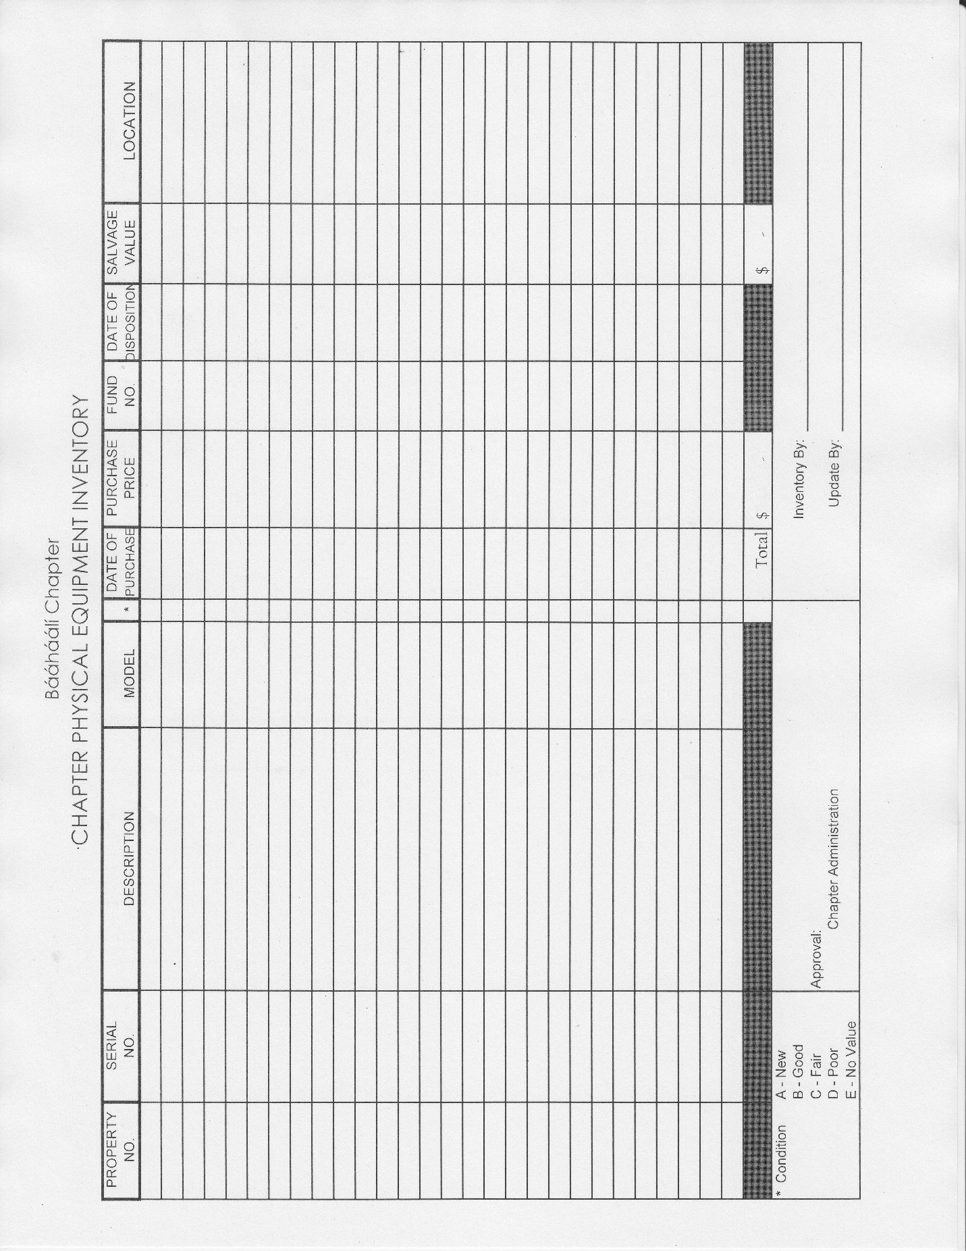EXHIBIT BB

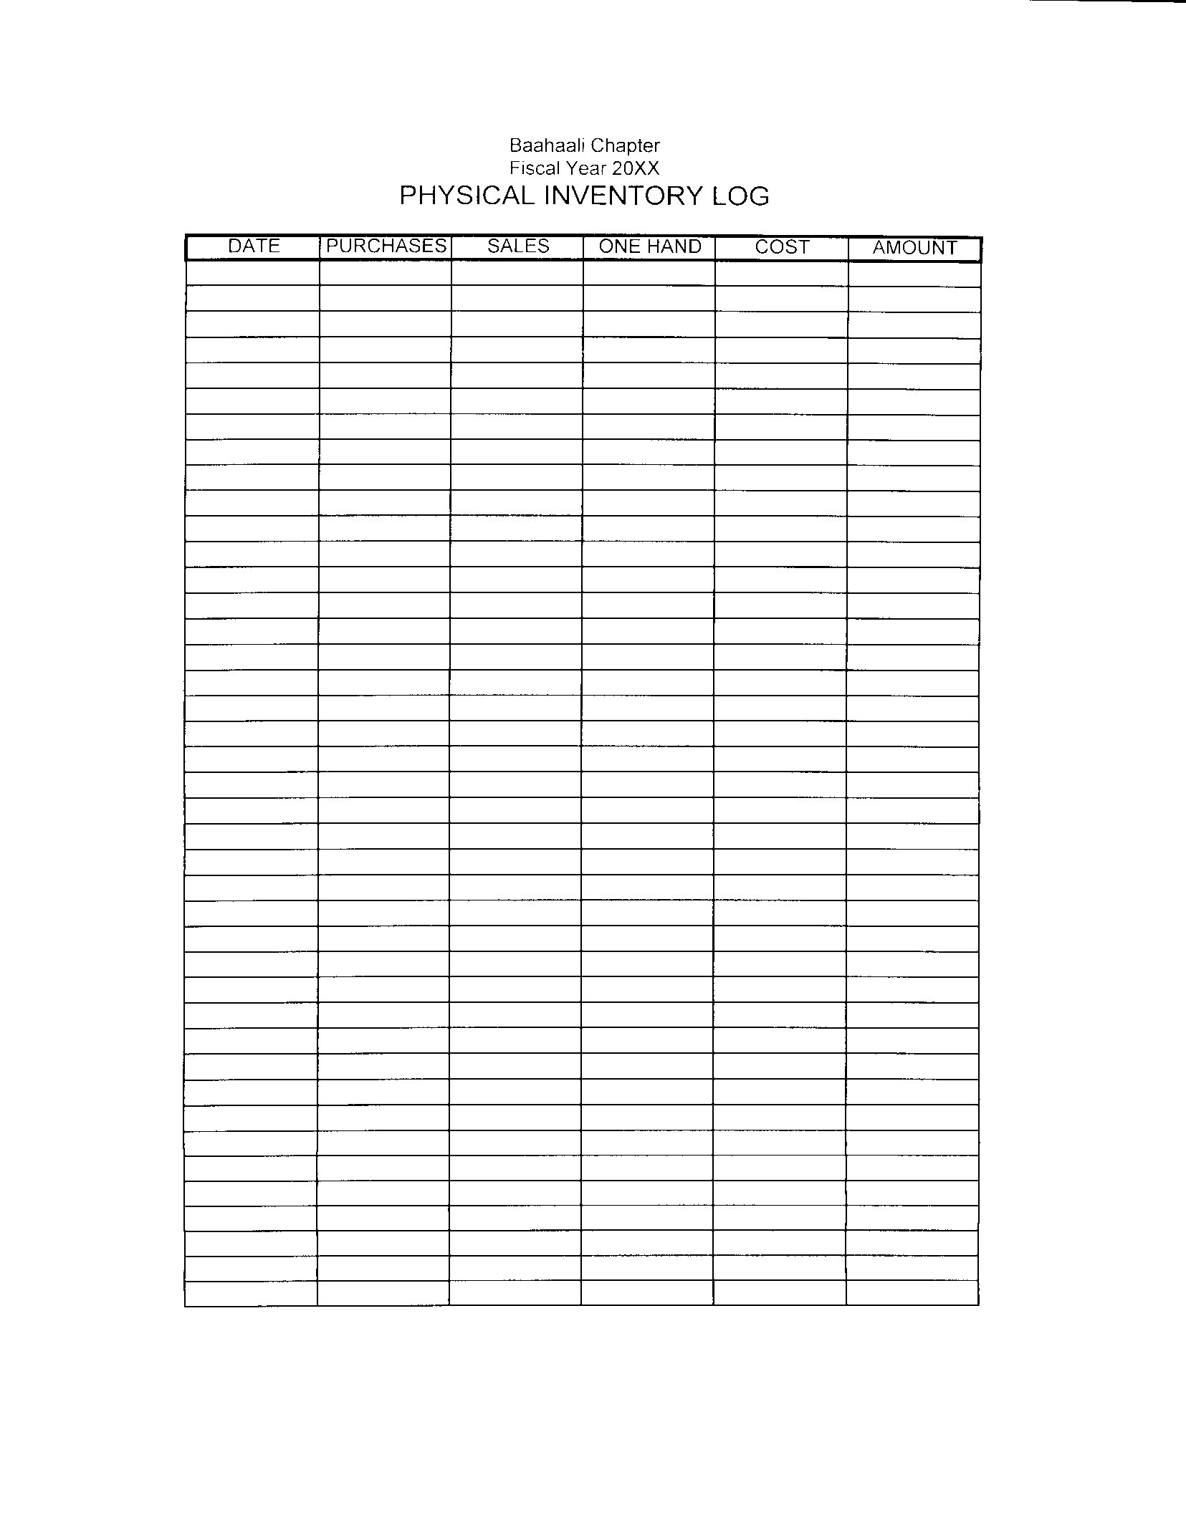

EXHIBIT CC

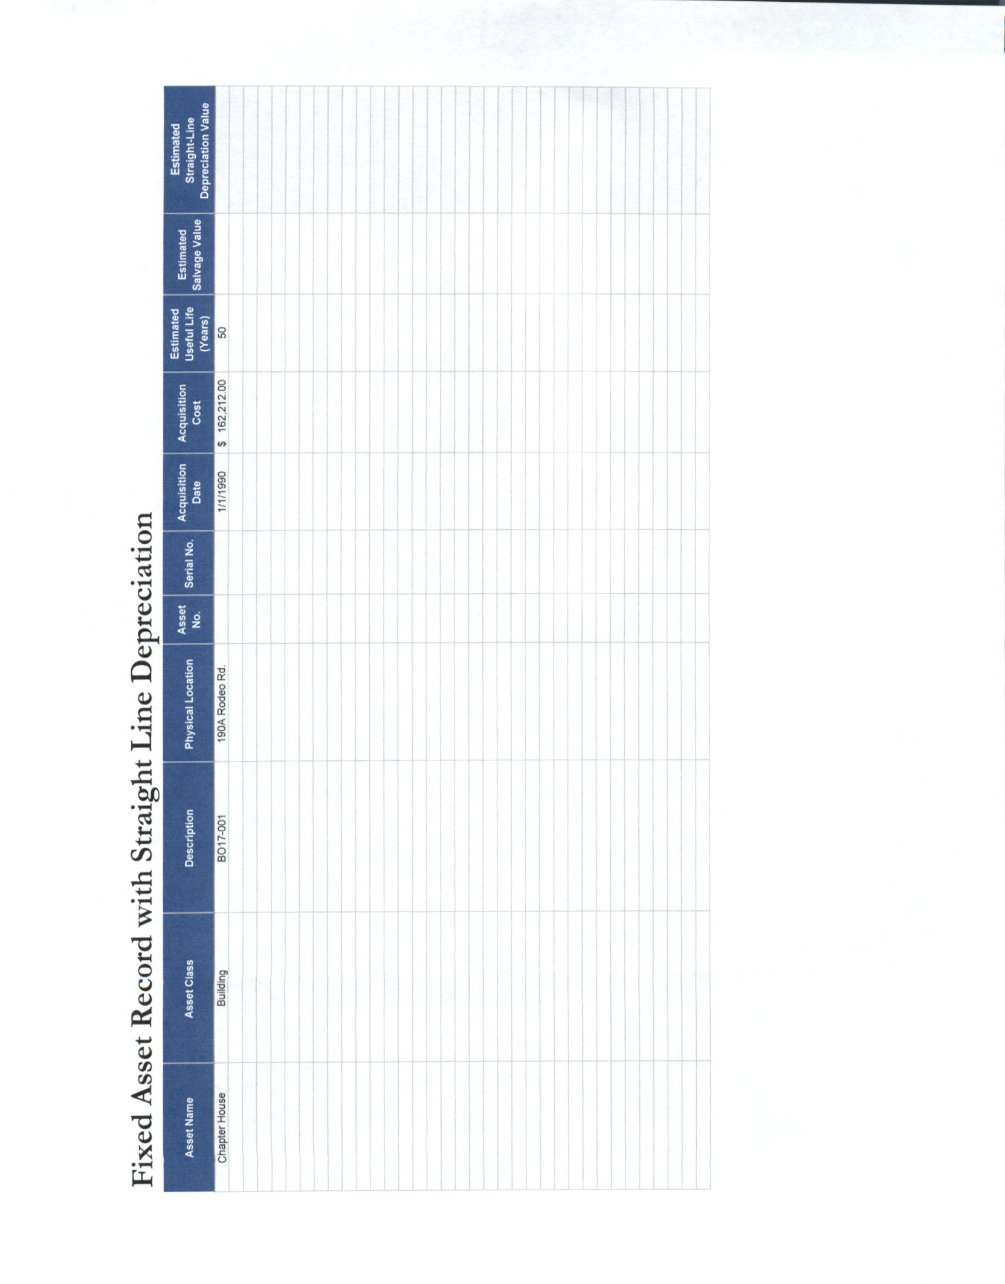

EXHIBIT DD  
PAGE 1 OF 7

BÁÁHÁÁLÍ CHAPTER

CHART OF ACCOUNTS

**FUNDS**

**UNRESTRICTED**

01 Chapter Activities General Funds

(02 TO 39)  **RESTRICTED**

02 Navajo Nation General Funds

03 Trust Funds/Claims Settlement Interest Funds

04 Trust Funds/Chapter Government Funds

06 General Lapse Funds

07 Grazing Official Stipends

08 Summer Youth Employment Funds

09 Housing Discretionary Funds

10 LGA Grant

11 Planning Grant Fund

12 Chapter Stipend Fund

13 Scholarship/General Fund

14 Scholarship/Claims Fund

15 PEP Funds

16 Veterans Funds

17 Emergency Funds

18 Federal Funds

19 State Funds

20 County Funds

21 Chapter Maintenance & Operations

22 Navajo Nation General Funds ($25,000 Supplemental)

23 Navajo Nation Sales Tax

24 Navajo Nation General Funds ($100,000 Supplemental)

25 Capital Improvement Funds (CIP)

50 Weaving Program

(80 TO 90) **RESTRICTED**

80 General Fixed Assets

90 General Long Term Debts

**CODE**

* 1. ASSETS XX - XXXX
  2. LIABILITIES Fund # Assets
  3. FUND BALANCE (01-90) Liabilities
  4. REVENUE Revenues
  5. EXPENSES Expenditures

PAGE 2 OF 7

**LIABILITIES**

2001 – 2099 PERSONNEL TAXES

2001 Accounts Payable

2011 Accrued Expenses

2021 Payroll Payable

2022 Federal Income Tax Withheld

2023 State Income Tax Withheld

2024 FICA Tax Payable

2025 Medicare Tax Payable

2026 FUTA Tax Payable

2027 SUTA Tax Payable

2028 Workman’s Compensation Payable

2029 Other Estimate Tax Liabilities

2030 401k Payable

2031 Health Insurance Payable

2032 Retirement Payable

2033 Life Insurance Payable

2099 Encumbrances

1. Deferred Revenue
2. Child Support Payable

2120 Deposits

2132 Retirement Payable

1. Bank Loan

FUND BALANCE

1. Fund Balance
2. Restricted Fund Balance
3. Reserve for Encumbrances

**GLOSSARY**

Accrued Expenses: Expenses resulting in liabilities which are either due or not payable until some future time

Deferred Revenue: A tribal government or entity receiving revenues in advance for services which will be performed at a later date

Encumbrances: An estimated amount of proposed expenditure.

Reserved for encumbrances: Encumbrances set aside a portion of an appropriation account

PAGE 3 OF 7

ASSETS

1000-1199 CASH AND CASH EQUIVALENT

1000 Cash on Hand

1001 General Checking Account

1005 Petty Cash

1100 General Savings Account

1150 State Farm CD

1201-1210 GRANTS RECEIVABLE

1200 Accounts Receivable

1203 Grants Receivable—Federal

1204 Grants Receivable—Navajo Nation

1205 Grants Receivable—State

1206 Grants Receivable—County

1207 Grants Receivable—Other

1210-1220 OTHER RECEIVABLE

1211 Accounts Receivable—Hay Sale

1212 Accounts Receivable—Arts and Crafts

1213 Accounts Receivable—Grain Sales

1214 Interest Receivable

1215 Miscellaneous Receivable

1220-1230 ADVANCES AND DEPOSITS

1224 Travel Advances—Employees

1225 Travel Advances—Chapter Officials

1226 Other Advances

1227 Payroll Advances

1230 Interfund Receivable

1300-1310 INVENTORY/RESALE ITEMS

1301 Inventory—Hay

1302 Inventory—Arts and Crafts

1303 Inventory—Grain

1304 Inventory—Veterinary Supplies

1305 Inventory—Wood and Coal

1309 Inventory—Other

1309-1320 FIXED ASSETS

1311 Office Equipment

1312 Heavy Equipment

1313 Other Equipment

1314 Office Furniture

1315 Vehicle

1318 Buildings

1320 Land

PAGE 4 OF 7

REVENUES

4100-4110 RESALE ITEMS

4101 Hay Revenue

4102 Wood Revenue

4103 Coal Revenue

4104 Water Revenue

4105 Grain Revenue

4106 Seeds Revenue

4107 Postage Stamps

4108 Mail Box Rental

4109 Water Delivery

4200-4215 RENTALS

4201 Office Rental

4202 Meeting Hall/Chairs/Tables Rental

4203 Heavy Equipment Rental

4204 Other Equipment Rental

SERVICES

4205 Farming Services Revenue

4206 Grazing Fees

4207 Veterinary Services

4208 Septic Services Revenue

4209 Disposal Fee Revenue

4210 Laundry Revenue

4211 Xerox/Fax Revenue

4212 Shower Revenue

4213 Telephone Revenue

4300-4310 OTHER INCOME

4301 Fundraising Revenue

4302 Concession Revenue

4303 Vending Machine Revenue

4304 Arts & Crafts Revenue

4305 Donations

4306 Oil & Gas Royalty

4400-4410 GRANTS/FUNDS

4401 Federal Grant

4402 County Grant

4403 State Grant

4404 Navajo Nation

4500-4510 MISCELLANEOUS

4501 Interest Income

4502 IRS Refund/Reimbursements

4503 Miscellaneous Income

4504 Unidentified Revenue

4505 Restitution

PAGE 5 OF 7

EXPENDITURES

6100-6115 PERSONNEL WAGES/TAXES/BENEFITS

6100 Salaries & Wages

6101 Salaries—Temporary

6102 Contractual Services

6103 FICA Expense

6104 Medicare Expense

6105 FUTA Expense

6106 SUTA Expense

6107 EE Group Insurance Expense

6108 Workman’s Compensation Expenses

6109 Annual Leave Expenses

6110 Sick Leave Expense

6111 Other Fringe Benefit Expense

6112 Bonus Pay

6113 Merit Bonus (Not in Sage Fund Accounting)

6114 Salary Adjustment (Not in Sage Fund Accounting)

6200-6210 TRAVEL EXPENSES

6202 Personal Travel Expense (Meals/Lodging/Mileage)

6203 Vehicle Mileage Expense

6204 Per Diem Meals

6300-6390 OPERATIONAL SUPPLIES

6300 Office Supplies

6301 Postage, Freight and UPS Expense

6302 Printing/Binding

6303 Operating Supplies

6304 Photo Copy/Reproduction

6305 Dues and Subscription

6306 Furniture/Equipment (Not in Sage Fund Accounting)

6320 Vehicle Operating Expense

6321 Gasoline—Vehicle

6322 Diesel Fuel

6324 Vehicle Parts (Not in Sage Fund Accounting)

6340 Veterinary Supplies

6350 Purchases—Hay

6351 Purchases—Grain

6352 Purchases—Food (Chapter)

6353 Purchases—Wood

6354 Purchases—Coal

6355 Purchases—Seeds

6356 Purchases-Gravel

6357 Purchases-Culverts

6380 Building Materials

6390 Other Supplies Expense

6400-6420 LEASE/COMMUNICATION/UTILITIES

6401 Space Rental

6402 Equipment Rental

6403 Building Rental

6404 Other Lease/Rentals

6410 Telephone Expenses

6411 Other Communication Expense

6412 Electric Expense

6413 Natural Gas/Propane

6414 Waste Disposal Collection

6415 Water Expense

6416 Sewage

6417 Internet Service

6500-6510 REPAIRS AND MAINTENANCE

6500 Repair & Maintenance—Office Equipment

6501 Repair & Maintenance—Construction Equipment

6502 Repair & Maintenance—Furniture

6503 Repair & Maintenance—Vehicles

6504 Repair & Maintenance—Buildings

6505 Repair & Maintenance—Others

6600-6620 CONTRACTUAL SERVICES

6600 Consultant Expense

6601 Legal Fees/Expense

6602 Audit Fees/Expense

6603 Other Professional Fees

6604 Catering Expenses

6605 Stipends—Meetings (Planning, Regular, Agency)

6606 Stipends—Mileage

6607 Seminars & Registration Fees

6608 Training & Tuition Fees

6609 Scholarship Awards

6610 Advertising/Promotional Expense

6611 Insurance—Property, Auto Liability, Equipment

6612 Insurance—Third Party Liability

6613 Insurance—Fidelity Bonds

6615 Bank Service Charges

6616 NSF Service Fees

6617 Late Charges

6618 Interest Expense

6619 Tax Penalties & Interest

6620 Gifts and Awards

6625 Bad Debt Loss

6720-6750 FINANCIAL ASSISTANCE

6720 Financial Assistance—Community

6721 Financial Assistance—Students

6722 Financial Assistance—Funeral

6723 Financial Assistance—Archeological

6724 Financial Assistance—Building Materials

6725 Financial Assistance—Survey (Not in Sage Fund Accounting)

6730 Emergency Assistance—Personal Needs

6731 Emergency Assistance—Furnishing Needs

6732 Emergency Assistance—Health Needs

6733 Emergency Assistance—Occupational Needs

6734 Emergency Assistance—Housing

6735 Donations

6800-6810 CAPITALIZED EXPENDITURES

6800 Office Equipment

6801 Construction Equipment

6802 Equipment

6803 Office Furniture

6804 Computers

6805 Vehicles

6806 Buildings

6807 Chapter Renovation

6808 Infrastructure—Bathroom Additions

6809 Infrastructure—Power Line

6810 Infrastructure—Waste Water

6811 Infrastructure—Water Line

6812 Infrastructure—House Wiring

6813 Infrastructure—Land Improvements

6814 Matching Funds—County

6815 Matching Funds—Federal

6816 Matching Funds—State

6817 Matching Funds—Navajo Nation

6818 Infrastructure--Telephone

6911-6999 MISCELLANEOUS

6911 Unidentified Expenses

6999 Other Miscellaneous Expenses

9999 Interfund Transfer

PROGRAM

01 Full Time

02 Part Time

03 Graduate Students

04 Summer Full Time

05 Summer Part Time

10 Livestock Roundup

21 160 Acre Project

22 Surveyor

23 Plumber

51 Head Start

52 Senior Center

99 No Program